WW1 Pre–film Research Presentation Names:
In a group of 2-3, research two weapons from WW1 and present to the class.
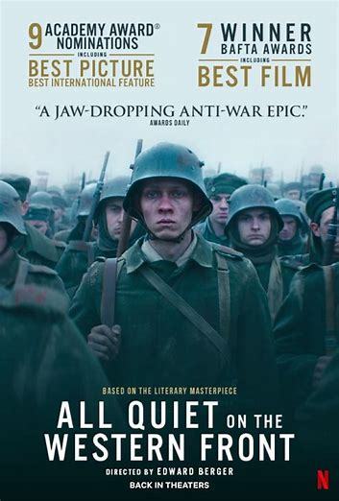
- Minimum 5 factoids each
- Use of whiteboard to supplement discussion
- All members participate in presentation
- Enthusiasm, maturity
- Fits within time frame 2-3 minutes
- A picture/drawing
- Optional Youtube clip

Comments:

/12

WW1 Pre–film Research Presentation Names:
In a group of 2-3, research two weapons from WW1 and present to the class.
- Minimum 5 factoids each
- Use of whiteboard to supplement discussion
- All members participate in presentation
- Enthusiasm, maturity
- Fits within time frame 2-3 minutes
- A picture/drawing
- Optional Youtube clip

Comments:

/12
- Maxim Gun
- Mark I Tank
- Mustard Gas
- Flammenwerfer (Flamethrower)
- German U-boats
- The Paris Gun
- Fokker Dr.I Triplane
- Mills Bomb
- Lee-Enfield SMLE
- Mauser 1918 T-Gewehr
- BL 18-inch Railway Howitzer
- German LZ Zeppelins
- Naval Mines
- Stokes Mortar
- Luger P08 Pistol
- Mauser Gewehr 98
- British Vickers Machine Gun
- French 75mm Field Gun
- Bayonets
- Trench Clubs
- Trench Knives
- Gas Masks (in response to chemical warfare)
- Artillery Shells
- Hand Grenades (various types, including the German Stielhandgranate)
- Observation Balloons
- Lewis Gun
- Renault FT Tank
- SMLE No.1 Mk III* (Short Magazine Lee-Enfield)
- Barbed Wire (used extensively in trench warfare); U-Boats; War Horses; Carier Pigeons, etc

