English 11 Name: ______________________

Assignment: In a formal composition with a clear thesis, introduction, blueprint, body paragraphs and a conclusion, respond to your choice of three options below.

“The Most Dangerous Game”: Option 1
Theme Composition
In a composition of 250-300 words, explain one theme of the story “The Most Dangerous Game.” You must state your theme as a proper theme statement and back it up with 2-3 specific and thoroughly explained reasons/examples from the story. You are required to properly integrate at least 2 quotes into your writing.

“The Most Dangerous Game”: Option 2
Synthesis Composition
In a composition of 300-350 words, discuss “The Most Dangerous Game” and either “The Sick Deer,” “Gentlemen, your verdict” or “Button, Button.” With direct reference to both texts, explain a theme that both have in common, and demonstrate how each text reflects that theme. You are required to properly integrate at least 2 quotes into your writing.

“The Most Dangerous Game”: Option 3
Synthesis Composition
In a composition of 250-300 words, discuss how General Zaroff would respond to the poem “The Sick Deer.” You must provide direct references to both texts. Use Zaroff’s actions and comments in “The Most Dangerous Game” to justify his hypothetical response to the ideas in the poem. You are required to properly integrate at least 2 quotes into your writing.

WORTH: 18 marks (Based on the 6 Point Scale – See rear of page)

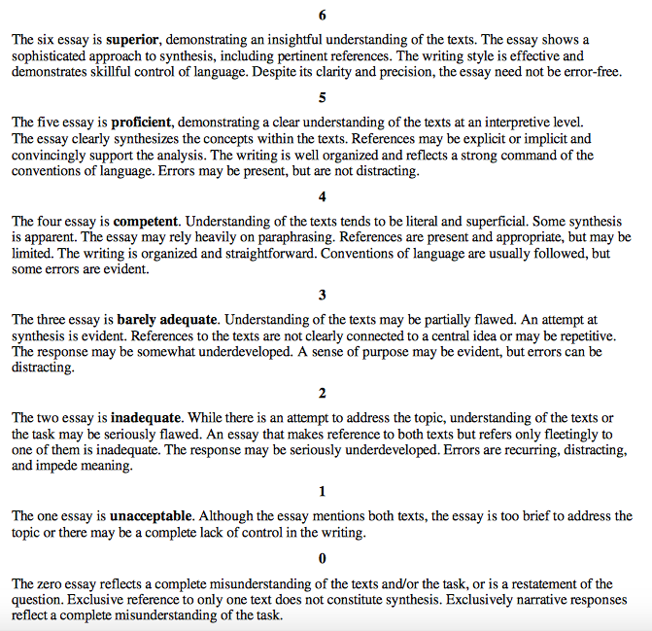

STAND-ALONE TEXT SCORING GUIDE

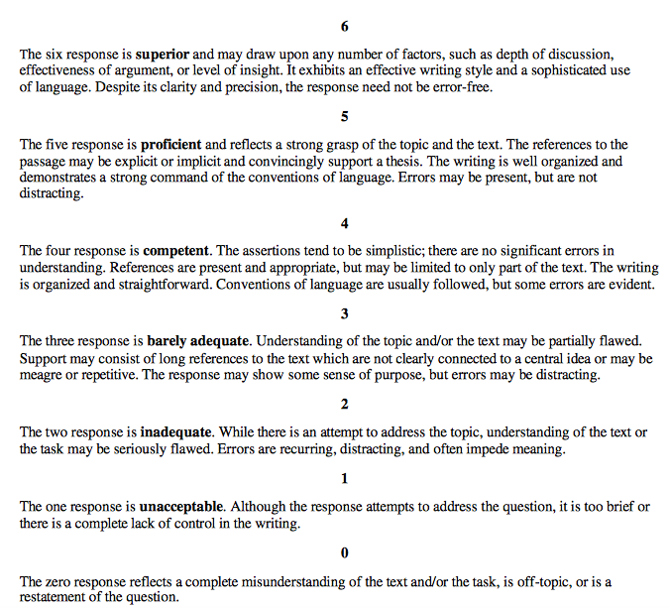

SYNTHESIS TEXT SCORING GUIDE

