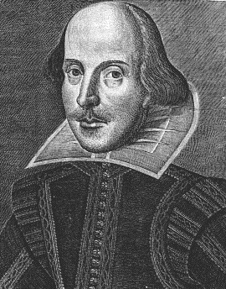
Language and Literature MYP Year Four – Let the Good Times Roll Mr. Fitton 6
“Read, read, read. Read everything – trash, classics, good and bad, and see how they do it. Just like a carpenter who works as an apprentice and studies the master.” -Faulkner

Introduction: English 9 is a skills-based course that aims to sharpen student’s minds and to provide pupils with strategies to become better readers, writers and connoisseurs of literature.

Course Objectives: Students will be able to:

*Develop confidence in reading, writing and speaking *Recognize literary devices in writing
*Read actively by taking notes, questioning & annotating *Develop proficient speaking and presentation skills
*Write expository, descriptive and narrative paragraphs as well as a basic essay; create amazing presentations
*Read and reflect upon reading via discussion/writing/creative projects *Have FUN with literature!

Curriculum Organizers. Learning Outcomes (Students will learn to:)

1.Criterion A: Analyzing i. Analyze the content, context, language, structure, technique & style of text(s) and the relationship among texts; analyze the effects of the creators choices on an audience; ii. justify opinions and ideas, using examples, explanations & terminology; iii. evaluate similarities & differences by connecting features across and within genres of texts.

2.Criterion B: Organizing i. Employ organizational structures that serve the context and intention; ii. organize opinions and ideas in a sustained, coherent and logical manner; iii. use referencing and formatting tools to create a presentation style suitable to the context and intention.

3. Criterion C: Producing Text. i. Produce text that demonstrate insight, imagination and sensitivity while exploring and reflecting critically on new perspectives and ideas arising from personal engagement with the creative process; ii. make stylistic choices in terms of linguistic, literary and visual devices, demonstrating an awareness of impact on audience; iii. Select relevant details and examples to develop ideas.

4. Criterion D: Using Language i. Use appropriate and varied vocabulary, sentence structures and forms of expression; ii. write and speak in a register and style that serve the context and intention; use correct grammar, syntax and punctuation; iii. spell, write and pronounce with accuracy; use appropriate non-verbal communication techniques.
Assessment and Evaluation
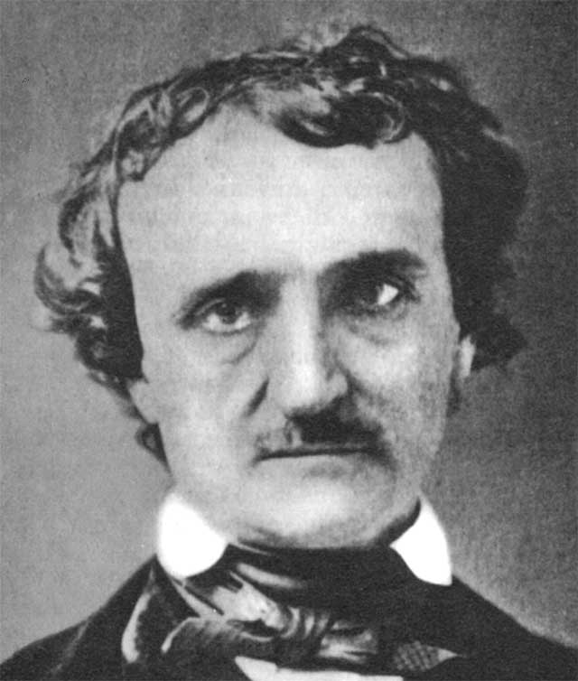
-Conducted on an ongoing basis.
-Criterion referenced (students know in advance how they will be marked); Formative and Summative
-Quizzes, Projects, thoughtful analysis of literature, written assignments, discussions, simulations, creative projects, student-choice.
Mark Breakdown
International Baccalaureate 8-Point Scale graded per criterion.
The pen is mightier than the sword!
-E. Bulwer-Lytton
Materials – Bring EVERY day: Binder w/dividers; Paper; Pencil; Texts
Label Dividers: *Helpful Handouts *Notes *Assignments

Late Policy – Assignments must be turned in at the beginning of class. If you have late assignments you will be kept in at lunch; let’s make a plan that works for you!

Attendance: Regular attendance is the most important predictor of success in this course.
Besides – you’re not going to want to miss all the fun!

Contact info: jfitton@sd67.bc.ca Website: www.mrfitton.weebly.com

Language and Literature Year 4 - We few, we happy few, we band of brothers!
“Books are the carriers of civilization. Without books, history is silent, literature dumb,
science crippled, thought and speculation at a standstill.” – Barbara W. Tuchman
OPTIONS FOR STUDY – You Get To Choose:
Unit 1: Literature Circles – Stargirl speaks up at the Stone Bear Lottery: You will be given a choice of several novels about bullying. Various activities will occur to help you achieve a deeper understanding. Novel choices: Speak, Touching Spirit Bear, The Lottery, Star Girl, Men of Stone, and More!

Unit 2: Short Stories - Death, Destruction and one Happy Day (AKA Short Stories) We will be interacting with stories and participating in various activities to help connect to the plot and the main ideas.
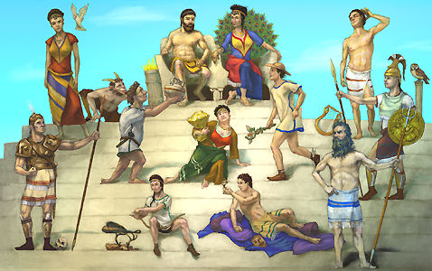
Stories include: “Mountain Journey,” “Monkey’s Paw,” “Toyland,” and “Adulthood.”

Unit 3: Mythology - Marvelous Men and Malignant Monsters
We will study an assortment of Greek mythology, the King Arthur myths and creation myths. You will have a variety options to reveal understanding.
Myths for Study: Creation myths, Greek Gods, “Deadelus and Icarus,” Greek Myth of Choice, King Arthur Myths, The Mighty
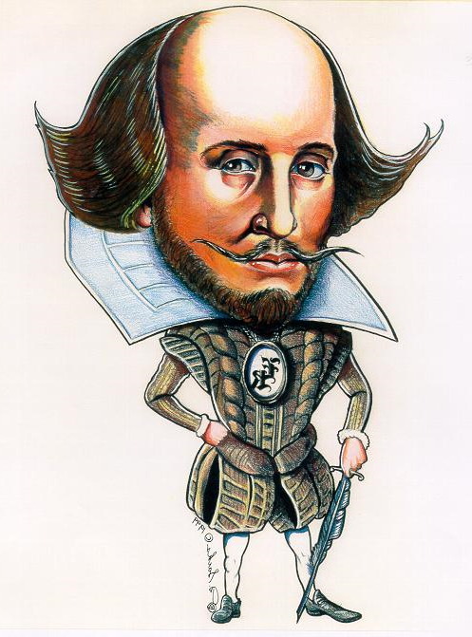
Unit 4: Action and Acting “Study thine play, thou foul pestilent foot licker”
We will study Shakespeare’s A Midsummer Night’s Dream. Get ready for some fun reading of the play out-loud in class! We will make Shakespeare come alive while learning about his life. The movie will be shown. Disclaimer: Pepto-Bismol & barf bags may be required on the last day

Unit 5: Sophistication - Modern Poetics. We will use a combination of written, performance & musical poetry to learn the elements of a poem, including poetic devices (metaphor, simile, etc)
Poetry to Study: “The Shark,” “Ironic,” “Richard Cory,” “Boulevard of Broken Dreams,” “Beautiful Day,” and poems that students will select.

Unit 6: Insight and Profound Understanding - Nonfiction Texts. In this unit we will explore texts such as directions and articles. Emphasis will be placed on reading strategies, understanding the texts and even writing your own instructions! You will also have a choice! Texts: “The Demon in the Freezer,” “Wither Amelia Erhardt,” “Paper Airplanes,” “When Ninja’s Attack,” and “The Sutter Boys.”

Unit 7: Mind Expanding Novels! Lovely Literature and Dandy Discussions
Again you will be given a choice of novels and we will do a variety of fun activities to increase your understanding of your text.* (See next page for more details) Choices include: Boy Who Couldn’t Die, Monster, Hunger Games, Ender’s Game, The Pearl, Acceleration, and multiple others.

Unit 8: Monsters – What are monsters? Literally and Figuratively. Every monster is a human fear personified – let’s delve deeply into psychology. In this unit we will examine Shane Koyczan’s poems, Monster Films, Short Stories, Art, Non-Fiction Psychology articles and Short Films. Make your own monster movie; annotate an article and look at how to conquer your fears!

Unit 9: Storytelling – Let’s tell our story through Photography and Narrative. In this unit we will learn some basic photography as part of researching non-fictions sources (webpages and youtube). Then we will learn how to interview, ask questions, and listen intently to produce a Humans of New York Style photograph enhanced story.

Unit 10: Psychology and Happiness – Want to know the inner workings of the mind and how to improve your happiness? We will take a journey into applied psychology and wellness to learn how to train your brain, become happier and develop skills to reduce anxiety as we create a better relationship with stress and our minds!

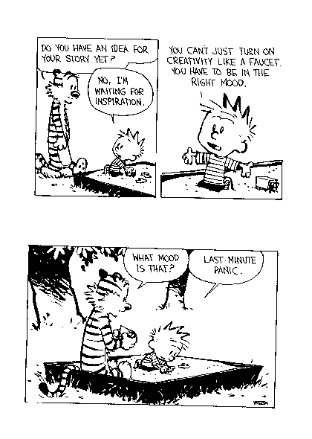
Congratulations, you are now a Language and Literature genius!

*Literature Circles allows students to choose a novel of their choice. They will study the novel in groups using roles and small group projects as a basis for discussion and as an avenue to discover the meaning of their novel.

*A primary goal within School district 67 is to improve student literacy by fostering independent reading for all students. The success of the Literature circle program is dependent upon offering current and relevant novels that will engage students. Therefore, some novels may contain realistic and mature themes. Student will be briefed on the style and content of each text prior to making their individual selections. Parents with an interest in Literature Circles are encouraged to contact the classroom teacher.

Please review this outline with your parents and have them sign it and include their email address and phone number and hand it back to me a week after class starts. Email is a great way to contact me. My email address is: jfitton@sd67.bc.ca . Please do not hesitate to email me if you (or your parents) have any questions. I am also available by phone at 770-7750. My website is a great source of information: www.mrfitton.weebly.com

---------------------------------------------------------------------------------------------------------

Student Name: _________________________________________________________

Parent(s) Name(s): _____________________________________________________

Signature: ____________________________________________________________

Email and phone number: (Phone) ____________________________________________
(E-mail)____________________________________________

Student Email address: _________________________________________________

