“The man who doesn't read books has no advantage over the man who can't read them.” ~ Mark Twain
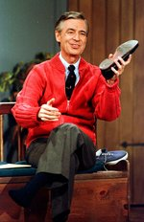
English 12 Course Outline Mr. Fitton – 2013/2014
English 12 will focus on continuing to improve student’s writing, thinking, speaking and listening skills. Students will study a variety of literary genres to improve their ability to appreciate and critique literature and to better understand society.

Throughout the course, the emphasis will be on the student’s abilities to express themselves clearly, logically and concisely in written and verbal form. As the provincial is worth 40% of the student’s final grade, considerable time will be spent familiarizing students with the format of the exam.

Mr. Roger’s Welcomes you to English 12 and Says: Please visit Mr. Fitton’s website at: http://mrfitton.weebly.com and/or follow him on twitter: @mrfittonteacher. Have a marvelous day in the neighbourhood.

Curriculum Organizers: Learning Outcomes (Students will learn to:)

1. Oral Language Communicate effectively through public speaking, acting, sharing opinions,
(Speaking and listening) debating and working in groups. Learn techniques to persuade/critique/engage others. Students will also learn how to become active listeners

2. Reading and Viewing. Read and view to comprehend the deeper meaning of a variety of fiction and nonfiction. We will also sharpen critical analytical skills through constant practice with a variety of texts and mediums.

3. Writing & representing. Express ideas meaningfully, clearly and creatively. Apply a range of strategies to improve writing by assessing their own work and others.

Expectations “Life's a game, all you have to do, is know how to play it.” Sidney J. Harris

1. I will endeavor to keep homework to a minimum. Most assignments will be done in class. In return, I expect that all students will make every effort to attend each class on time. Parents will be contacted when students have unexcused absences or excessive lates. If you must be absent from a class, it is your responsibility to pick up the assignments you missed, preferably before class. My website is available 24-7!

2. Come to class on time, prepared and ready to work. Treat everyone with respect.

3. Students are encouraged to finish assignments ahead of time and bring them in so I can offer suggestions for improvements. Students may re-write assignments.

4. During class discussions leave all electronics in your bag. During independent work you may use an ipod, but please do not use your cell phone in class unless it is part of a learning activity designated by me.
5. Have a good semester; you get out of this course as much as you are willing to put in.

Evaluation:*
Writing and Representing 50%
Reading and Viewing 40%
Oral Language 10%

Final Evaluation: Course Mark=60% Provincial Exam=40%
English 12 Provincial Exam: http://www.bced.gov.bc.ca/exams/ (provincial exam website)

Course Units: (Dates and length of units are tentative)

“To read without reflecting is like eating without digesting.” ~ Edmund Burke ~
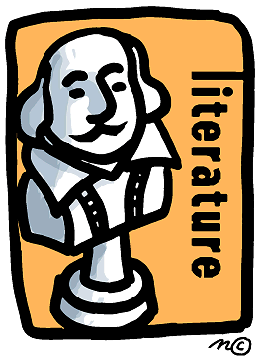
- 1. The Writing Process
  - Creative/personal/literary writing
  - Techniques for structure and style
  - Evaluating your own writing and peer evaluation
  - Blogging

  - 2. Short Prose
  - Elements of the short story (fiction)
  - Non-fiction/Informational Text
  - Critical literacy
  - Reading strategies
  - Media analysis

  - 3. Poetry
  - Poetry in modern music/performance poetry
  - Poetic forms /figures of speech
  - Analysis and comparisons (synthesis)
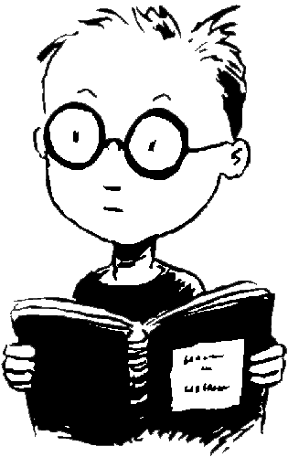
  - Poetry Cafe

  - 4. Novel Study
  - Major elements of fiction/non-fiction
  - Connections to current events/ universal themes
  - Lit Circles (choice of novels) and an independent novel

  - 5. Drama
  - Shakespeare - The Taming of the Shrew
  - Comic Life or Comparison with Ten Things I Hate About You

  - 6. Public Speaking, Debate and/or Presentation Skills (Throughout the semester)

Note: These units are not completely contained; they will overlap and at times be combined.

“Today a reader, tomorrow a leader.” ~ W. Fusselman ~

