Semester (2017) English 11 Mr. Fitton
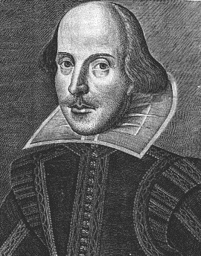
“Read, read, read. Read everything – trash, classics, good and bad, and see how they do it. Just like a carpenter who works as an apprentice and studies the master.” -William Faulkner


Introduction: English 11 is a skills based course that aims to sharpen student’s minds and to provide pupils with strategies to become better readers, writers and connoisseurs of literature.

Course Objectives: Students will develop the ability to:

*Develop confidence in reading, writing and speaking *Recognize stylistic & rhetorical techniques in writing
*Read actively by taking notes, questioning & annotating *Develop proficient speaking and presentation skills
*Write literary analysis, personal essay,& other forms *Read and reflect upon reading via discussion/writing
*Assess bias and objectivity in literature and media *Sharpen Critical Analytical Skills

Curriculum Organizers. Learning Outcomes (Students will learn to:)

1. Oral Language Communicate effectively through public speaking, acting, sharing opinions,
(Speaking and listening) debating, collaborating in groups, techniques to persuade/critique/engage others. Students will also use effective academic listening strategies.


2. Reading and Viewing. Read and view to comprehend the complexities of a variety of text forms. Will also engage with vocabulary and content to sharpen critical analytical skills while interpreting, evaluating and synthesizing texts.

3. Writing & representing. Express ideas meaningfully and creatively with clarity. Apply a range of strategies to improve their writing by using meta-cognitive strategies to assess their work. Use new media, spoken language and creativity!

Assessment and Evaluation
-Conducted on an ongoing basis.
-Criterion referenced (students know in advance how they will be marked)
-Tests, Quizzes, Projects, Analysis of Material, Essays, Seminars, Simulations, new media.
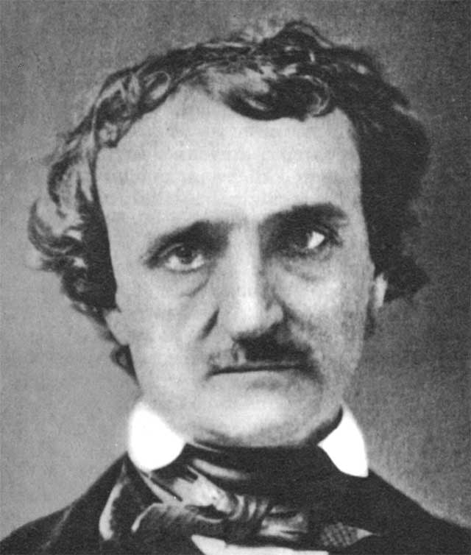
Mark Breakdown (This is tentative; we’ll be flexible)
40% of the School Mark will be based Reading Comprehension Assignments
50% of the School Mark will be based on Assignments.

10% of the School Mark will be based on quizzes, checks, etc.
Terms 1 & 2 = 80% Exam = 20%
Materials – Bring EVERY day: Binder w/dividers; Paper; Pencil; Texts
The pen is mightier than the sword!
-E. Bulwer-Lytton

Late Policy – Our goal is to learn together. Let me know if there are life circumstances prohibiting you from learning at the same pace as the class.

Attendance: Regular attendance is the most important predictor of success in this course.
Arrive on time and prepared. If you must miss class, inform me in advance to receive the
material missed. If you are late, enter quietly and like an adult .

No electronic devices during shared time; drinks and food are great

English 11 - We few, we happy few, we band of brothers!
“Books are the carriers of civilization. Without books, history is silent, literature dumb,
science crippled, thought and speculation at a standstill.” – Barbara W. Tuchman

UNIT 1 –Ethics and Morality - Unit (Short Stories, Film, Podcasts, Prose)
Timeline Titles Studied Goals and Skills: Assessment
September A Long Way Gone, “The Test” *Structure of story *character type 1. Questions
“Mirror Image” “Sat. Climbing” *symbolism *irony *theme 2. Descriptive Composition
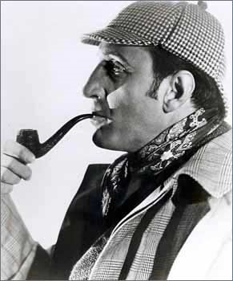
“Gentlemen Your Verdict” *Explain how literary devices help 3.Synthesis Essay
“Most Dangerous Game” with understanding *context clues 4. Quiz/tests
“Maiden Wiser than the Tsar” *Inference *Synthesize 5. Active Reading
The Boy in the Striped Pajamas

Unit 2 – New Media - Class Music Video; Happiness Thematic Unit/ Racism Thematic Unit
Timeline Titles Studied Goals and Skills: Assessment
October Fairly Flexible Creative Thinking, Critical Thinking Criterion Referenced
Teamwork, use of media Class Music Video
October Humans of New York Interviewing/Listening/Writing Humans of Penticton
Photo story/Photo-essay Narrative through photography Photo-essay

Unit 3 – Media Analysis Unit
Timeline Titles Studied Goals and Skills: Assessment
November Ad-persuasion, Adbusters, Film Study *Critical analytical skills 1.Project
Variety of magazines and video clips *Understand rhetorical/propaganda 2. Quizzes, tests
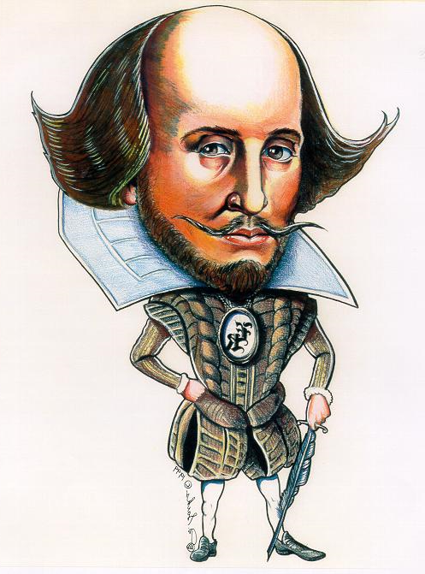
WW2 Propaganda, Cartoons. Fake news Strategies. *Become a knowledgeable 3. Advertisement
OR: Myth Unit, The Iliad and consumer. *Understand myths *Gain 4. Creative Write
A variety of aboriginal & contemporary a cultural appreciation and insight 5. Discussion
myths – decided with student input. Into myth-making. 6. Self assess tools

Unit 4 – Shakespeare
Timeline Titles Studied Goals and Skills: Assessment
November Macbeth *Motifs, Themes, Quotes 1.Quotations
Films, Poems, *Analysis of Literature *Memorize 2. Quiz. / Unit Test
Articles, Internet *Research/Historical Context 3. Presentations
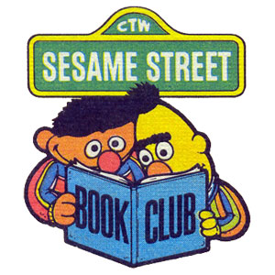
*Quotation analysis *Read aloud 4. Research Project
*Collaborate/reader’s theatre 5. Motif/Theme Essay

Unit 5 – Poetry and Lit Circles*
Timeline Titles Studied Goals and Skills: Assessment
Dec Poetic Devices, Death Poems, Rap *Create/Appreciate Poetry 1.Anthology/Quizzes
Various songs/Found Poems, Film Study *Explain how poetic devices relate 2. Sight Poems
A variety of novels: Glass Castle to meaning *Offer textual insights 3. Sticky Notes
Lord of Flies, Lovely Bones, Life of Pi *interpret *Collaborate with 4. Annotations/Unit Test
The Long Walk, A Child Called It etc.. peers to determine meaning. 5. Analytical Paragraphs
6. Lit Circles
Unit 6 – Creative Writing, Information Circles & Review
Timeline Titles Studied Goals and Skills: Assessment
January Guide to non-fiction prose *Analyze and emulate great writers
Various creative work *Express self creatively and create
Selected information circles own style. *Exam tips
Exam review booklets *Review all course components for exam.

Unit 7 – Genius Hour – (Ongoing unit involving project you are passionate about)



Congratulations, you are now an English genius!

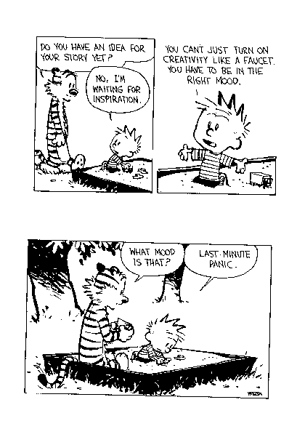

Literature Circles* allows students to choose a novel of their choice. They will study the novel in groups using club sheets and small group projects as a basis for discussion and as an avenue to discover the meaning of their novel.

*A primary goal within School district 67 is to improve student literacy by fostering independent reading for all students. The success of the Literature circle program is dependent upon offering current and relevant novels that will engage students. Therefore, some novels may contain realistic and mature themes. Student will be briefed on the style and content of each text prior to making their individual selections. Parents with interest in Literature Circles are encouraged to contact the classroom teacher.

Please review this outline with your parents and have them sign it and include their email address and phone number and hand it back to me. Email will be my primary mode of contact. My email address is: jfitton@summer.com Please do not hesitate to email me if you (or your parents) have any questions.

Student Name: ________________________________________________

Parent(s) Name(s): _____________________________________________________

Email and phone number: (P) _____________________________________________
(E)_____________________________________________

Student Email address: _________________________________________________

