Activity 1: Emotion Charades
Objective: To improve emotional awareness and empathy.
Materials Needed:
- A set of cards with different emotions written on them (e.g., happiness, sadness, anger, fear, surprise, disgust, etc.).
- A timer.
Instructions:
- Preparation: Before the activity, prepare a set of emotion cards. Each card should have one emotion written on it.
- Divide the Class: Split the class into small groups or pairs.
- Playing the Game: Students take turns drawing a card from the pile and then have to act out the emotion without using words. The rest of the group has to guess what emotion is being portrayed.
- Discussion: After each round, have a brief discussion. Ask questions like:
  - How did you feel acting out this emotion?
  - What physical signs did you notice that helped you guess the emotion?
  - Can you share a time when you felt this emotion?
Educational Aspect: This activity helps students recognize and understand different emotions, both in themselves and in others. It also encourages empathy, as they have to put themselves in the shoes of someone experiencing that emotion.

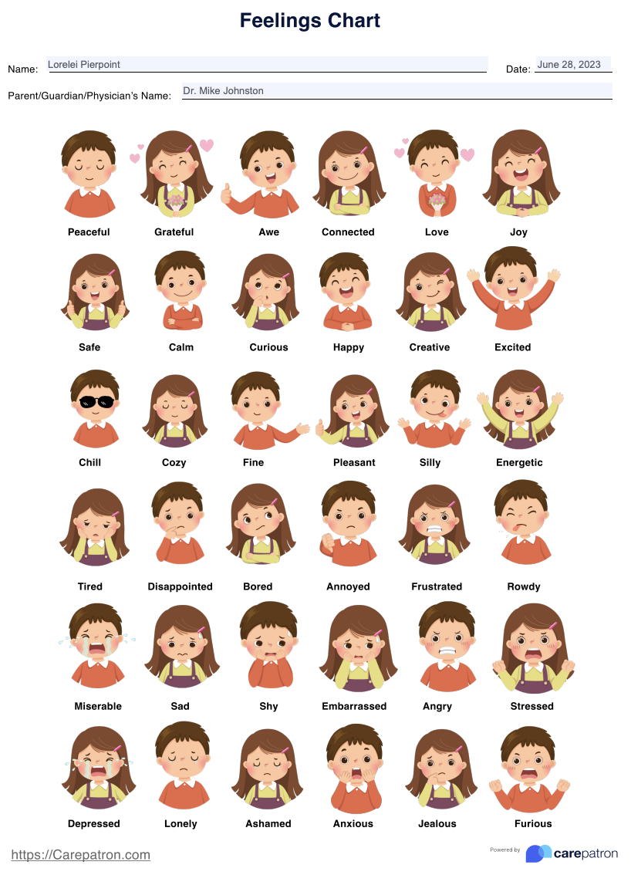

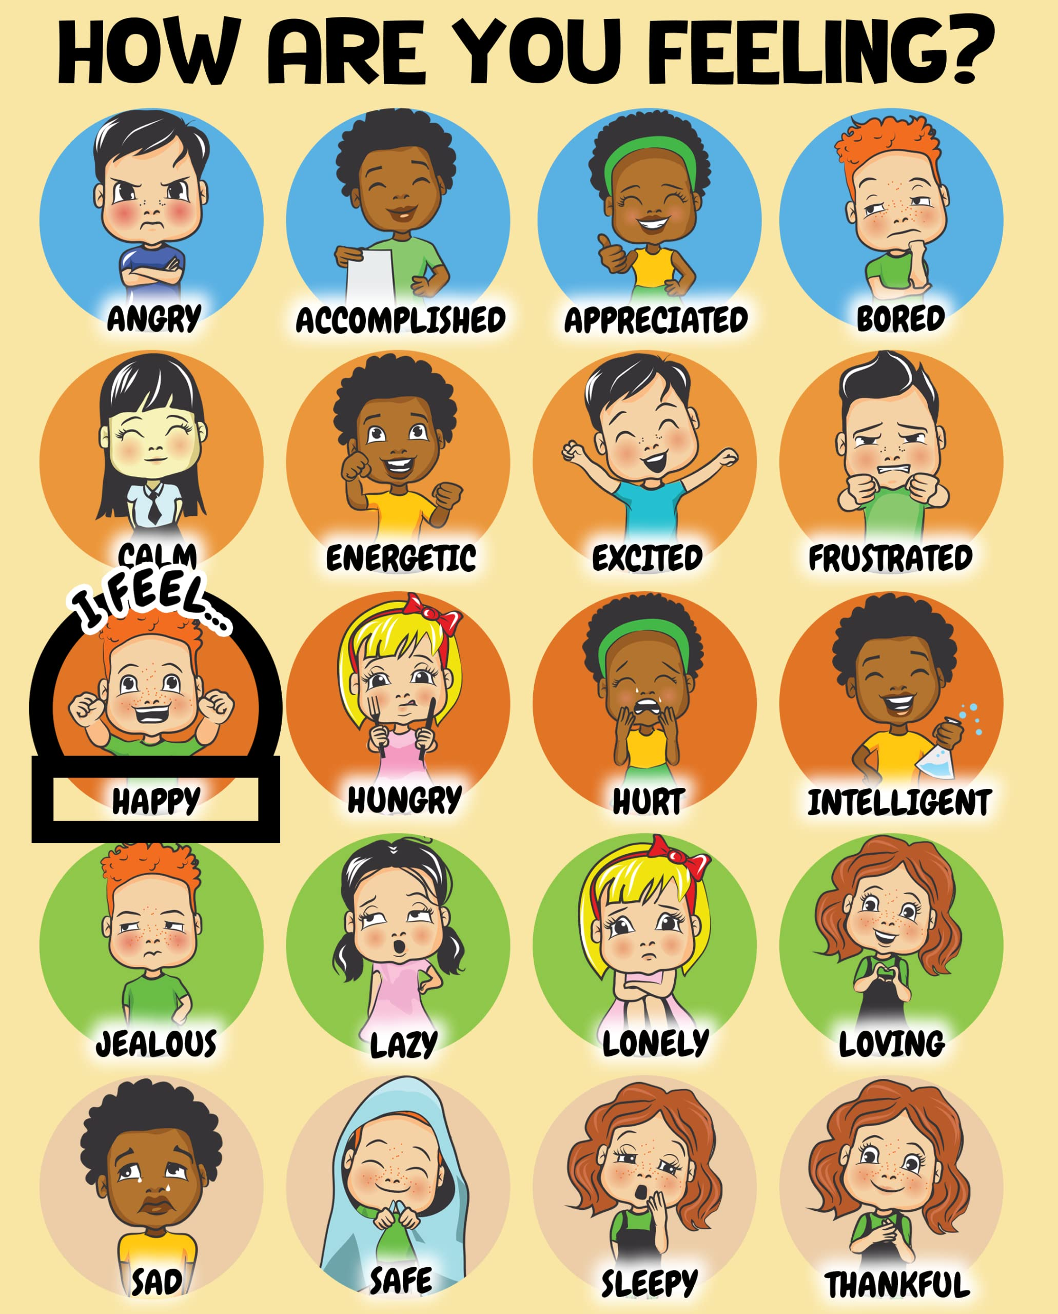

Positive Emotions
- Happiness: A state of well-being and contentment.
- Love: A deep, tender feeling of affection and attachment.
- Joy: A feeling of great pleasure and happiness.
- Excitement: A feeling of great enthusiasm and eagerness.
- Contentment: A state of satisfaction and peace.
- Pride: A feeling of self-respect and personal worth.
- Gratitude: A feeling of thankfulness and appreciation.
- Hope: An optimistic attitude of mind based on an expectation of positive outcomes.
- Amusement: The state of finding something funny or entertaining.
- Awe: A feeling of reverential respect mixed with fear or wonder.
- Euphoria: A feeling or state of intense excitement and happiness.
- Nostalgia: A sentimental longing for the past.
- Serenity: The state of being calm, peaceful, and untroubled.
- Satisfaction: Fulfillment of one's wishes, expectations, or needs.
- Eagerness: Enthusiastic and keen desire or interest.
- Triumph: A feeling of joy or exultation because of a success or victory.
Negative Emotions
- Sadness: A feeling of sorrow and unhappiness.
- Anger: A strong feeling of annoyance, displeasure, or hostility.
- Fear: An unpleasant emotion caused by the belief that someone or something is dangerous.
- Disgust: A feeling of revulsion or profound disapproval aroused by something unpleasant or offensive.
- Anxiety: A feeling of worry, nervousness, or unease about something with an uncertain outcome.
- Disappointment: The feeling of sadness or displeasure caused by the non-fulfillment of one's hopes or expectations.
- Frustration: A feeling of dissatisfaction, often accompanied by anxiety or depression, resulting from unfulfilled needs or unresolved problems.
- Guilt: The fact of having committed a specified or implied offense or wrong.
- Shame: A painful feeling of humiliation or distress caused by the consciousness of wrong or foolish behavior.
- Envy: A feeling of discontented or resentful longing aroused by someone else's possessions, qualities, or luck.
- Jealousy: A feeling of envy regarding a rival's success, advantages, or relationship.
- Despair: The complete loss or absence of hope.
- Boredom: A state of feeling disinterested in one's surroundings, having nothing to do, or feeling that life is dull.
- Loneliness: Sadness because one has no friends or company.
- Confusion: A state of being bewildered or unclear in one’s mind about something.
- Melancholy: A deep, pensive, and long-lasting sadness.
- Resentment: Bitter indignation at having been treated unfairly.
- Indignation: Anger or annoyance provoked by what is perceived as unfair treatment.
- Embarrassment: A feeling of self-consciousness, shame, or awkwardness.
- Sorrow: A feeling of deep distress caused by loss, disappointment, or other misfortune.
- Agitation: A state of nervousness or unrest.
- Irritation: The state of feeling annoyed, impatient, or slightly angry.
- Overwhelm: A feeling of being completely overcome in mind or emotion.
- Yearning: A feeling of intense longing for something.
Complex or Mixed Emotions
- Empathy: The ability to understand and share the feelings of another.
- Compassion: Sympathetic pity and concern for the sufferings or misfortunes of others.
- Schadenfreude: Pleasure derived by someone from another person's misfortune.
- Apathy: Lack of interest, enthusiasm, or concern.
- Anticipation: The action of anticipating something; expectation or prediction.
- Sympathy: Feelings of pity and sorrow for someone else's misfortune.
- Calmness: The quality of being tranquil and free from agitation or strong emotion.
- Relief: A feeling of reassurance and relaxation following release from anxiety or distress.

Activity 2: The Empathy Circle
Objective: To enhance listening skills and empathy.
Materials Needed:
- A set of prompts or scenarios that involve emotional responses (e.g., feeling left out, winning a competition, dealing with a misunderstanding).
Instructions:
- Setting Up: Arrange chairs in a circle and have students sit down. Explain that this is a safe space where everyone’s thoughts and feelings are respected.
- Scenario Introduction: Introduce a scenario or prompt that involves an emotional response.
- Sharing in Turn: Each student takes a turn to respond to the scenario. They can share a personal experience that relates to it, how they would feel in that situation, or what they think someone experiencing it might feel.
- Active Listening: While one student is sharing, others should practice active listening – this means no interrupting, maintaining eye contact, and showing empathy.
- Reflection: After each student has shared, open the floor for reflections. Ask questions like:
  - How did it feel to share your thoughts/feelings?
  - Did you notice any common feelings or reactions?
  - How did actively listening to others affect your understanding of the situation?
Educational Aspect: This activity encourages students to listen actively and empathetically to others. It fosters a deeper understanding of how different people can experience and interpret the same situation differently.
Additional Tips:
- Debriefing: After each activity, it’s crucial to have a debriefing session. This helps students process what they’ve learned and understand the relevance of these skills in real life.
- Safe Environment: Ensure that the classroom is a safe and respectful space for all students to express themselves without fear of judgment.
- Integration with Curriculum: Where possible, integrate these activities with relevant subjects or topics in the curriculum to reinforce the importance of emotional intelligence across different contexts.
By engaging in these activities, students not only learn about emotional intelligence but also develop critical life skills that will benefit them in both their personal and professional lives.

Scenario 1: New Student in School
Description: Imagine you're a new student in a school where you know no one. On your first day, you see everyone else chatting and laughing with their friends. You feel isolated and unsure about how to make new friends.
Scenario 2: Academic Success
Description: You've been working extremely hard for a major test. When the results come out, you find out you've scored the highest in your class. You feel a mix of pride and excitement but also worry about how your classmates might react, fearing they might see you as a show-off or become jealous.
Scenario 3: Social Media Misunderstanding
Description: You post a picture on social media that you think is funny, but it accidentally offends a group of your peers. They confront you about it the next day, and you feel a mix of confusion, guilt, and defensiveness.
Scenario 4: Family Illness
Description: Your parent or guardian has been diagnosed with a serious illness. You're overwhelmed with worry and fear about their health, but you also feel the need to be strong and supportive for your family.
Scenario 5: Peer Pressure
Description: Your friends are pressuring you to skip class and go to a party. You feel torn between wanting to fit in with the group and knowing that skipping class goes against your values and could have negative consequences.
Scenario 6: Breakup of a Relationship
Description: Your significant other, whom you cared about deeply, has just broken up with you. You're experiencing a whirlwind of emotions: sadness, confusion, anger, and a sense of loss.
Scenario 7: Winning a Competition
Description: You win a competition that you and your best friend entered together. You're thrilled about your victory but also feel guilty because your friend didn't win and seems upset.
Scenario 8: Rumors and Gossip
Description: A false rumor about you is spreading through the school. You feel angry and hurt that people are talking about you and believe something untrue, and you're unsure how to handle the situation.
Scenario 9: Exclusion from a Social Group
Description: You find out that a group of your friends planned an outing and intentionally didn't invite you. You feel rejected, confused, and upset, wondering what you might have done to be excluded.
Scenario 10: Academic Failure
Description: Despite studying hard, you fail an important exam. You feel a mix of disappointment, frustration, and embarrassment, and you're worried about the consequences this failure might have on your academic record.
Using the Scenarios:
Each of these scenarios is designed to evoke a range of emotions and encourage students to explore and discuss different emotional responses. They can share how they would feel in each situation, relate personal experiences, or discuss how they might support someone else in that scenario. This activity not only fosters empathy but also helps students develop a deeper understanding of their own and others' emotional processes.

Scenario 1: New Student in School
Description: Imagine you're a new student in a school where you know no one. On your first day, you see everyone else chatting and laughing with their friends. You feel isolated and unsure about how to make new friends.
Scenario 2: Academic Success
Description: You've been working extremely hard for a major test. When the results come out, you find out you've scored the highest in your class. You feel a mix of pride and excitement but also worry about how your classmates might react, fearing they might see you as a show-off or become jealous.
Scenario 3: Social Media Misunderstanding
Description: You post a picture on social media that you think is funny, but it accidentally offends a group of your peers. They confront you about it the next day, and you feel a mix of confusion, guilt, and defensiveness.
Scenario 4: Family Illness
Description: Your parent or guardian has been diagnosed with a serious illness. You're overwhelmed with worry and fear about their health, but you also feel the need to be strong and supportive for your family.
Scenario 5: Peer Pressure
Description: Your friends are pressuring you to skip class and go to a party. You feel torn between wanting to fit in with the group and knowing that skipping class goes against your values and could have negative consequences.
Scenario 6: Breakup of a Relationship
Description: Your significant other, whom you cared about deeply, has just broken up with you. You're experiencing a whirlwind of emotions: sadness, confusion, anger, and a sense of loss.
Scenario 7: Winning a Competition
Description: You win a competition that you and your best friend entered together. You're thrilled about your victory but also feel guilty because your friend didn't win and seems upset.
Scenario 8: Rumors and Gossip
Description: A false rumor about you is spreading through the school. You feel angry and hurt that people are talking about you and believe something untrue, and you're unsure how to handle the situation.
Scenario 9: Exclusion from a Social Group
Description: You find out that a group of your friends planned an outing and intentionally didn't invite you. You feel rejected, confused, and upset, wondering what you might have done to be excluded.
Scenario 10: Academic Failure
Description: Despite studying hard, you fail an important exam. You feel a mix of disappointment, frustration, and embarrassment, and you're worried about the consequences this failure might have on your academic record.
Scenario 11: Cyberbullying
Description: You discover that someone has been posting hurtful and embarrassing comments about you online. These comments are being shared and laughed at by others in your school. You feel a mix of anger, helplessness, and humiliation, and you're unsure how to respond or who to turn to.
Scenario 12: Climate Anxiety
Description: You've been reading a lot about climate change and its impacts. Seeing news about natural disasters and environmental destruction makes you feel anxious and worried about the future. You want to do something to make a difference but feel overwhelmed by the scale of the problem.
Scenario 13: Social Media and Self-Esteem
Description: You spend a lot of time on social media and start noticing that seeing others' posts about their achievements, looks, or seemingly perfect lives makes you feel inadequate and lowers your self-esteem. You begin to question your own accomplishments and appearance.
Scenario 14: Gender Identity Exploration
Description: A close friend confides in you that they are questioning their gender identity. They are experiencing a mix of confusion, fear, and the need for acceptance. They haven't told anyone else yet and are worried about how their family and other friends will react.
Scenario 15: School Shooting Drills
Description: Your school frequently conducts active shooter drills. Although you understand the necessity, these drills make you feel anxious, scared, and sometimes even paranoid about your safety at school. The drills disrupt your sense of security and make it hard to concentrate on your studies.

Using the Scenarios:
Each of these scenarios is designed to evoke a range of emotions and encourage students to explore and discuss different emotional responses. They can share how they would feel in each situation, relate personal experiences, or discuss how they might support someone else in that scenario. This activity not only fosters empathy but also helps students develop a deeper understanding of their own and others' emotional processes.

