Elements of the Short Story Communications Name: __________________

Title:

Term | Paraphrased Explanation | Example from the story / video
Conflict type (man vs. man, self, supernatural, environment, society)
Protagonist

Antagonist

Climax

Falling Action

Quality of Character

Static vs. dynamic

Flat vs. round

Stereotype vs. original
Direct Presentation

Indirect Presentation

Resolution
Point of View
Objective

Omniscient

Limited omniscient

First person
Setting

Atmosphere

Suspense

Flashback

Foreshadow
Define Theme:
The Theme is that:

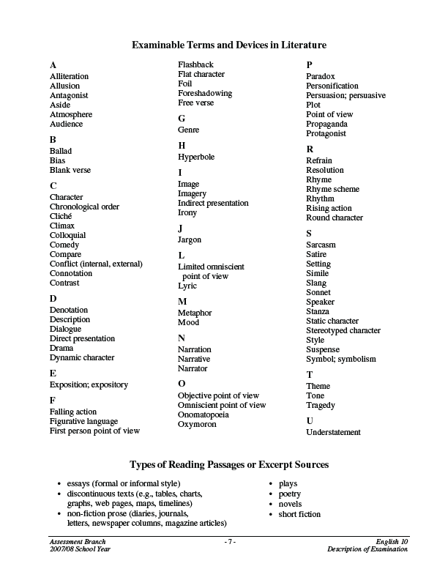

Elements of the Short Story Comm KEY Name: __________________

Title:

Term | Paraphrased Explanation | Example from the story / video
Conflict type (man vs. man, self, supernatural, environment, society) | THE PROBLEM OR ISSUE THAT MUST BE RESOLVED
Protagonist  Antagonist | THE MAIN CHARACTER  CHARACTER OPPOSING MAIN CHARACTER
Climax | THE HIGH POINT OF ACTION IN THE STORY
Falling Action | SEQUENCE OF EVENTS THAT FOLLOWS CLIMAX AND LEADS TO RESOLUTION
Quality of Character  Static vs. dynamic  Flat vs. round  Stereotype vs. original | STATIC = DOES NOT CHANGE  DYNAMIC = LEARNS AND CHANGES  FLAT – VERY FEW TRAITS  ROUND – MANY TRAITS  STEREOTYPE= COMMONLY HELD BELIEVE ABOUT A GROUP
Direct Presentation  Indirect Presentation | -NARRATOR STATES CHARACTER’S TRAITS  -ACTIONS, THOUGHTS, WORDS DEFINE WHAT TYPE OF CHARACTER A PERSON IS
Resolution | HOW THE CONFLICT IS SOLVED
Point of View  Objective  Omniscient  Limited omniscient  First person | -WRITER TELLS WHAT HAPPENS. CAN’T TELL ANYTHING OTHER THAN WHAT DIALOGUE STATES  -GODLIKE VIEWPOINT – KNOWS CHARACTERS THOUGHTS  -KNOWS ONE CHARACTERS THOUGHTS  -“I” POINT OF VIEW – THROUGH EYES OF ONE CHARACTER OR NARRATOR
Setting  Atmosphere | LOCATION, TIME WHERE STORY TAKE SPLACE. OFTEN SIGNIFICANT TO THEME AND PLOT  -MOOD OR EMOTION CONVEYED BY SETTING
Suspense | -FEELING CREATED BY STORY THAT MAKES READER TENSE
Flashback  Foreshadow | -REFERING TO PAST EVENTS  -HINTING AT FUTURE EVENTS
Define Theme: THE MAIN IDEA OR MESSAGE OF A LITERARY WORK.
The Theme is that:

