English 9 DOCUMENTARY ASSIGNMENT Name: ____________________

1. Find an article or YouTube video on the subject of the documentary we choose.

TOPIC:

Watch/read it and answer the questions below.

Article/Video name: _________________________________________________________________________________________

Purpose of the video/article: ________________________________________________________________________________________________________________________
__________________________________________________________________________________________________________________________________________________________________________________________________________________________________________________

Three interesting facts/quotes form the article/video

1.

2.

3.

Reasons for the argument of the article | Reasons against the argument of the article

During the movie answer the questions below:
- Write down the attention grabbing “hook” that this documentary uses to pull in the viewer. Explain how it works or does not work.

2. What is the purpose of the film?

3. What is the “call to action” for the viewer in the movie?

Types of Persuasion | Rhetorical Strategies | Examples from the movie
Pathos  (Emotional Appeal) | Creating pity  Creating an emotional  response  Visceral Reactions (make  viewer sick to their  stomach or overjoyed)  Vivid descriptions
Logos (Logical  Appeal) | Facts  Statistics  Repetition  Technical Language/  Scientific Jargon
Ethos (Ethical  Appeal) | Expert Opinions
After the documentary:
1. In a group of 2-3, decide whether you are for or against the argument in the film. Next, fill out a persuasive paragraph outline. Finally, use the information to create one of the following:

a. A persuasive paragraph

b. A poem outlining your position

c. Film/write a newscast/newspaper article

d. Create an informational graphic (see below for examples).

Whatever you choose, your final product must contain a hook, your thesis (argument), at least three persuasive points with specific point to prove them, a rebuttal (example from the other side of the argument and explanation of why it is wrong) and a conclusion.

Rubric:

Hook (pulls the reader in to your project in a creative way) /2 Total: /14
Thesis (outlines argument clearly and concisely): /2
Has three specific and well explained persuasive points /6
Rebuttal /2
Conclusion /2

Comments:

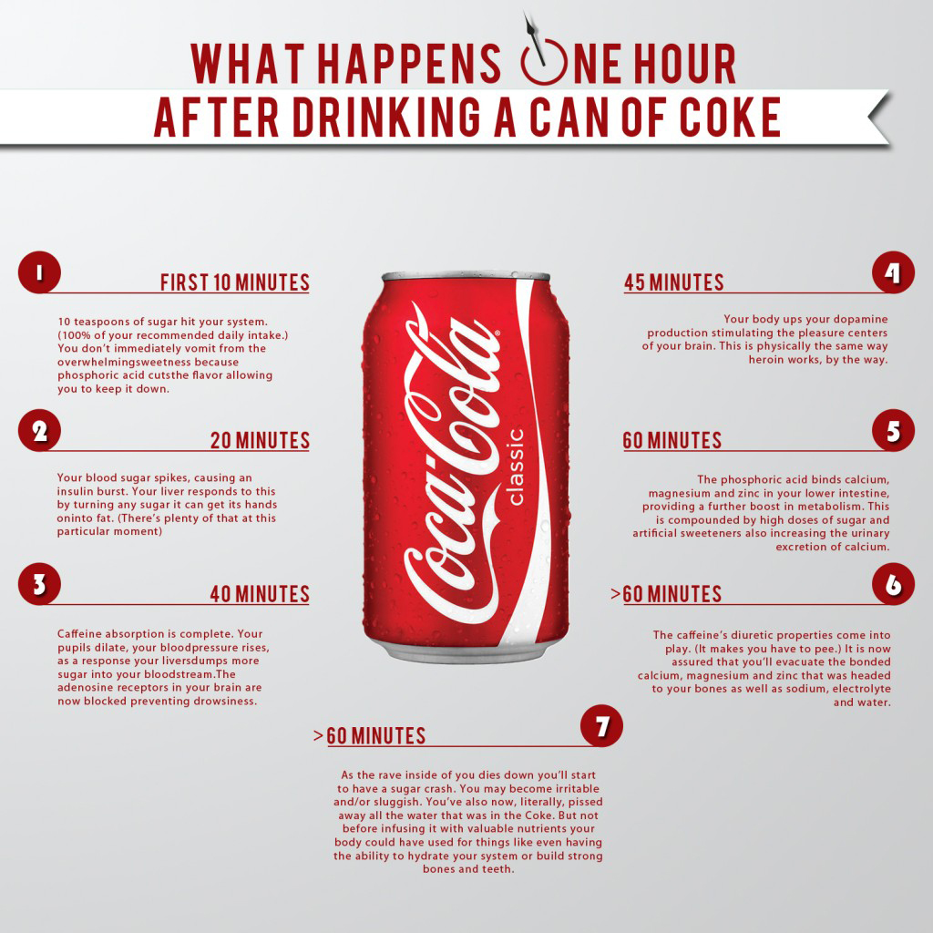
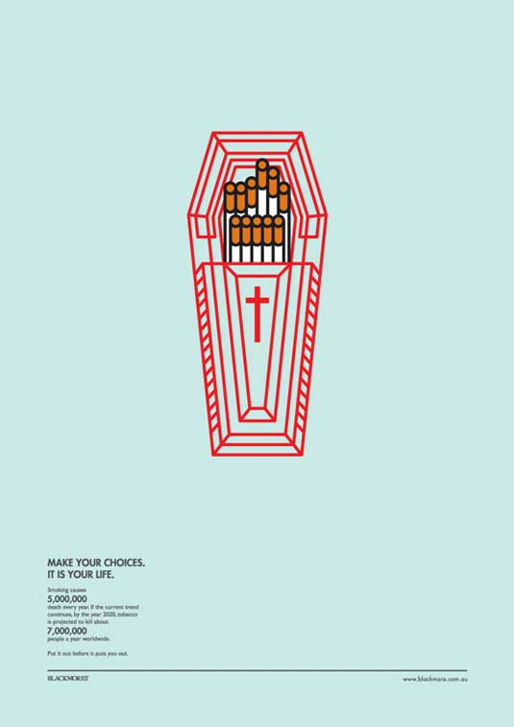
A: Analyzing
Level | Level Descriptor | Task-Specific Clarification
0 | The student does not reach a standard described by any of the descriptors below. | Add your own expectations here!
1-2 | The student:  - provides limited analysis of the content, context, language, structure, technique and style of text(s) and the relationship among texts,  - provides limited analysis of the effects of the creator’s choices on an audience,  - rarely justifies opinions and ideas with examples or explanations; uses little or no terminology,  - evaluates few similarities and differences by making minimal connections in features across and within genres and texts.
3-4 | The student:  - provides adequate analysis of the content, context, language, structure, technique and style of text(s) and the relationship among texts,  - provides adequate analysis of the effects of the creator’s choices on an audience,  - justifies opinions and ideas with some examples and explanations, though this may not be consistent; uses some terminology,  - evaluates some similarities and differences by making adequate connections in features across and within genres and texts.
5-6 | The student:  - competently analyses the content, context, language, structure, technique, style of text(s) and the relationship among texts,  - competently analyses the effects of the creator’s choices on an audience,  - sufficiently justifies opinions and ideas with examples and explanations; uses accurate terminology,  - evaluates similarities and differences by making substantial connections in features across and within genres and texts.
7-8 | The student:  - provides perceptive analysis of the content, context, language, structure, technique, style of text(s) and the relationship among texts,  - perceptively analyses the effects of the creator’s choices on an audience,  - gives detailed justification of opinions and ideas with a range of examples, and thorough explanations; uses accurate terminology,  - perceptively compares and contrasts by making extensive connections in features across and within genres and texts.

Criterion B: Organizing
Level | Level Descriptor | Task-Specific Clarification
0 | The student does not reach a standard described by any of the descriptors below. | Add your own expectations here!
1-2 | The student:  - makes minimal use of organizational structures though these may not always serve the context and intention,  - organizes opinions and ideas with a minimal degree of coherence and logic,  - makes minimal use of referencing and formatting tools to create a presentation style that may not always be suitable to the context and intention.
3-4 | The student:  - makes adequate use of organizational structures that serve the context and intention,  - organizes opinions and ideas with some degree of coherence and logic,  - makes adequate use of referencing and formatting tools to create a presentation style suitable to the context and intention.
5-6 | The student:  - makes competent use of organizational structures that serve the context and intention,  - organizes opinions and ideas in a coherent and logical manner with ideas building on each other,  - makes competent use of referencing and formatting tools to create a presentation style suitable to the context and intention.
7-8 | The student:  - makes sophisticated use of organizational structures that serve the context and intention effectively,  - effectively organizes opinions and ideas in a sustained, coherent and logical manner with ideas building on each other in a sophisticated way,  - makes excellent use of referencing and formatting tools to create an effective presentation style.

Criterion C: Producing Text
Level | Level Descriptor | Task-Specific Clarification
0 | The student does not reach a standard described by any of the descriptors below. | Add your own expectations here!
1-2 | The student produces texts that:  - demonstrate limited personal engagement with the creative process; demonstrates a limited degree of insight, imagination or sensitivity and minimal exploration of and critical reflection on new perspectives and ideas,  - makes minimal stylistic choices in terms of linguistic, literary and visual devices, demonstrating limited awareness of impact on an audience,  - selects few relevant details and examples to develop ideas.
3-4 | The student produces texts that:  - demonstrate adequate personal engagement with the creative process; demonstrates some insight, imagination or sensitivity and some exploration of and critical reflection on new perspectives and ideas,  - makes some stylistic choices in terms of linguistic, literary and visual devices, demonstrating adequate awareness of impact on an audience,  - selects some relevant details and examples to develop ideas.
5-6 | The student produces texts that:  - demonstrate considerable personal engagement with the creative process; demonstrates considerable insight, imagination or sensitivity and substantial exploration of and critical reflection on new perspectives and ideas,  - makes thoughtful stylistic choices in terms of linguistic, literary and visual devices, demonstrating good awareness of impact on an audience,  - selects sufficient relevant details and examples to develop ideas.
7-8 | The student produces texts that:  - demonstrate a high degree of personal engagement with the creative process; demonstrates a high degree of insight, imagination or sensitivity and perceptive exploration of and critical reflection on new perspectives and ideas,  - makes perceptive stylistic choices in terms of linguistic, literary and visual devices, demonstrating good awareness of impact on an audience,  - selects extensive relevant details and examples to develop ideas with precision.

Criterion D: Using Language
Level | Level Descriptor | Task-Specific Clarification
0 | The student does not reach a standard described by any of the descriptors below. | Add your own expectations here!
1-2 | The student:  - uses a limited range of appropriate vocabulary and forms of expression,  - writes and speaks in an inappropriate register and style that do not serve the context and intention,  - uses grammar, syntax and punctuation with limited accuracy; makes errors that often hinder communication,  - spells/writes and pronounces with limited accuracy; makes errors that often hinder communication,  - makes limited and/or inappropriate use of non-verbal communication techniques.
3-4 | The student:  - uses an adequate range of appropriate vocabulary, sentence structures and forms of expression,  - sometimes writes and speaks in a register and style that serve the context and intention,  - uses grammar, syntax and punctuation with some degree of accuracy; makes errors that sometimes hinder communication,  - spells/writes and pronounces with some degree of accuracy; makes errors that sometimes hinder communication,  - makes some use of appropriate non-verbal communication techniques.
5-6 | The student:  - uses a varied range of appropriate vocabulary, sentence structures and forms of expression competently,  - writes and speaks competently in a register and style that serve the context and intention,  - uses grammar, syntax and punctuation with a considerable degree of accuracy; makes errors that do not hinder effective communication,  - spells/writes and pronounces with a considerable degree of accuracy; makes errors that do not hinder effective communication,  - makes sufficient use of appropriate non-verbal communication techniques.
7-8 | The student:  - effectively uses a range of appropriate vocabulary, sentence structures and forms of expression,  - writes and speaks in a consistently appropriate register and style that serve the context and intention,  - uses grammar, syntax and punctuation with a high degree of accuracy; makes errors that are minor and communication is effective,  - spells/writes and pronounces with a high degree of accuracy; makes errors that are minor and communication is effective,  - makes effective use of appropriate non-verbal communication techniques.

