Designing A Prison
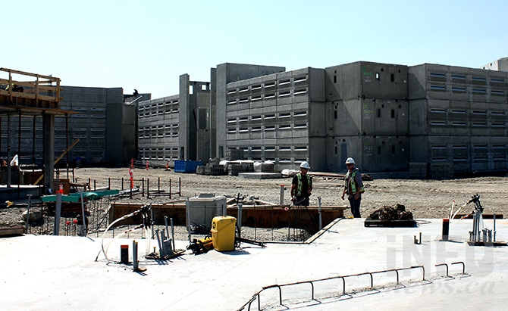
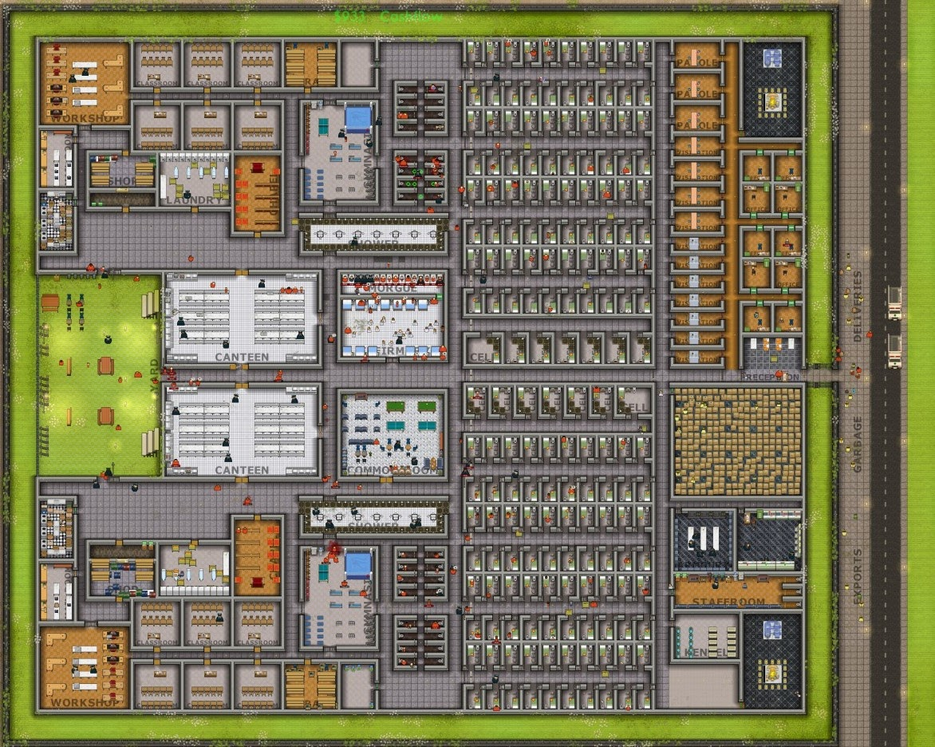

This is the Prison I designed in the video game Prison Architect
I tried to go for a rehabilitation design by offering lots of programs like spiritual guidance and addiction therapy.

My facility can hold
- 330 Super Max Prisoners
- 100 Guards
- 5 Armed Guards
- 5 Dog Handlers

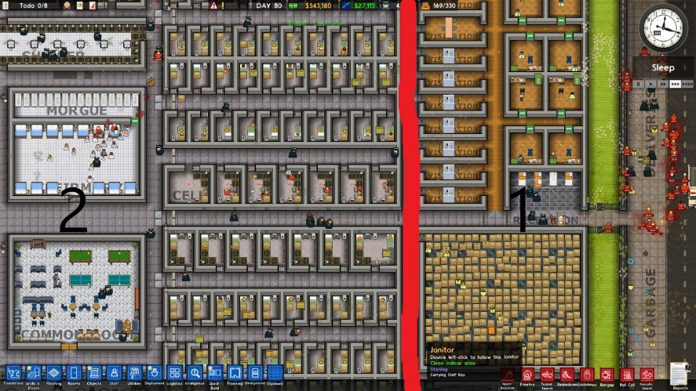
The correctional facility is divided into 2 sections.

- This first section is for civilians like visitors and other staff members. This includes offices, storage, security, and utilities.
- The rest of the building is where the prisoners are held.

In this image here to can see the security room responsible for controlling things like cctv, phone taps and other electrical systems. To the west in the Armour where firearms are stored. Other rooms consist of a staff room, cleaning cupboard, kennel, and a utility room.

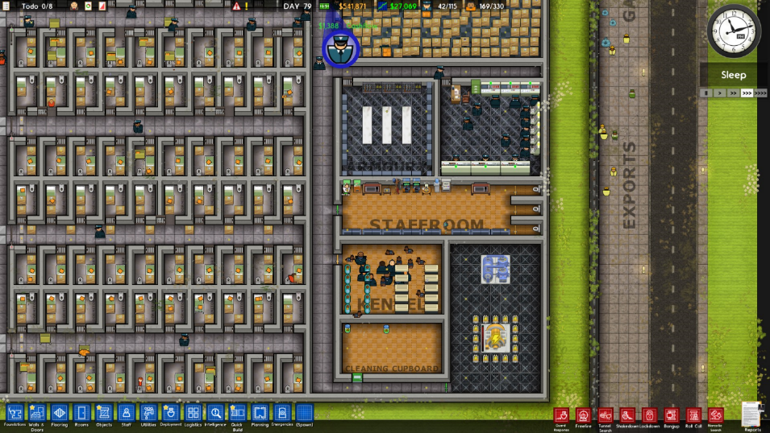
Cell Block

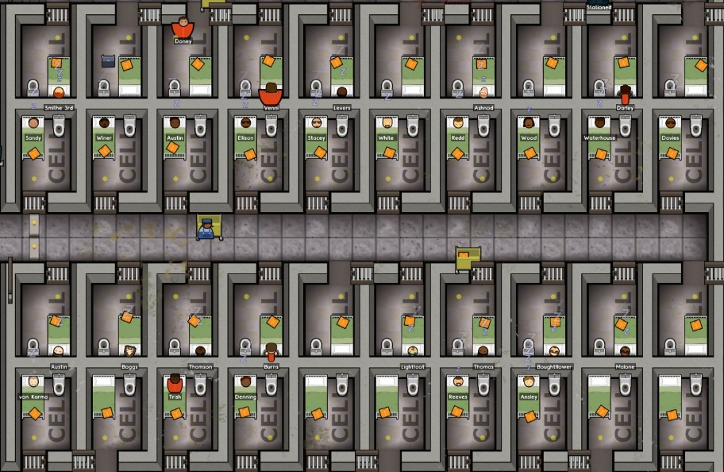
Yard and Canteen

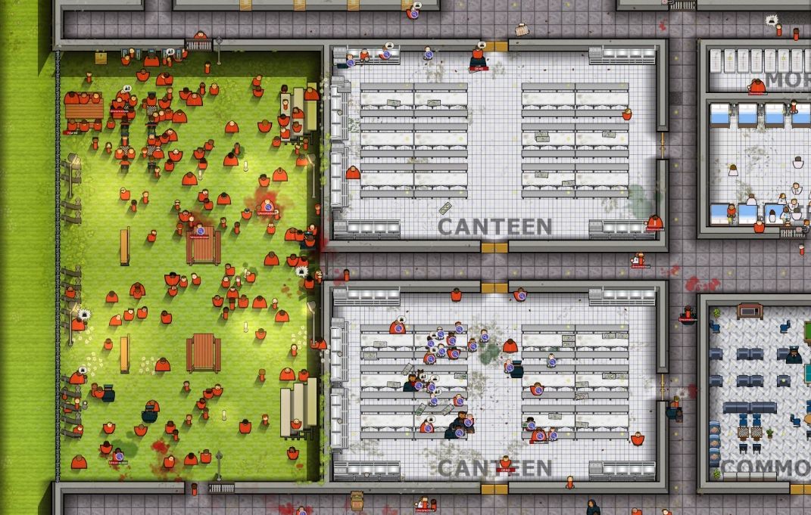
Here is the solitary cell where naughty prisoners are sent for a long-isolated period for punishment.

Also, good prisoners can go to the gymnasium on their free time and stay fit.

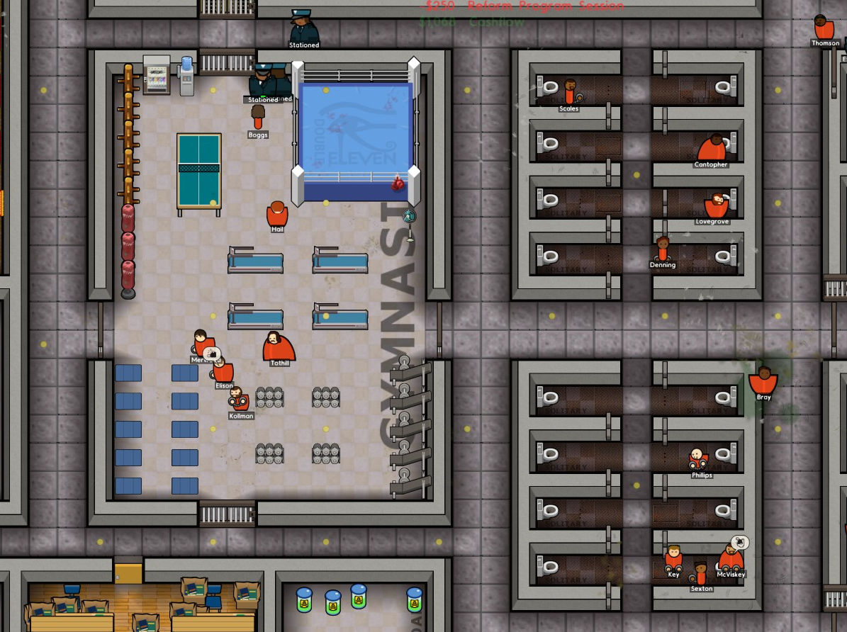

A lot of Prisoners enjoy the luxury of having a religious room for spiritual guidance.

Laundry is also a job that some prisoners can do as a job!

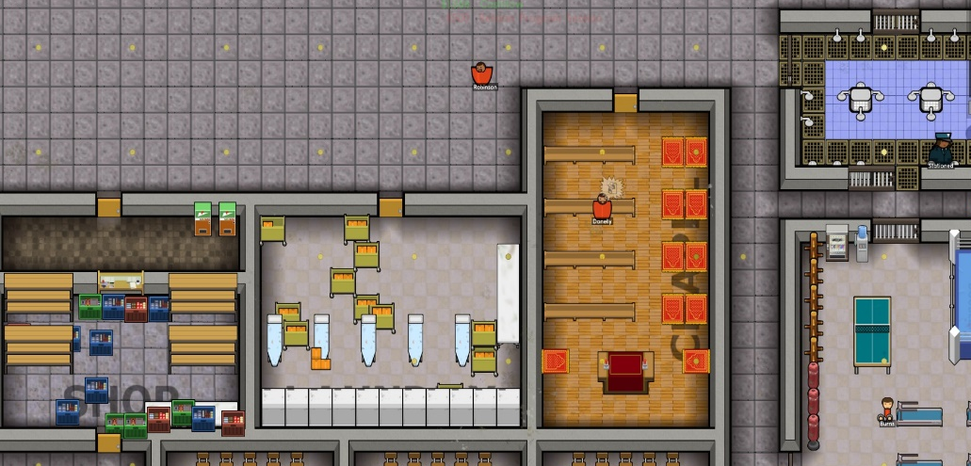
I also added lots of education opportunities for the rehabilitation aspect of my prison.
There are 12 classrooms in the prison that can but use for several different programs.
The workshop also enhances skills and inmates can earn money by making license plates
The mail room in also important as prisoners enjoy revieing letters from loved ones.
And a shop is important as inmates can buy items many different items that are safe in a prison setting.
The library also helps in education and entertainment.

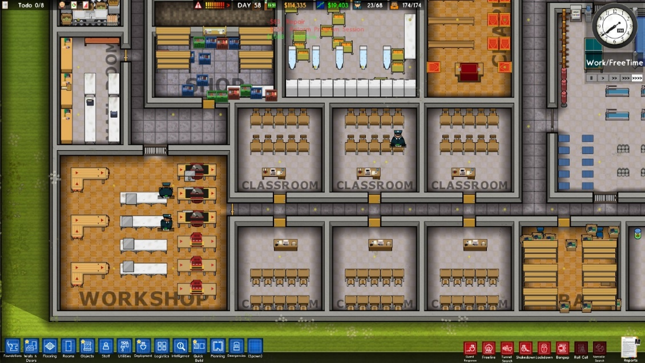

After spending 8 hours designing and running this prison, I have had 0 Escapes. This is because I have chosen to have only 1 entrance in this prison so if you tried to escape you would first have to walk past these 5 armed guards.

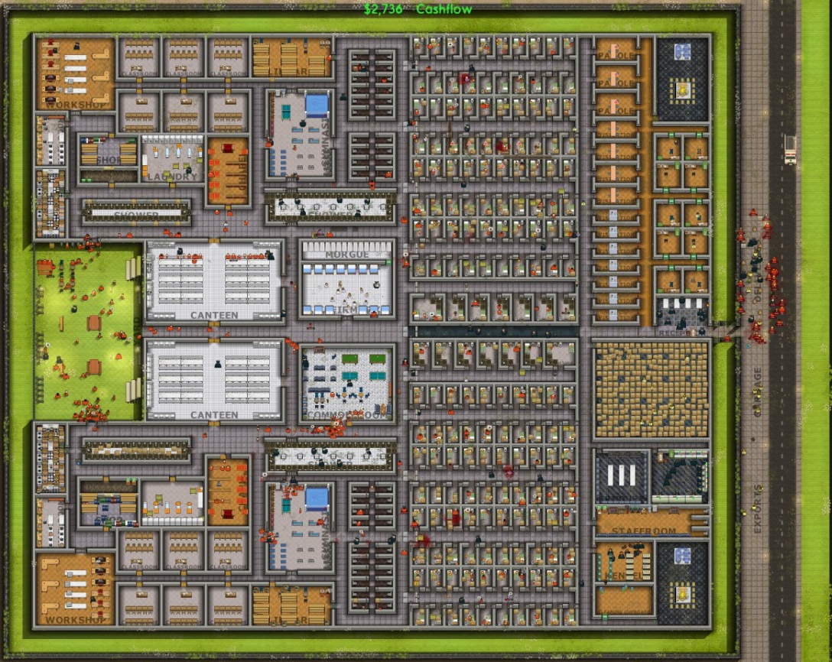
Dennis A. Kimme & Gary M. Bowker & Robert G. Deichman. (March 2011). Jail Design Guide Third Edition. https://s3.amazonaws.com/static.nicic.gov/Library/024806.pdf
https://nicic.gov/jail-design-guide

Statista Research Department. (October 2020). Number of federal prison escapees in Canada in FY 2006 to FY 2019. https://www.statista.com/statistics/562221/number-of-federal-prison-escapees-canada/

