Descriptive Paragraph Assignment Communications Name: __________________

Task: Using powerful, precise word, detailed images and comparisons, describe one of the following (or use your own idea)
Topics: 1. Your greatest fear
2. The grossest thing you have ever done.
3. Your most vivid memory
4. Someone who inspires you OR
Idea | Specific way to approach it
Memory | Death/birth, birthday, Christmas, first day of school/highschool, Vacation, holiday, best/worst thing that ever happened
Person | Parent, friend, grandparent, teacher, role model, realize something about them
Animal | Pet, wild animal, zoo, nature
Object | Childhood toy, special object, symbol
Activity | Shopping, game, hobby, volunteer work, job
Sport | Scoring goal, embarrassing moment, firsts,
Location (think small part of it, not whole thing) | Room/house, place you went on vacation, place you love
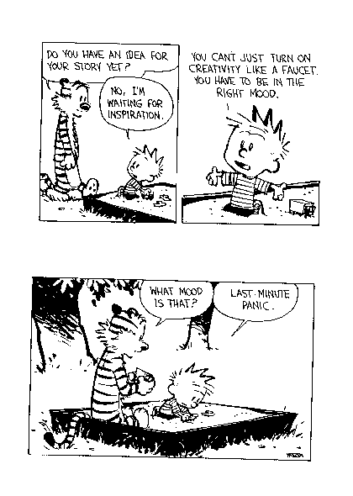
Must include:
1. Topic Sentence that establishes the focus for your paragraph (where are you or what are you describing) and pulls the reader in (start in the middle of the action, not “In this paragraph I will describe”)
2. Body Language must be sensory language
3. Conclusion

Reminder: A Descriptive paragraph if build around ONE MAIN
IMPRESSION OR IDEA about a person, scene or object. It presents a word picture with vivid and precise sensory words and phrases and poetic devices (onomatopoeia, simile, metaphor, personification, hyperbole and alliteration)

Length: 150-300 words (at least 1 ½ pages), double spaced, typed or in ink

Worth: 16 Marks (see attached marking rubric as editing checklist)

Brainstorm:
Idea: _________________________________________________

Image that appeals to: | Sight | Sound | Taste | Touch | Smell
Descriptive Paragraph Criteria

Criteria

Content
-Strong, forceful,
detailed descriptions of item that result in
‘imagery’
-Ideas clearly described
Form
-A distinct paragraph
-Introduction and
concluding sentence
-Clear transitions
Conventions
-Sentence Structure
- Spelling
- Punctuation
Personal Checklist
- Content – I have used strong, forceful, detailed descriptions which provide a single, clear picture of a person, place, thing, or idea.

- Form – I have written an organized paragraph with topic sentence, supporting details, and a concluding sentence complete with transitions between ideas.

- Conventions- I have proofread and have no spelling or sentence errors. Any errors that I have do not interfere with the meaning of my paragraph

Aspect | Not Yet Within Expectations  (1) | Meets Expectations  (Minimal)  (2) | Fully Meets Expectations  (3) | Exceeds Expectations  (4)
Content | - No descriptions provided (may be a simple list or discussion) | - Descriptions lose focus.  - Descriptions are vague | - Descriptions are clear.  - Attempts at creativity made. | - Descriptions are vivid  - Descriptions are creative  - Descriptions create ‘images’ in readers mind
Form | - Introduction is missing  - Supporting details missing or off topic  - No transitions  - Conclusion missing | - Topic sentence is there but is weak  - Supporting details are vague or unconnected to topic sentence  - Weak transitions  - Weak conclusion | - Topic sentence  - Supporting Details  - Transitions  - Concluding Sentence | -Topic sentence is engaging ‘hook’  -Powerful supporting details  -Transitions are creative and strong  -Powerful conclusion
Conventions | -Many errors in spelling in structure interfere with meaning | -Errors in simple words and structures noticeable but don’t interfere with meaning | -One or two errors in some difficult passages but meaning is clear | -No errors in spelling, sentence structure punctuations or grammar

Must haves Score Total
-Neat Content *2= _____
-Double Spaced Form *1=_____ /16
-Name Conventions *1=_____

