The Great Depression
(A result of “Boom and Bust” Economics: The ever-popular Capitalism!)
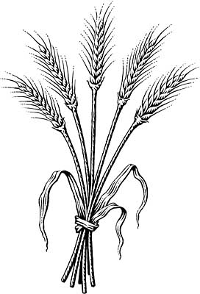
1. Longterm Causes (Emerging in the 1920s)

A. Overexpansion of Agriculture
- 1929-Usa/Ausst/Argentina/Canada = record crops –therefore prices fall
- Flour mills/railways lose $ due to drought in 1930s

B. Surplus Production in Industry
-Profits spend on new factories / stockpiling goods (create too much)
- Unsold goods lead to layoffs, layoffs lead to less sales (people have no $)
C. Technological Displacement
- Factories mechanize and thus no need for as many people to work.
- less workers = less people with money

D. Over-speculation in the Stock Market
- Buying on margin: buy with borrowed money, hoping stocks will rise
- Despite indicators that prices were falling, more people began to invest.

CLUE: During the Great Depression some people were so poor they would go into restaurants and pretend they were going to order when the waitress went back into the kitchen they would poor all the stuff on the table like ketchup, salt, pepper, etc into their water. They would drink it down before the waitress came back and then they would tell her that they changed their minds and they didn't see anything on the menu they wanted. This drink mixture was called "Bennett soup." Go to the place where you get breakfast every Thursday to find out information on the trigger of the Great Depression.

2. Trigger: Black Tuesday
- Massive stock drop
- TSE drops 1 million $ per minute; loss of stock money = bankruptcy for many people.

CLUE:
After the initial crash, there was a wave of suicides in the New York’s financial district. It is said that the clerks of one hotel even started asking new guests if they needed a room for sleeping or jumping. To find out about conditions in the 1930s that made The Great Depression worse, “book it” up to a window that looks over the common area and may have been good for jumping (if this were 1930s America)

3. Conditions in the 1930s that made the Great Depression worse

Banking Drought
Few regulations/anyone can be a bank Alberta to Sask = dry area
Invest lots = lose lots; no insurance on banks no rain = no crops
now required. “run on banks” – ppl go and
take out all of their money

Unemployment Protectionism
-arrestable for Vagrancy (no job) poverty is now a crime -put up tariff walls “Bennett wanted to
-25% on the pogey (welfare) in 33, UI runs out blast a hole in USA markets – but tariffs
make them put up tariffs
-tariffs raised by 50%

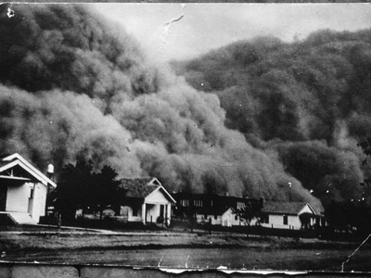

CLUE: As businesses and farms closed during the Great Depression, an alarming number of Americans began turning to crime—such as Bruno Hauptmann, who kidnapped and murdered aviation hero Charles Lindbergh’s 20-month-old son; John Dillinger, a kind of Robin Hood hero; Lester M. Gillis (“Baby Face” Nelson); Machine Gun Kelly; Pretty Boy Floyd; Ma Barker and her Boys; and the famous Bonnie and Clyde, who were actually despised by other Midwestern bandits who felt they lowered the standard of the profession. Head to the place where if you committed a “crime” at Maggie you would be detained without “habeas corpus.” Here you will find out how the “administration” of Canada dealt with the Depression.

4. Political Responses

King: 5 cent speech, provincial gov’t can take care of it

Bennett: tighten belt, poverty builds character, Dear Mr. Prime Minister, work camps, 20 million to provinces, welfare (pogey), unemployment relief act, Prairie Rehabilitation act, increase tariffs, NEW DEAL
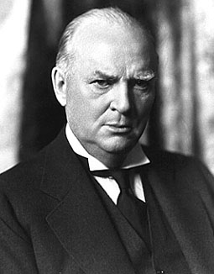
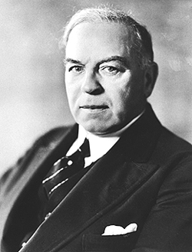

R.B. Bennett W.L. Mackenzie King

CLUE: In Canada and The United States, The New Deal meant that A number of great structures, including the Empire State Building and the Golden Gate Bridge and Vancouver City Hall, were completed during the Great Depression, providing many jobs to the unemployed. Head to a “great structure” outside of Maggie that once gave someone a job and demonstrates the animal that represents Maggie. Make sure there is no “horse’n around” out there while you learn about new political parties that developed during The Great Depression.
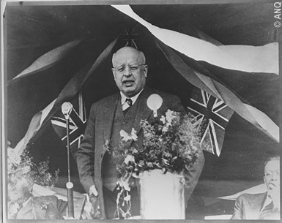
5. New Political Parties Emerge

Social Credit: Bible Bill Aberhart, give everyone $25/month to spend and that would get the economy going

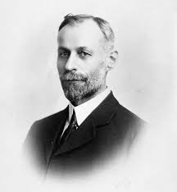
CCF: JS Woodsworth -socialist party -public ownership of key industries
-social programs to assist people in need of money (elderly, unemployed, homeless, sick) -gov’t should spend money on public works to create employment -became the NDP

Parti Nationale: Maurice Duplessis -nationalistic French-Canadian party
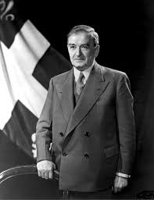
-relied on Catholic Church for support-blamed many of Quebec’s problems on the English minority in Quebec and communists
Padlock law: 1937-57, Bans communism, padlocks any house/shop used to print communist material or used for communist meetings.

CLUE: The craze of the 1930s was mini golf! Mini golf courses sprung up all over Canada and any free time people had was used to perfect their putt! Head back to your favourite place in the school (where you learn about your favourite subject each day) and try your hand at mini golf while you learn about new economic theories during the depression.

6. New Economic Theories Emerge

- Keynes – New deal – opposite of conventional wisdom (save money during bad times) – spend when poor to jump start the economy (like BC Job Action Plan now)

- Social Credit party; everyone gets cash

- socialism – govn’t owns production, social programs (welfare, pensions)

Clue: Love the shows “Kate plus Eight,” or “Quints by Surprise”? You can thank the great Depression that shows like them exist. Canada was the first country to exploit cute identical quintuplets by putting them on display in exchange for people’s money. Find out about the Dionne Quintuplets and other ways Canadians distracted themselves from the Depression. Look for this information just outside where all the teachers eat their lunch and escape their own depression .

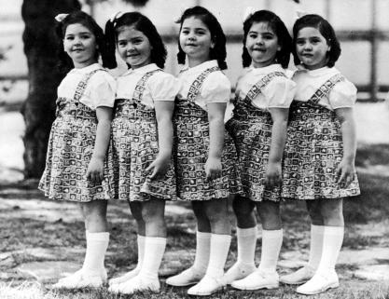
7. Social Responses to the Depression

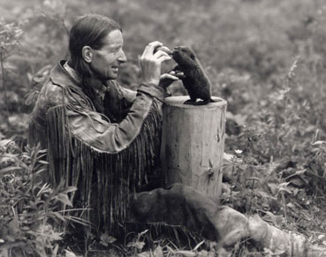
Dionne Quintuplets: World’s first surviving identical quintuplets. Family poor so government seized them and put them on display. People paid to watch them

Grey Owl: A supposed Apache conservationist who turned out to be an Englishman who wore buckskin clothing and married an Iroquois woman, He made films, wrote books and promoted the conservation of Canadian forests and the beaver.

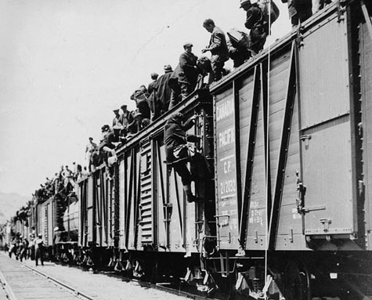
Mini Golf/Movies: -fun activities to forget their troubles

Farming: -Trash Farming, Stubble Farming, Tree Screen

Protests:- “on to Ottawa trek” – Regina Riot -Vancouver sit-ins

Clue: Ever wonder why so many people store their glasses upside down in the cupboard? This is a relic of the Great Depression when dust Storms blew sand and dust literally everywhere. In fact, on May 9, 1934, a dust storm carried an estimated 350 million tons of dirt 2,000 miles east ward and dumped four million tons of prairie dirt in Winnipeg. The drought and dust killed tens of thousands of animals. As a result of the dust, People stored their cups upside down to keep them clean. Go to a place in the school where you would get help from teachers like Ms. Woolner and Mrs. Richert. But don’t go into the room, check out the cups in the kitchen attached to it. Make sure you go through the door into the kitchen from the hallway. There, you will find out how the Great Depression ended.

8. WWII Ends Depression
- Total war; all factories mobilized – therefore, increased production and jobs
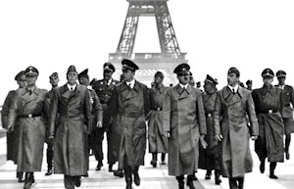

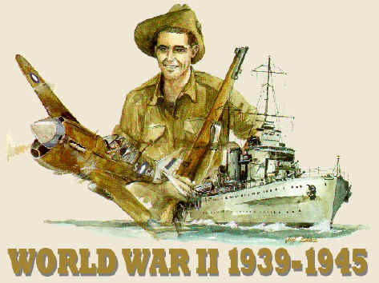

CLUE: Some people who became homeless would ride on railroad cars because they didn’t have money to travel. Some scholars claim that more than 50,000 people were injured or killed while jumping trains. If you want to find out information on getting a career so that you don’t one day have to ride the rails, go see this person for information on university and on long-term causes of the Great Depression.
1. CLUE: During the Great Depression some people were so poor they would go into restaurants and pretend they were going to order when the waitress went back into the kitchen they would poor all the stuff on the table like ketchup, salt, pepper, etc into their water. They would drink it down before the waitress came back and then they would tell her that they changed their minds and they didn't see anything on the menu they wanted. This drink mixture was called "Bennett soup." Go to the place where you get breakfast every Thursday to find out information on the trigger of the Great Depression.

2. CLUE:
After the initial crash, there was a wave of suicides in the New York’s financial district. It is said that the clerks of one hotel even started asking new guests if they needed a room for sleeping or jumping. To find out about conditions in the 1930s that made The Great Depression worse, “book it” up to a window that looks over the common area and may have been good for jumping (if this were 1930s America)

3. CLUE: As businesses and farms closed during the Great Depression, an alarming number of Americans began turning to crime—such as Bruno Hauptmann, who kidnapped and murdered aviation hero Charles Lindbergh’s 20-month-old son; John Dillinger, a kind of Robin Hood hero; Lester M. Gillis (“Baby Face” Nelson); Machine Gun Kelly; Pretty Boy Floyd; Ma Barker and her Boys; and the famous Bonnie and Clyde, who were actually despised by other Midwestern bandits who felt they lowered the standard of the profession. Head to the place where if you committed a “crime” at Maggie you would be detained without “habeas corpus.” Here you will find out how the “administration” of Canada dealt with the Depression.

4. CLUE: In Canada and The United States, The New Deal meant that A number of great structures, including the Empire State Building and the Golden Gate Bridge and Vancouver City Hall, were completed during the Great Depression, providing many jobs to the unemployed. Head to a “great structure” outside of Maggie that once gave someone a job and demonstrates the animal that represents Maggie. Make sure there is no “horse’n around” out there while you learn about new political parties that developed during The Great Depression.

5. CLUE: The craze of the 1930s was mini golf! Mini golf courses sprung up all over Canada and any free time people had was used to perfect their putt! Head back to your favourite place in the school (where you learn about your favourite subject each day) and try your hand at mini golf while you learn about new economic theories during the depression.

6. Clue: Love the shows “Kate plus Eight,” or “Quints by Surprise”? You can thank the great Depression that shows like them exist. Canada was the first country to exploit cute identical quintuplets by putting them on display in exchange for people’s money. Find out about the Dionne Quintuplets and other ways Canadians distracted themselves from the Depression. Look for this information just outside where all the teachers eat their lunch and escape their own depression .

7. Clue: Ever wonder why so many people store their glasses upside down in the cupboard? This is a relic of the Great Depression when dust Storms blew sand and dust literally everywhere. In fact, on May 9, 1934, a dust storm carried an estimated 350 million tons of dirt 2,000 miles east ward and dumped four million tons of prairie dirt in Winnipeg. The drought and dust killed tens of thousands of animals. As a result of the dust, People stored their cups upside down to keep them clean. Go to a place in the school where you would get help from teachers like Ms. Woolner and Mrs. Richert. But don’t go into the room, check out the cups in the kitchen attached to it. Make sure you go through the door into the kitchen from the hallway. There, you will find out how the Great Depression ended.

8. CLUE: Some people who became homeless would ride on railroad cars because they didn’t have money to travel. Some scholars claim that more than 50,000 people were injured or killed while jumping trains. If you want to find out information on getting a career so that you don’t one day have to ride the rails, go see this person for information on university and on long-term causes of the Great Depression.

