Law 12 Name:
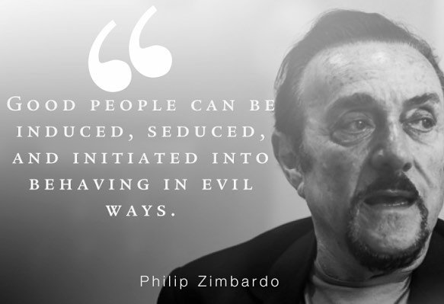
Corruption Unit Synthesis Assignment:
Option one: Video/Podcast Response to the following questions
Option two: Blog or written response to the following questions

Task: Students will watch the Dr. Philip Zimbardo Ted Talk "The Psychology of Evil" and the documentary film "The 7-5."

Then, you will have Dr. Zimbardo comment on three situations from “The7-5.” You should have a thesis (argument) and analysis (what would Zimbardo say based on quotes you’ve gathered).
How to Start
1. Gather quotes from the Ted Talk (I have included a couple below)
2. Using Specific Examples/Quotes from the Ted Talk, explain how Dr. Zimbardo would respond to/ react to the film "The 7-5."
3. Choose quotes/situations/specific examples from "The 7-5". *** Take two-three events from “The 7-5” and have Zimbardo comment on them.
4. Then justify the comment he would make with quotes from his talk. (This is analysis)

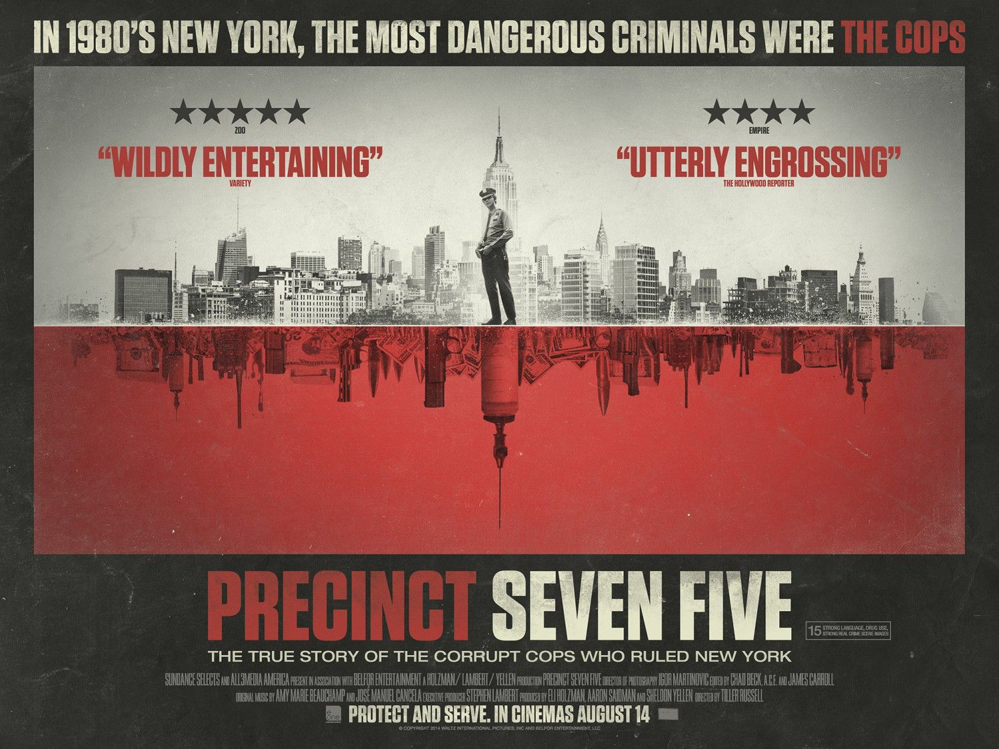
Suggested items Zimbardo might comment on:
-Conditions that made corruption possible in the 7-5
-Advice on how the NY City police could prevent corruption
-What made some police corrupt during this time
-He could reflect on a specific situation or statement that was made in the film
-Mike Or Kenny’s 15-Volt Moment; parts of the 7 social processes that grease the slipper slope of evil
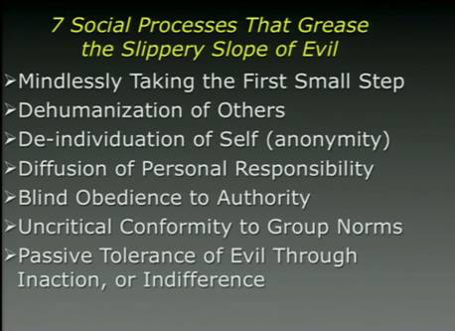
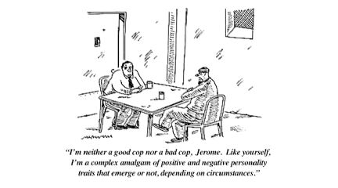

SYNTHESIS GRADING RUBRIC - This is a first-draft response and will be assessed as such.

6 -The six response is superior.
Demonstrates an insightful understanding of the texts/films. Has a clear and thought-provoking THESIS.
The response shows a sophisticated approach to synthesis, including pertinent references / quotes.
The response has incredibly detailed examples.
The writing / video / podcast style is effective and demonstrates skilful control of language.
Despite its clarity and precision, the response need not be error-free.

5 -The five response is proficient, demonstrating a clear understanding of the texts/films at an interpretive level. Has a clear THESIS.
The response clearly synthesizes the concepts within the texts/films.
References (quotes/paraphrasing) may be explicit or implicit and convincingly support the analysis or argument.
The response has included mostly detailed examples
The writing / video / podcast is well organized and reflects a strong command of the conventions of language. Errors may be present, but are not distracting.

4 -The four response is competent. Has a simple thesis or a clear topic.
Understanding of the texts /films tends to be literal and superficial.
Some synthesis is apparent but mainly from one text/film.
The response may rely heavily on paraphrasing or just retell parts of the texts/films without synthesizing.
References are present and appropriate, but may be limited.
Some details / examples but could describe in more detail.
The writing / video / podcast is organized and straightforward.
Conventions of language are usually followed, but some errors are evident.

3 -The three response is a pass. Attempts a thesis/topic sentence.
Understanding of the texts / films may be partially flawed.
An attempt at synthesis is evident. References are not clearly connected to the topic or may be repetitive.
The response may be somewhat underdeveloped and emergent; needs more time.
Some examples, but not enough to show understanding of text/film
A sense of purpose may be evident, but errors can be distracting.

2 -The two response is inadequate.
While there is an attempt to address the topic, understanding of the texts / films or the task may be seriously flawed.
A response that makes reference to both texts but refers only fleetingly to one of them is inadequate.
The response may be seriously underdeveloped.
Errors are recurring, distracting, and impede meaning.

1- The one response is unacceptable. Although the response mentions both texts/films, it is too brief to respond to the topic or there may be a complete lack of control in the film / writing/ podcast. Does not include worst two offenses. Does not attempt to contribute to the education of others through commenting.

0 -The zero reflects a complete misunderstanding of the texts / films and/or the task, or is a restatement of the questions. Exclusive reference to only one text / film does not constitute synthesis.

