Communications Name: _______________________________________
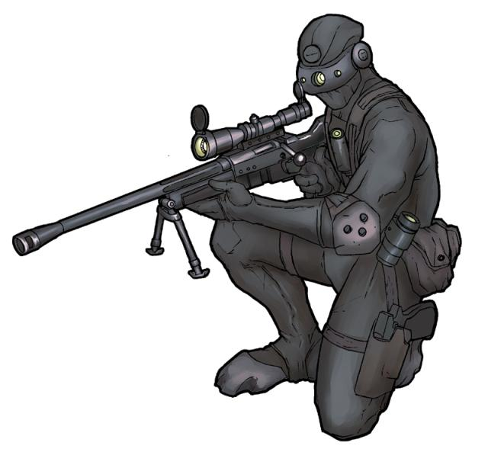
“The Sniper”
Quotes (3) | Inferences (What you can assume about character, theme etc. from the quote)

Chart for “Toyland:”

Images (choose 3) | Why are they important
Quotes (Choose 3) | Why are they important

Chart for “The Little Terrorist”

Quotes/Images (choose 3 total) | Why are they important

