English Name: ____________
KEY: Characterization/Character Development Date: _____________

Characterization
There are a number of ways that an author creates the PERSONALITY of a character for a reader. A character is REVEALED by:

INDIRECT PRESENTATION:
What he/she says or THINKS
What he/she DOES (actions)
What other characters SAY about him/her (may or may not be reliable)
His/her APPEARANCE (clothing, hygiene, accessories etc.)
Direct Presentation: Commentary from the NARRATOR (may or may not be reliable)
The SETTING (where they spend their time may reflect or symbolize who they are, for example, Oscar the Grouch lives in a trash can)

** Characterization is different from character development

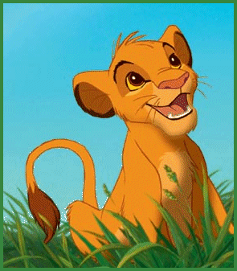Character Development

Character development refers to how a character CHANGES over the course of a novel or story.

The character could change in the following ways:

Changes PERSPECTIVE
Gains knowledge/learns LESSONS
Relationship with other characters or position in society changes
APPEARANCE changes (which usually reflects a change in perspective or knowledge)

** Note: A significant amount of development in a major character is usually related to a key THEME of a literary work.

Symbol: Concrete object represents an abstract idea (ie:: Lamb = innocence / Heart = love)
Direct Presentation: Narrator directly states character traits. Ie: Mr. Fitton is a Jerk.
Indirect Presentation: Characters actions, thoughts, interactions reveal personality
Static Character: Does not change through their experiences: (Napoleon)
Dynamic Character: Learns and changes through experiences (ie: Scrooge/Grinch)
Round Character: Many characteristics/details about them are known (Bart Simpson)
Flat Character: Few personality traits/details are known (Disco Stu)

English Name: ____________
Notes: Characterization/Character Development Date: _____________

Characterization
There are a number of ways that an author creates the _______________ of a character for a reader. A character is ________________ by:

INDIRECT PRESENTATION:
What he/she says or ________________
What he/she ________________ (actions)
What other characters _________ about him/her (may or may not be reliable)
His/her ________________ (clothing, hygiene, accessories etc.)
Direct Presentation: Commentary from the _______________ (may or may not be reliable)
The______________ (where they spend their time may reflect or symbolize who they are, for example, Oscar the Grouch lives in a trash can)

** Characterization is different from character development

Character Development

Character development refers to how a character ______________ over the course of a novel or story.

The character could change in the following ways:

Changes ______________________
Gains knowledge/learns _____________________
Relationship with other characters or position in society changes
_______________ changes (which usually reflects a change in perspective or knowledge)

** Note: A significant amount of development in a major character is usually related to a key ______________________ of a literary work.

________: Concrete object represents an abstract idea (ie:: Lamb = innocence / Heart = love)
____________________: Narrator directly states character traits. Ie: Mr. Fitton is a Jerk.
______________________: Characters actions, thoughts, interactions reveal personality
______________________: Does not change through their experiences: (Napoleon)
_____________________: Learns and changes through experiences (ie: Scrooge/Grinch)
_________________: Many characteristics/details about them are known (Bart Simpson)
______________________: Few personality traits/details are known (Disco Stu)

