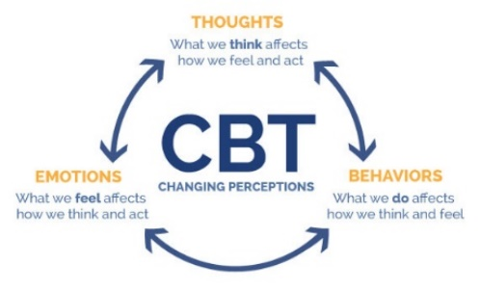
COGNITIVE BEHAVIOUR THERAPY ROAD MAP GUIDE
1. When you are feeling anxious, depressed, or distressed take a minute to write down what you are thinking:

2. Write down your level of distress between 1-10 (Circle)
1 2 3 4 5 6 7 8 9 10
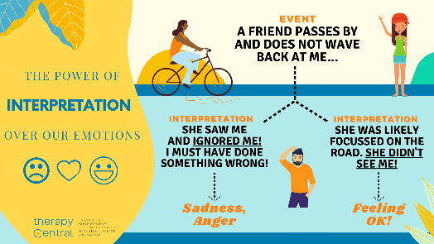
3. What happened? What were your automatic thoughts (ie: a friend cancelled a lunch so you think you are a loser and are not worthy of love)

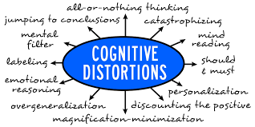
4. Examine the sheet of “Cognitive Distortions” and examine which ones you may be experiencing. Write them below.

5. Examine evidence FOR and AGAINST your Thoughts
For Against

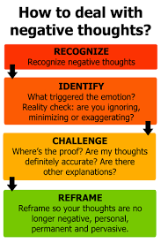
6. Ask yourself – what might someone say who disagrees with you. What merit would there be to their opinion?

7. What advice would you give a friend, family member or person who was in the same situation?

8. Consider what happened when you realize you may have included cognitive distortions. Rewrite your thoughts.

9. Write down new thoughts / feelings about the event.

10. Write down how you feel now on the scale between 1-10 (Circle)
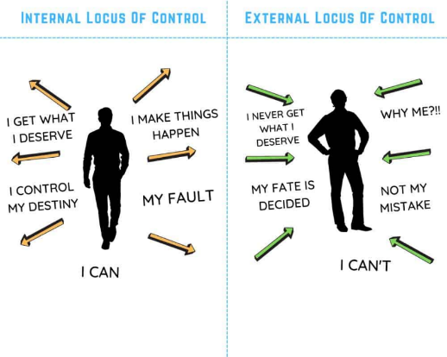
1 2 3 4 5 6 7 8 9 10
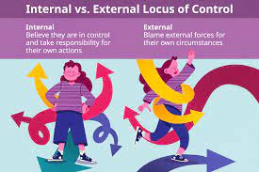

*Go back and think about question 7 – why do you suppose your advice is different than what you would give yourself?

