B.E.
BLK 2
Feb 11th 2019

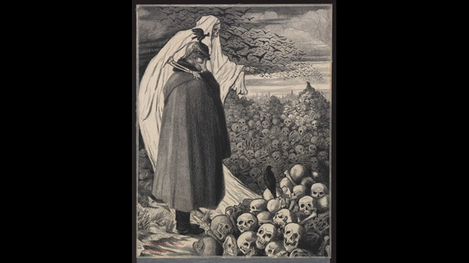

‘Bandit! Voila’ ton oeuvre!’ Gizbert Combaz, 1916

STYLE: Gizbert Combaz’s graphite drawing ‘villain! This is your work!’ is sorrowful, showing the leader of Austria (Franz Joseph) surrounded by death. The image contains large amounts of repetition involving the background of the skulls. To repeat this image to the point where most of the background and even some of the foreground is dominated by skulls illustrates the abundance of lives lost during the war and the inability to define one dead person from the next. The artists’ decision to choose pencil for this piece indicates that he wanted an absence of colour to create a darker illustration. While pencil style can create strong accuracy and realness, it can also blend and blur together easily. This is seen in the foreground where the skulls and person are seen very precisely and in focus, while the background is very out of focus and blurred together. The clarity of the skulls in focus represent the soldiers fallen that Joseph knew (family, friends, his people etc..) while the blurred skulls represent all of the hundreds of thousands of fallen who he did not know, soldiers who became nameless and faceless beings, blurred into a statistic. The way the birds and sky start off large and in focus, and slowly shrink smaller indicate the vast distance of death.

MOOD: Combaz creates a very dark and ominous mood in this illustration by using pencil to eliminate colour and simulate a dark, black and white scene. The only colour present in the photo is a patch of blood at the leaders feet, indicating that their blood and their deaths were caused by his actions. Due to the artists Bulgarian decent, Joseph is viewed as the villain of world war one, which he tries to persuade in this image by drawing the grim reaper, with one hand around the leaders shoulders and the other with his finger pointed in toward the skeletons simulating blame upon their deaths. Another indication of this idea is the way many of the skulls look as if they are looking directly at the Austrian leader, as if they too blame him for their deaths. The grim mood is also captured through death symbols, including the ravens, the grim reaper, blood and of course the skulls, all stereotypical symbols of death and darkness. Lastly Combaz doesn’t put an ending to the background, for it continues on and is blurred together in a never-ending haze, much like how the war was viewed in 1916. The message captured in that implication suggests that if Franz Joseph didn’t realize the damage he was causing, the war and the casualties would never end.
RECURRING THEMES: Like most world war one art, this illustration paints a gruesome picture of the war. There is no happiness portrayed in many war art pieces, which is demonstrated here through lack of colour, and the overall darkness of the portrait. The morbid and macabre theme is demonstrated through the single splash of red at the leaders feet, indicating blood and wounds; wounds that the war so clearly left on society and on the world during 1916. Morbid themes such as these are seen throughout world war one art because the war created an emotion and darkness that many couldn’t express in other ways besides art. Due to the leader Joseph Franz being seen as responsible or as the “villain” in this piece though means of his head being hung in shame, and the finger being pointed towards the deaths emphasizing his blame, we can indicate that the artist and most likely the world also seen him as the villain and as the cause of the war. This image is a very negative image, because war was not seen as a positive or happy event.

EMOTIONAL RESPONSE: The initial response that the illustration made me feel was grief. I felt physically sick to my stomach for the family and friends of the millions who actually perished in world war one. Knowing that every skull drawn in the photo actually represented a human life lost in the war is overwhelming to comprehend. The agony that must have been felt when all those men didn’t come home would’ve had an effect on every single person living in the world at that time. I feel sorrow and empathy for mothers, wives and children who had to live their lives without fathers, husbands and sons. Unexpectedly though, this picture also gives me hope. The way the birds fly towards the light among the horizon I believe represents peace and hope that the world so desperately needed in 1916. It is wild how such a dark and morbid image can also contain elements of hope that possibly inspired thousands of people.

APPRECIATION: This piece gave me a better appreciation for world war one because of the emotional response it sparked inside me of sorrow and grief. It also helped me realize the amount of deaths caused by world war one. I believe that each skull in this picture represents a victim of the war, and since there are countless skulls in this image, it brought me to realize the extreme and countless cases of trauma that the war caused. The darkness and ominous vibe this portrait gives off was something I could physically feel in my stomach. It made me feel sympathy and gave me understanding to the people of that time, which I believe to be groundbreaking. However, my absolute favourite part of this image is the way the birds are flying towards the light. The classic trait of portraying hope among the horizon is something I consider very beautiful and inspirational, even for a piece that is supposed to be horrid and gruesome. I appreciate the element of hope in the image because I connect the hope and light to the world we live in today. Because of world war one and the millions of men who laid down their lives for their country, my family, friends and I are able to live in a free and democratic society where we can live happily and well educated which I believe is the “light” the artist was hoping the world would head towards in this illustration.

Website

Gizbert Combaz(1916) ‘Bandit! Voila’ ton oeuvre!’ [lithographic print]. Koninklijke bibliotheek van Belgie, Belgium
Retrieved from : https://www.bl.uk/collection-items/villain-your-work

