History 12 Name ___________________________
Mr. Fitton
Cornell Notes - Appeasement

Key Terms: Containment Brinkmanship Appeasement Lebensraum National Self-Determination

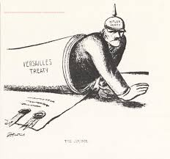
Nazi Foreign Policy – Basic Principles

1. Condemn Versailles Cancel Reparations
Enlarge the armed forces
Military re-occupation of Rhineland

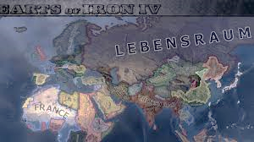
2. National self-determination Unite Germans living in Austria, Sudetenland, Western Poland, and East Prussia

3. Lebensraum “living space” for Germans
“The Hunger Plan” (invade
and starve USSR to feed Germany)

Definitions of Appeasement
A foreign affairs policy whereby nations give an aggressor nation what they want so that they will not start a war

Practiced by Britain and France towards Hitler (Assumes people prefer peace)
*Motivated by hope, not fear. Br. and Fr. brutalized by WWI
*Britain Saw a strong Germany offsetting Fr. and Soviet influence in Europe
*Feared Communism more than Fascism
*Br and Fr fooled by Hitler’s “take an inch take a mile” philosophy

Sequence of Events

1 1936 – Re-occupation of the Rhineland
Gr Army enters area forbidden by the Treaty of Versailles.

2 1936 – Rome-Berlin axis Germany and Italy

3 1938 – Anschluss Versailles Forbid joining Austria/Germany
Hitler now appearing as a conqueror

4 1938 – Munich Pact Hitler only asks for Sudetenland (Germans)
players: Chamberlain (Br) non-players: Stalin (USSR)
Daladier (Fr.) Benes (Czech)
Mussolini (It)
Hitler (Ger)

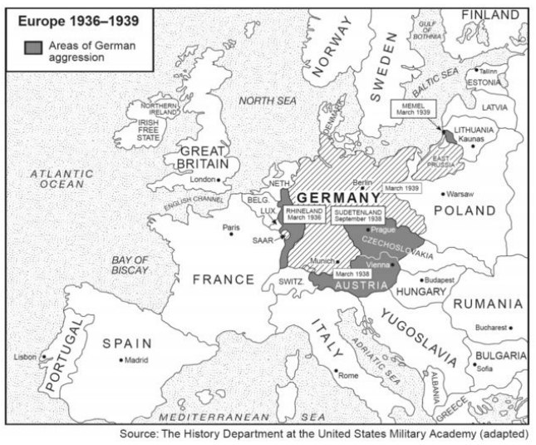

Note: Czechoslovakia was a functioning democracy, an ally of France, and a nation of minorities, including Sudeten Germans

Hitler’s Claim for the Sudetenland: “It is my unshakable belief to wipe Czechoslovakia off the map.”

Czechoslovakia had a large, well-equipped standing army
Britain’s worry War in Europe and Asia disastrous for them
What does Hitler want for peace?
Bombing of British cities
Britain would not support France if supported Czech

Hitler after Munich Pact: “I have no more territorial demands to make in Europe”.
March 1939 - Hitler invades all of Czechoslovakia; Britain ends appeasement.

Historical significance of the Munich Pact and the Conquest of Czechoslovakia

Chamberlain’s Mistake appeaser or peace-loving statesman?
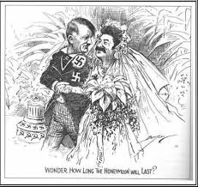
(revisionism!) Morality of sacrificing a functioning democracy.

1939 (Aug) Nazi-Soviet Non-Aggression Pact
Ribbentrop (Ger) and Molotov (USSR) sign agreement
- Germany and USSR agree not to fight each other
- Secretly agree to carve up Poland
- Both gained time from this agreement
- Shocked the international community!

1939 Sept 1 Hitler attacks Poland (blitzkrieg)
Sept 3 Britain/France declare war on Germany *WWII begins

History 12 Name ___________________________
Mr. Fitton
Cornell Notes - Appeasement

Key Terms: Containment Brinkmanship Appeasement Lebensraum National Self-Determination

Nazi Foreign Policy – Basic Principles

1. ________________ Cancel Reparations
Enlarge the armed forces
Military re-occupation of Rhineland

2. ________________________ Unite Germans living in Austria, Sudetenland, Western Poland, and East Prussia

3. _______________“living space” for Germans
“The Hunger Plan” (invade
and starve USSR to feed Germany)

Definitions of Appeasement
A __________________ whereby nations give an aggressor nation what they want so that they will not start a war

Practiced by Britain and France towards Hitler (Assumes people prefer peace)
*Motivated by hope, not fear. Br. and Fr. brutalized by WWI
*Britain Saw a strong Germany offsetting Fr. and Soviet influence in Europe
*Feared Communism more than Fascism
*Br and Fr fooled by Hitler’s “take an inch take a mile” philosophy

Sequence of Events

1 1936 – ____________________________________
Gr Army enters area forbidden by the Treaty of Versailles.

2 1936 – ___________________ Germany and Italy

3 1938 –_______________ Versailles Forbid joining Austria/Germany
Hitler now appearing as a conqueror

4 1938 – _____________________ Hitler only asks for Sudetenland (Germans)
players: Chamberlain (Br) non-players: Stalin (USSR)
Daladier (Fr.) Benes (Czech)
Mussolini (It)
Hitler (Ger)

Note: Czechoslovakia was a functioning democracy, an ally of France, and a nation of minorities, including Sudeten Germans

Hitler’s Claim for the Sudetenland: “It is my unshakable belief to wipe Czechoslovakia off the map.”

Czechoslovakia had a large, well-equipped standing army
Britain’s worry War in Europe and Asia disastrous for them
What does Hitler want for peace?
Bombing of British cities
Britain would not support France if supported Czech

Hitler after Munich Pact: “I have no more territorial demands to make in Europe”.
March 1939 - Hitler invades all of Czechoslovakia; Britain ends appeasement.

Historical significance of the Munich Pact and the Conquest of Czechoslovakia

Chamberlain’s Mistake appeaser or peace-loving statesman?
(revisionism!) Morality of sacrificing a functioning democracy.

1939 (Aug) _______________________________________
Ribbentrop (Ger) and Molotov (USSR) sign agreement
- Germany and USSR agree not to fight each other
- Secretly agree to carve up Poland
- Both gained time from this agreement
- Shocked the international community!

1939 Sept 1 Hitler attacks Poland (blitzkrieg)
Sept 3 Britain/France ________________________________

