English 9 Name: ________________________

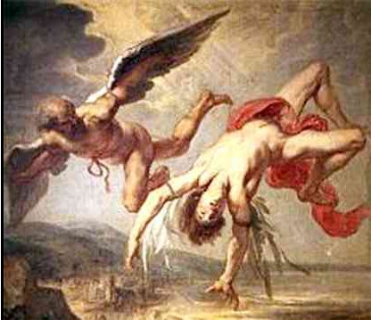
The desire to reach for the sky runs deep in our human psyche. ~Cesar Pelli

1. Why do you think people afraid to fly? How can they combat this fear?

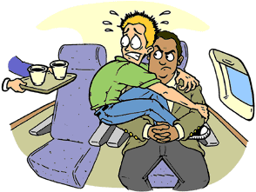
2. Cartoon Recap of “Daedalus and Icarus.” What was the message about flight in this Greek myth?

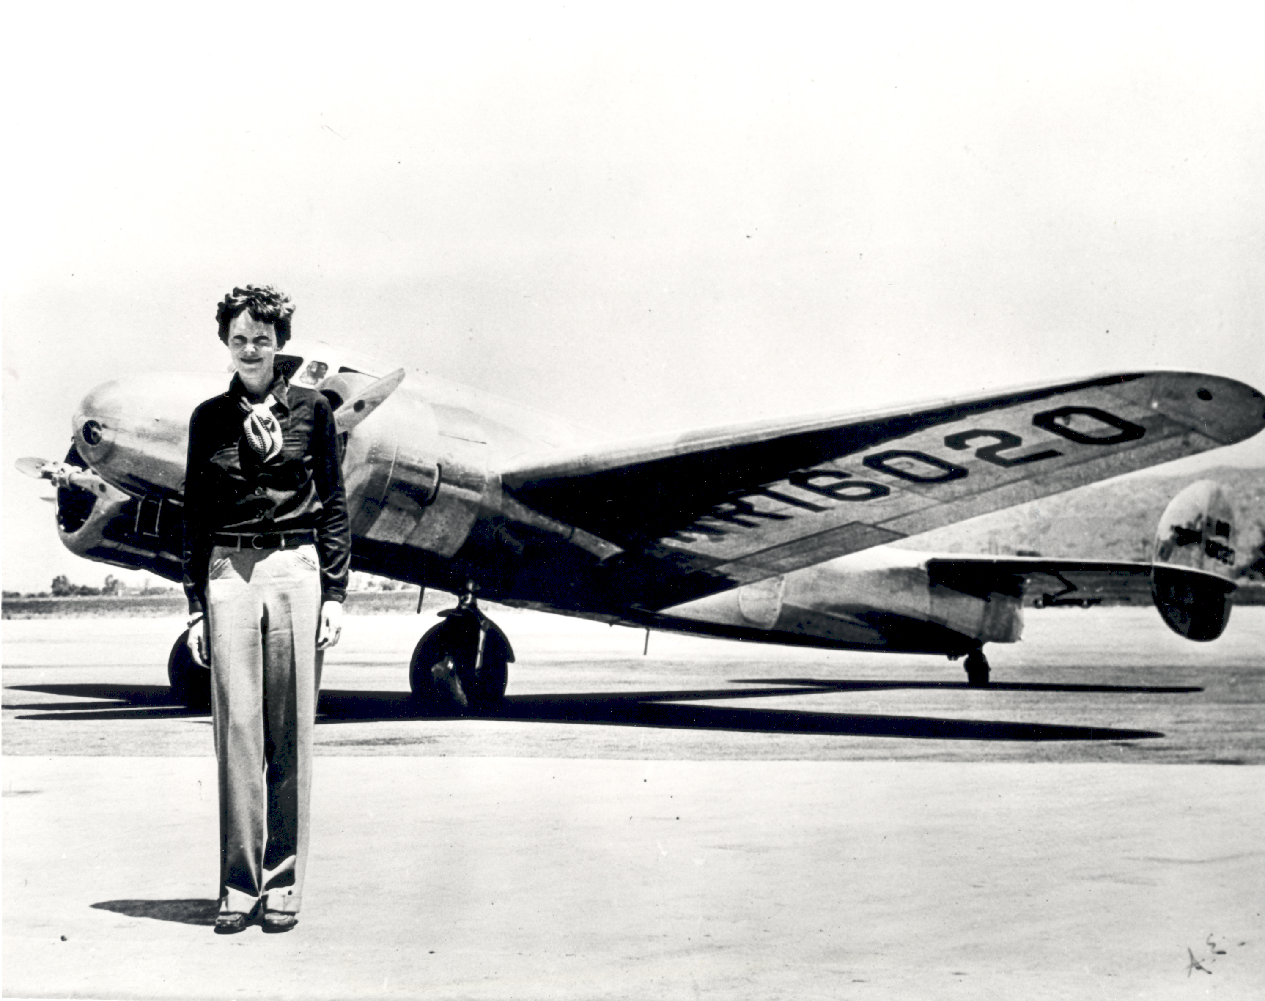
3. Use your prior knowledge and text features to make a prediction of what the article is about

4. Chunking: Stop three times while you are reading the article and sketch or write what is going on

a.

b.

c.

Multiple Choice:

1. Amelia achieved all of the following feats except:
a. First woman to complete Trans-Atlantic Flight b. First women to fly at 14 000 ft.
c. First woman to complete a Trans-Atlantic Flight Solo d. First women to fly around the world

2. Where was Amelia last heard from?
a. Miami b. Gardner Island c. The Central Pacific d. Europe

3. How many times did Amelia attempt to fly around the world?
a. Once b. Twice c. Three times d. Four times

4. Is the following quote a fact, or an opinion? Amelia Earhart’s accident can be blamed “squarely on [her] lack of ability as a pilot” --Harry Manning
a. Fact b. Opinion

5. Is the following quote a fact, or an opinion? “She left for her trip June 1, 1937”
a. Fact b. Opinion

6. According to the article, all of the following are theories on her disappearance except:
a. Sunk in the ocean b. Made it to Europe and is hiding there
c. Crashed into Gardner Island d. Captured and executed by the Japanese

7. How has this case recently resurfaced?
a. They found her body b. They found her alive in Europe
c. Another woman is attempting to d. They are searching the island where
fly around the world she likely ended up on.

8. Based on the sentence it is in, as well as the article’s subject, what do you think the word “whither means”?
a. Where b. Who c. Why d. Disappear

After Reading

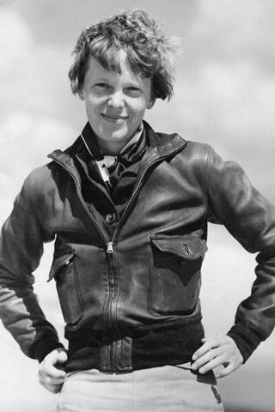
1. Why do you think Amelia became a “national hero […] a trend setter in matters of style, as well as a early feminist icon?”

2. Do you see flight as a symbol of hubris and man’s arrogance and stupidity? Or as worthy challenge that represents man’s courage and vision? Support your answer with reference to both the article and the myth.

With a partner, put together a 30 second speech answering the following question:
You may write your answer on cue cards/paper.

