Popular Songs of the 1920s and 1930s

1920s

1. “Sitting on Top of the World” Mississippi Sheiks
2. “Ain’t We Got Fun?” Benson Orchestra of Chicago
3. “On the Sunny Side of the Street” Dorthy Fields
4. “My Suppressed Desires” Bing Crosby
5. “Happy Days are Here Again” Ipana Troubadors; Bing Crosby
6. “Singin in the Rain” Cliff Edwards

1930s
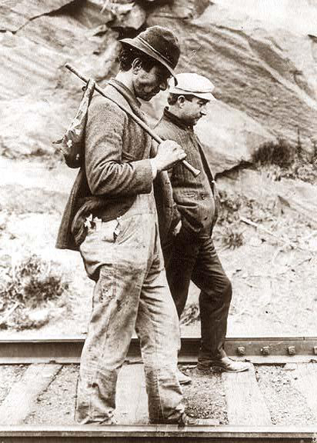
1. “Brother Can you Spare a Dime” Bing Crosby
2. “Somewhere Over the Rainbow” Judy Garland
3. "Bye Bye Blues" W.M. Bert Lown
4. "The Little Things in Life" Irving Berlin
5. "Time on My Hands" w. Harold Adamson & Mack Gordon
6. "The Lonesome Road" by Paul Robeson
7. "A Perfect Day" by Paul Robeson

Based on the titles of these songs, what do you predict will be some differences between the 1920s and the 1930s?

