Summary of Chapter 4 THE DIRTY THIRTIES Mr. Fitton
The Great Depression Socials 11

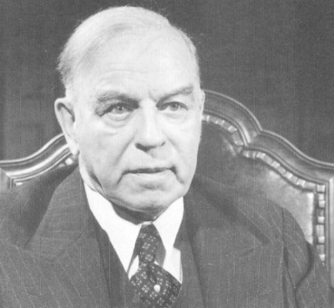
After a decade of prosperity, the “Roaring 20s” subsided into the “Dirty Thirties,” marked by poverty and hopelessness. On October 29th, 1929, the New York Stock market collapsed, bankrupting many. Before the crash, indicators revealed that a recession was imminent: wheat prices declined due to overproduction. Second, many industries were overproducing and the stockpile of goods led to layoffs. Third, countries put up tariff walls to protect industries, thus the economy slowed causing unemployment.

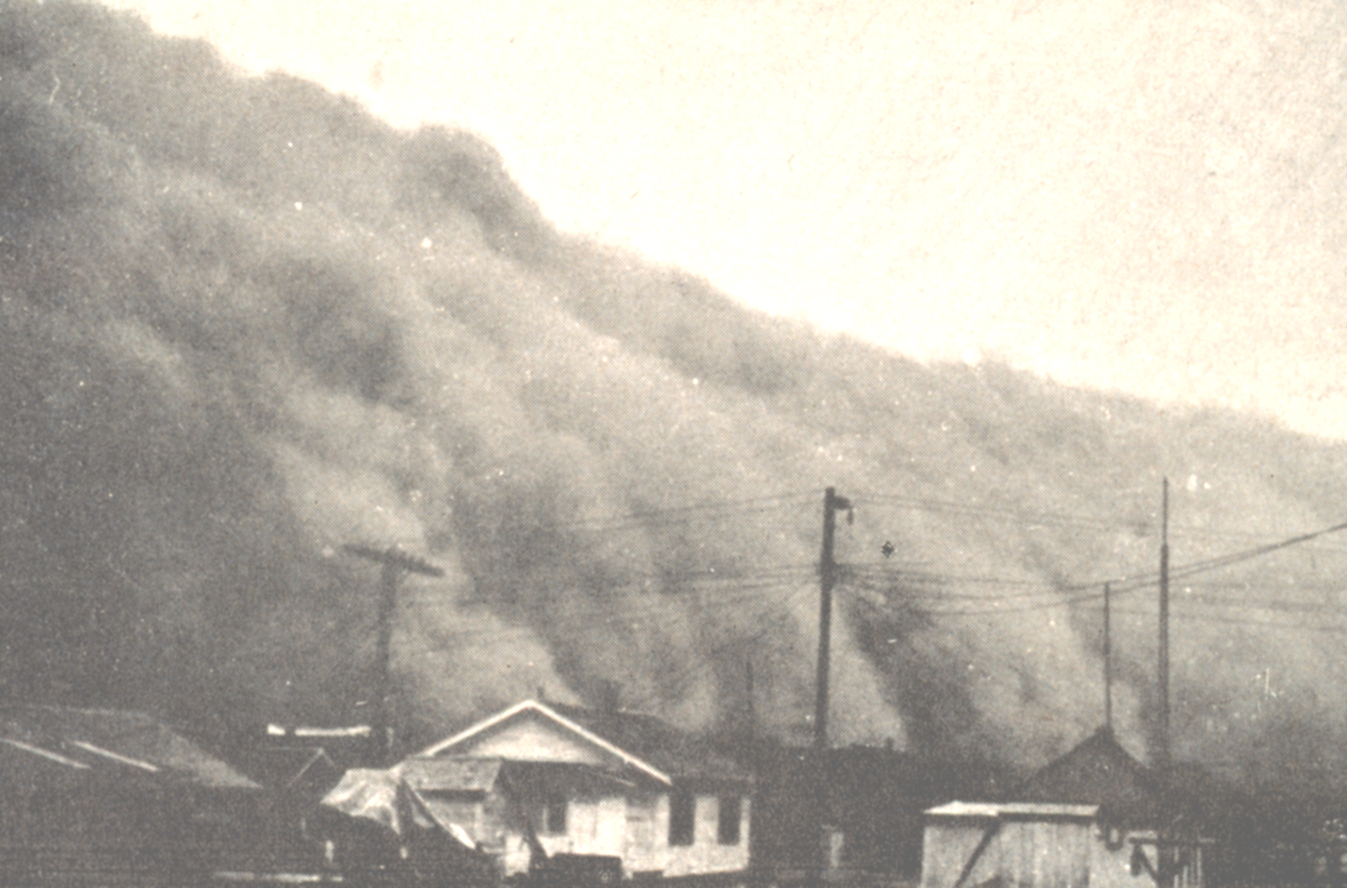
The Domino Effect: Employees were laid off; they couldn’t buy products; employees from product producing companies were laid off; they couldn’t afford items; factories shut down. Many Canadians were forced to collect “pogey.” The stigma of accepting pogey was embarrassing and many avoided it. By 1933, ¼ of the Canadian workforce was unemployed. Many men were homeless and engaged in “riding the rods” looking for work. Vagrancy was made a crime & men were thrown in jail. Poverty had become against the law.

The Prairies were the most hurt by the depression. Apart from low wheat prices, a drought from 1928-1936 led to hardship. The drought combined with winds caused tremendous dust storms that spread dirt from Alberta to the Arctic. (The Dust Bowl.)

A Poor economy leads to intolerance. Some men claimed that women contributed to the depression by stealing men’s work. Aboriginal were given a pittance and expected to live off the land. Immigrants were reviled as job thieves; Jews were shut out of the professions; in 1931 the Canadian government completely halted all immigration into Canada.

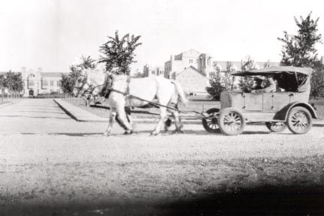
Government Response: Mackenzie King was cited that relief was the responsibility of municipal and provincial governments. He also said he would not give so much as “a five-cent piece” to a Tory (Conservative) provincial government. In 1930, King was not re-elected based on his on his remark and his lack of sensitivity to the unemployment problem. R.B. Bennett, a Conservative, became Canada’s new PM. He pumped 20 million dollars into job creation programs and put up tariffs. His plan backfired; other nations instituted tariffs walls for Canadian goods. Many poverty stricken Canadians wrote letters to Bennett pleading for help.
“A Bennett Buggy”
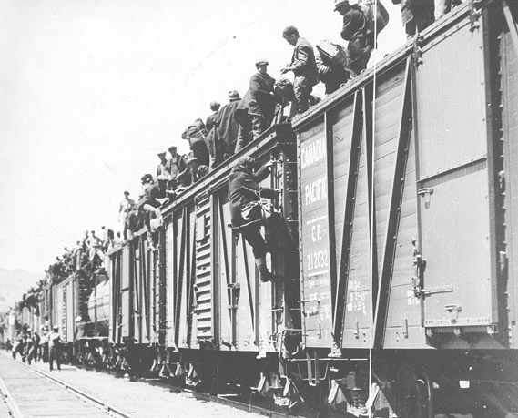
During the depression, many Canadians lived in work camps. In 1935 over 1000 men left BC to Ottawa to protest camp conditions. This was called the On-To-Ottawa-Trek. In Regina, police would only allow the leaders to pass to Ottawa to speak with Bennett. The PM had them leave after they called him a “liar… unfit to run a great country like Canada.” In Regina, police fought crowds, arrested 130 and killed 1.

Meanwhile in the USA, John Maynard Keynes’s theory for how to deal with a depression was gaining acceptance. He believed that the economy needed to be jump started by having the government spend money on work projects. Once people were working, they would spend money on
products which would increase the demand for these products. Increased demand would mean more jobs and the cycle would eventually end the depression. US President Franklin Delano Roosevelt agreed and created “The New Deal.” Bennett was listening and promised UI, Workplace Reforms, Pensions, work camps and support for farmers in Canada.

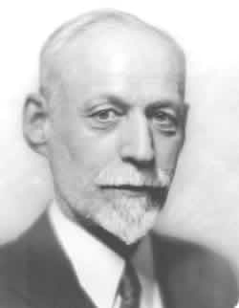
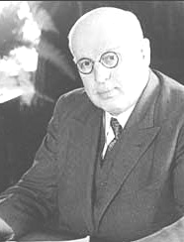
In times of economic trouble, voters will look for alternatives. In 1932, the Cooperative Commonwealth Federation (CCF) was formed by J.S. Woodsworth. They were socialists whose platform was introduced in the “Regina Manifesto.” The party called for nationalization of key industries, social programs and public works to create employment. Eventually the CCF would become the NDP. Similarly, in 1935, William Aberhart formed the Social Credit Party. The party called for government to give money to citizens so that they could spend it instead of having currency waste away in a bank. The Unione Nationale in Quebec was led by Maurice Duplessis who believed in tradition and banning communism (Padlock law.)

The worst time to be in power is during a depression. Canadians were tired of Bennett’s perceived ineffectiveness and they voted for Mackenzie King in 1935. In 1937, King created the Rowell-Sirois Commission to examine Federal-Provincial relations. The report outlined that the Federal government should have more power over taxation and be able to give poorer provinces “Equalization payments.” Richer provinces were understandably unhappy.

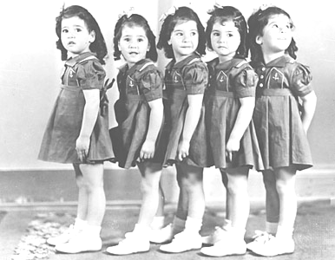
The depression was a time of despair where Canadians needed distraction from their woes. Movies, magazines, and the radio were immensely popular. Indeed, the CBC was created in 1936. However, most Canadians began to listen to American radio and read American magazines, which slowly began to blurr Canada’s cultural independence. The Dionne Quintuplets became an international sensation and were put on public display: over three million people visited the hospital where they were raised. Grey Owl was another Canadian sensation in the era. A supposed Apache conservationist, he turned out to be an Englishman who wore buckskin clothing and married an Iroquois woman. He made films, wrote books and promoted the conservation of Canadian forests and the beaver.
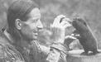
VOCABULARY FOR THE CHAPTER

Depression CCF

Pogey Mackenzie King

R.B. Bennett Dionne Quintuplets

Regina Manifesto Protectionism

Buying on Margin Grey Owl

Riding the Rods Equalization payments

On-to-Ottawa Trek J.S. Woodsworth

Rowell-Sirois Commission William Aberhart

Tariffs John Maynard Keynes

Five Cent Speech Prohibition

The New Deal Regina Riot

