Mr. Fitton Psychology Report Dr.’s Name:
English 11
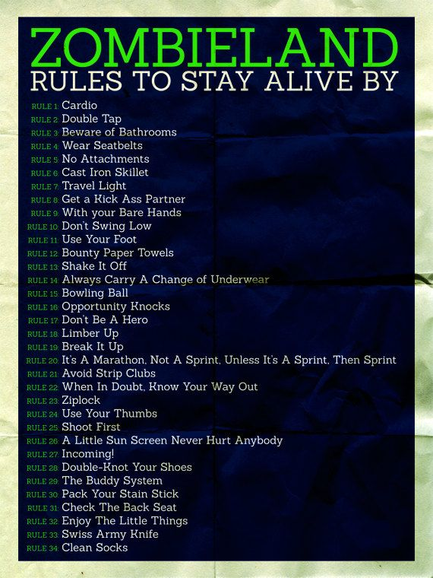
A. List 5 fears Identifiable in the Film and their Latin Names:
1.
Latin:___________________________________
2.
Latin:___________________________________
3.
Latin:___________________________________
4.
Latin:___________________________________
5.
Latin:___________________________________

B. Identify “Monsters” in the film and the Social Fears they Represent:
1.

2.

3.

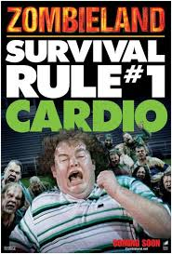
C. What Elements make this an effective Horror film / Make the Monster effective?

D. What does the movie teach us about fears? Monsters? *Think on a deeper level.

