WW2 Arms Auction
“We shall fight on the beaches, we shall fight on the landing grounds, we shall fight in the fields and on the streets, we shall fight in the hills; we shall never surrender.” Winston Churchill
Name of Country: ____________________________________________________
Names of Group Members: ___________________________________________________________________
This sheet is to help you keep track of your bidding. Each team starts the game with $100. There are 18 weapons up for sale, so make sure you budget! Check mark on the LEFT if you end up buying it!
Weapon Name: | How useful do you think it will be? (Rate from 1-10) | What is your ceiling bid? (highest you can spend?)  Ceiling bids should not add up to more than $100 total. | What will be your opening bid? (Don’t start with your ceiling bid, you might end up getting it for cheaper!) | At end: What is effectiveness of the weapon? (1-10)
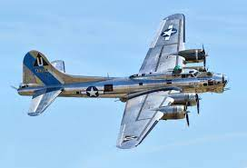  1. B-17 Flying Fortress |  |  | How much did you spend: _____
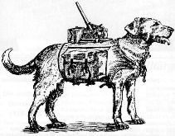  2. Dog Bombs |  |  | How much did you spend: _____
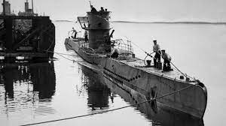  3. U-Boat |  |  | How much did you spend: _____
4. Aircraft Carrier  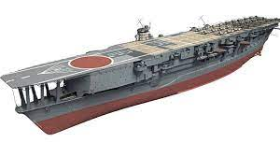 |  |  | How much did you spend: _____
5. Landkreuzer P-1000 Ratte Tank  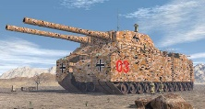 |  |  | How much did you spend: _____
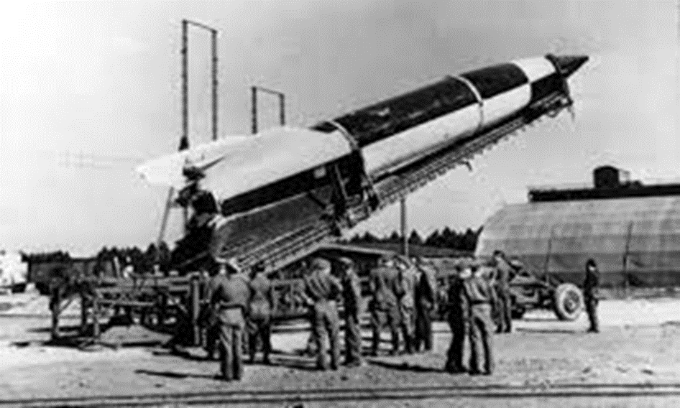  6. V1 & V2 Rockets |  |  | How much did you spend: _____
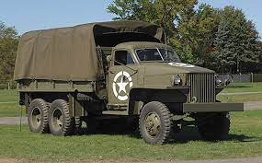  7. Studebaker Trucks |  |  | How much did you spend: _____
8. Fighter Plane  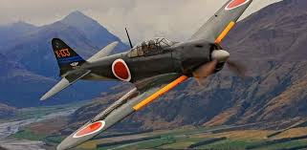 |  |  | How much did you spend: _____
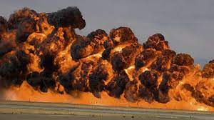  9. Napalm |  |  | How much did you spend: _____
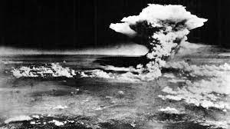  10. Atomic Bomb |  |  | How much did you spend: _____
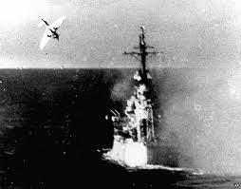  11. Kamikaze |  |  | How much did you spend: _____
12. Schwerer Gustav  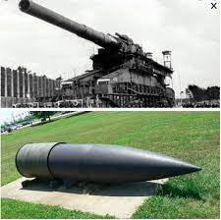 |  |  | How much did you spend: _____
13. Radar  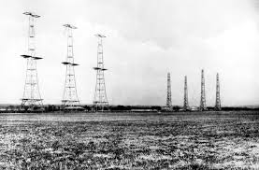 |  |  | How much did you spend: _____
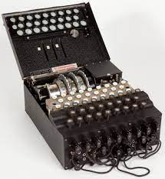  14. Enigma Code Machine |  |  | How much did you spend: _____
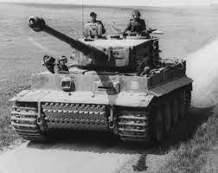  15. Tanks |  |  | How much did you spend: _____
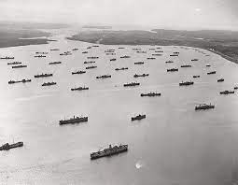  16. The Convoy |  |  | How much did you spend: _____
17. Infantry Weapons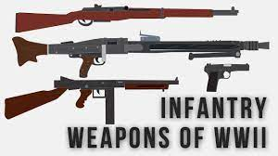 |  |  | How much did you spend: _____
Total Points _______
WW2 Arms Auction - EFFECTIVENESS KEY
“We shall fight on the beaches, we shall fight on the landing grounds, we shall fight in the fields and on the streets, we shall fight in the hills; we shall never surrender.” Winston Churchill
Name of Country: ____________________________________________________
Names of Group Members: ___________________________________________________________________
This sheet is to help you keep track of your bidding. Each team starts the game with $100. There are 18 weapons up for sale, so make sure you budget! Check mark on the LEFT if you end up buying it!
Weapon Name: | How useful do you think it will be? (Rate from 1-10) | What is your ceiling bid? (highest you can spend?)  Ceiling bids should not add up to more than $100 total. | What will be your opening bid? (Don’t start with your ceiling bid, you might end up getting it for cheaper!) | At end: What is effectiveness of the weapon? (1-10)
1. B-17 Flying Fortress |  |  | How much did you spend: _____ | 4
2. Dog Bombs |  |  | How much did you spend: _____ | 1
3. U-Boat |  |  | How much did you spend: _____ | 9
4. Aircraft Carrier |  |  | How much did you spend: _____ | 8
5. Landkreuzer P-1000 Ratte Tank |  |  | How much did you spend: _____ | 0
6. V1 & V2 Rockets |  |  | How much did you spend: _____ | 3
7. Studebaker Trucks |  |  | How much did you spend: _____ | 6
8. Fighter Plane |  |  | How much did you spend: _____ | 8
9. Napalm |  |  | How much did you spend: _____ | 5
10. Atomic Bomb |  |  | How much did you spend: _____ | 9
11. Kamikaze |  |  | How much did you spend: _____ | 4
12. Schwerer Gustav |  |  | How much did you spend: _____ | 1
13. Radar |  |  | How much did you spend: _____ | 5
14. Enigma Code Machine |  |  | How much did you spend: _____ | 9
15. Tanks |  |  | How much did you spend: _____ | 8
16. The Convoy |  |  | How much did you spend: _____ | 5
17. Infantry Weapons |  |  | How much did you spend: _____ | 6
Total Points _______

