Depths of Knowledge – Student Tasks: Literacy

 | Depth of Knowledge (DOK)  Level 1 | Depth of Knowledge (DOK)  Level 2 | Depth of Knowledge (DOK)  Level 3
Definition | The student uses simple skills to retrieve or locate information from the text. The responses require only literal understanding of text presented. The student records simple facts and basic ideas. | The student shows initial comprehension, understands important concepts, literal main ideas and is beginning to connect ideas using a simple organizational structure. The student is engaged in first draft writing for a limited purpose and audience. | The student applies deep knowledge to go beyond the text to explain, generalize, or connect ideas and is able to support their thinking, making references and interpretations from the text or other sources. The student is developing multi-paragraph compositions that may include complex sentence structures or demonstrate some synthesis and analysis. Revisions improve precision of language to produce a logical progression of ideas.
Comprehend and Connect | - Recall, recognize, or locate basic facts, details, events or ideas explicit in texts.  - Define terms.  - Identify or describe literary elements (characters, setting sequence, etc.)  - Select appropriate words when intended meaning/definition is clearly evident.  - Describe/explain who, what, where, when, or how.  - Use language structure (pre/suffix) or word relationships (synonym/antonym) to determine meaning of words  - Identify whether specific information is contained in graphic representations (e.g., map, chart, table, graph, T-chart, diagram) or text features (e.g., headings, subheadings, captions) | - Specify, explain, show relationships; explain why, cause-effect.  - Give non-examples/examples  - Summarize results, concepts, ideas.  - Make basic inferences or logical predictions from data or texts.  - Identify main ideas or accurate generalizations of texts.  - Locate information to support explicit-implicit central ideas.  - Use context to identify the meaning of words/phrases  - Obtain and interpret information using text features.  - Categorize/compare literary elements, terms, facts, details, events.  - Identify use of literary devices.  - Analyze format, organization, and internal text structure (signal words, transitions, semantic cues) of different texts.  - Distinguish: relevant/irrelevant information; fact/opinion  - Identify characteristic text features; distinguish between texts, genres  - Generate conjectures or hypothesize based on observations or prior knowledge and experience. | - Explain, generalize, or connect ideas using supporting evidence (quote, example, text reference)  - Identify/make inferences about explicit or implicit themes.  - Describe how word choice, point of view, or bias may affect the readers’ interpretation of a text.  - Apply a concept in a new context.  - Analyze interrelationships among concepts, issues, problems.  - Analyze or interpret author’s craft (literary devices, viewpoint, or potential bias) to critique a text.  - Use reasoning, planning, and evidence to support inferences.  - Cite evidence and develop a logical argument for conjectures.  - Describe, compare, and contrast solution methods.  - Verify reasonableness of results.  - Critique conclusions drawn.  - Synthesize information within one source or text.  - Develop a complex model for a given situations.  - Develop an alternative solution.
Create and Communicate | - Describe or define facts, details, terms.  - Select appropriate words to use when intended meaning/definition is clearly evident.  - Write simple sentences.  - Apply rules or use resources to edit specific spelling, grammar, g=punctuation, conventions, word use.  - Apply basic formats for documenting sources.  - Decide which text structure is appropriate to audience and purpose.  - Brainstorm ideas, concepts, problems, or perspectives related to a topic or concept. | - Specify, explain, show relationships; explain why, cause-effect.  - Give non-examples/examples.  - Take notes; organize ideas/data.  - Summarize results, concepts, ideas.  - Identify main ideas or accurate generalizations of texts.  - Use context to identify the meaning of words/phrases.  - Obtain and interpret information using text features.  - Develop a text that may be limited to one paragraph.  - Apply simple organizational structures (paragraph, sentence types0 in writing.  - Compare literary elements, terms, facts, details, events.  - Analyze format, organization, and internal text structure (signal words, transitions, semantic cues) of different texts.  - Distinguish: relevant-irrelevant information; fact/opinion.  - Generate conjectures or hypotheses based on observations or prior knowledge and experience. | - Explain, generalize, or connect ideas using supporting evidence (quote, example, text reference0  - Write multi-paragraph composition for specific purpose, focus, voice, tone, and audience.  - Revise final draft for meaning or progression of ideas.  - Apply internal consistency of text organization and structure to composing a full composition.  - Apply a concept in a new context.  - Apply word choice, point of view, style to impact readers’ interpretation of a text.  - Analyze interrelationships among concepts, issues, problems.  - Apply tools of author’s craft (literary devices, viewpoint, or potential dialogue) with intent.  - Use reasoning, planning and evidence to support inferences made.  - Cite evidence and develop a logical argument for conjectures.  - Describe, compare, and contrast solution methods.  - Verify reasonableness of results.  - Justify or critique conclusions.  - Develop a complex mode for a given situation.  - Develop an alternative solution.
Source: https://www.google.ca/url?sa=t&rct=j&q=&esrc=s&source=web&cd=4&ved=0ahUKEwjdnKnh9sHPAhUW72MKHYz1AfcQFgguMAM&url=http%3A%2F%2Fschools.nyc.gov%2FNR%2Frdonlyres%2F39A50715-BDF2-4C3C-8180-D5075FFD36BE%2F0%2FCognitiveRigorMatrixReadingWriting.doc&usg=AFQjCNEyFUbdPeEhlrEObaclIDt5LmE6fw

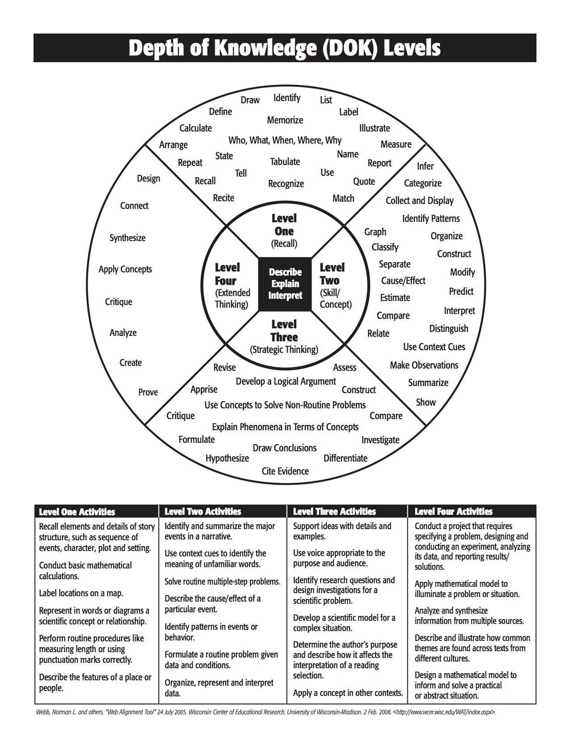

Questions For Checking Critical Reading

Literacy for Expression

Before Reading | - How am I influenced by the layout of the text on the page?  - Why did the author write this text?  - How has this purpose influenced the writing?  - What is the illustrator’s purpose? (e.g. to surprise? to make it attractive? to provoke?)  - What questions do I ask myself on about the topic?  - What previous experiences, knowledge and beliefs do I bring to the text?
During Reading | - Why did the author choose certain words?  - What is the author’s tone?  - What mood does the author create?  - Why does the author use humour, satire, irony or sarcasm?  - Who does this character (X) represent in society?  - Why does X feel…?  - Why does X…?  - What would I do in X’s place?  - Why is the character represented differently in the illustration?  - What is the consequence of…?  - What is the author’s purpose in writing this text?
After Reading | - What does this remind me of?  - If I was character…, how would I react?  - How is this situation different from the one described in this other author’s text? How is it the same?  - What values are conveyed in the text?  - What is the author’s point of view?  - What does the author want me to think?  - What groups of people are represented?  - What groups of people are left out?  - What other text, image or situation with which I am familiar gives a different point of view?  - How could I change this text to present a different point of view?  - How can I use the information in the text to promote social justice, appreciation of family, tolerance of others, etc.?  - Why would I read or not read this text to someone else?  - What did I find surprising in the text?  - What connections can I make between this text and my own experiences?

Questions For Checking Critical Reading

Literacy for Information

Before Reading | - How am I influenced by the layout of the text on the page?  - Why did the author write this text?  - How is the author’s background related to the topic?  - How has the author’s purpose influenced the writing?  - What is the impact of the photos on the page? (e.g. surprise? attractiveness? shock?)  - What questions do I ask myself about the topic?  - What experiences, assumptions, knowledge and perspectives do I bring to the text?
During Reading | - What does the author want me to think about by posing the question…?  - Why has the author used this word?  - What could be the result if…?  - What is the author’s underlying purpose?  - Has the author made inconsistent statements?  - Does a particular statement depend on context for its intended meaning?  - Are the author’s words to be taken exactly as they appear, or are they slang, idioms, or figures of speech?  - What modes of analysis are used (e.g. definition, explanation, description, elaboration)?  - Who or whose points of view are not represented in the text?  - What facts are missing from the text?  - Do any claims seem too certain?  - What assumptions or omissions prevent me from being objective about the subject?
After Reading | - Does this text cause me to change my opinion related to the subject? How?  - Has the author really said what I think he said?  - Has important information been left out?  - How is the point of view of this author different from the one described in the text written by…? How is it similar?  - What is fact in this text? What is opinion?  - Of the author’s conclusions, which are justified? Which are not?

Essential Questions

A Fertile Question

The pedagogical model of a Community of Thinking places the question at the center of teaching and learning. It deflects teaching from a focus on a “correct answer” to a focus on a “fertile question.” The first stage of teaching and learning in a Community of Thinking is to find or to invent a fertile question. A fertile question can be described in terms of six basic characteristics:
- An open question – a question that in principle does not have one definite answer, but actually several answers different from and even contradictory to each other.
- An undermining question – a question that undermines the basic assumptions and fixed beliefs of the learners; casts doubt on the “self-evident,” on “common sense”; uncovers basic conflicts lacking a simple solution; and requires thinking about the roots of things.
- A rich question – a question that requires grappling with rich content indispensable to understanding humanity and the world, that is impossible to answer without careful and lengthy research, and that tends to break up into sub questions.
- A connected question – a question relevant to the life of the learners, to the society in which they live, and to the discipline and subject within which it is asked.
- A charged question – a question having an ethical dimension, a strong emotional and ethical charge able to motivate learning and inquiry.
- A practical question – a question that can be developed into a research question; a question about which information is available to students
Examples:
Open question: How are our lives enriched through a connection to nature?

Undermining question: How do our attitudes toward nature influence the choices we make about how we treat it?

Connected question: What responsibilities do we, as individuals, have toward nature?

Rich question: In what ways does the survival of all humanity depend on our personal relationship to nature?

Practical Questions: How can experiences in nature teach people the importance of looking after it?

Charged Question: To what extent will the natural world adapt to its mistreatment by humans?

https://pdfs.semanticscholar.org/e713/a6b2728fb8f9f3f22d35c4456b31bc854cd0.pdf

