Walter Prynne

- Prynne, Henry Burton and John Bastwick had all been imprisoned because of their vigorous objections to decorations of the Church.

- Prynne had been jailed for attacking the wickedness of stage plays, calling all women actresses “notorious whores” – a sideways attack at the Queen

- He had also criticized bishops

- All 3 of the men had been sentenced to have their ears “cropped” – while standing in a pillory their ear would be cut off.

- Others thought Prynne should also have his forehead branded with S & L (seditious libel) and his nose slit.

- Supporters commented on Prynne’s bravery, so he continued denouncing bishops, but suffered again as the remaining stumps of his ears were cut off and both cheeks burned with S & L. (Prynne claimed it stood for stigmata laudis - the mark of praise, or alternatively, the Sign of Laud

- The hangman who cut his ears hacked savagely at his ears, purportedly because Prynne promised him 5 shillings if he was treated well, but only gave him five sixpence.

- Onlookers and the general public were generally impressed with the courage of all 3 men, and sided with them.

Power to our People!

Are ye tired of the King’s taxes?

Don’t wish to feed and board his soldiers who are sent to kill you?

Broke from tonnage & poundage?

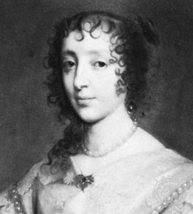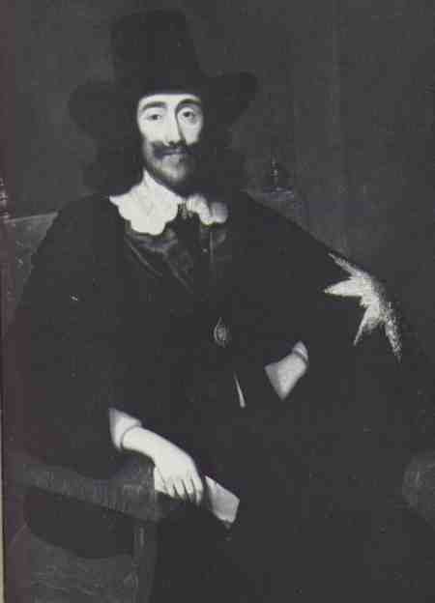

Then take up arms and REVOLT!

Support parliament’s right to meet and determine the future of all England’s Godly people.

Rid England of the Catholic scourge – Henrietta Maria!

Meet in the village square at dawn on Saturday.

