History Through Film 12 Name ___________________________

“THE UNTOUCHABLES,” Prohibition and the Great Depression

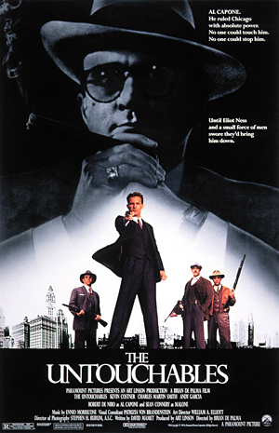
“The Untouchables”, 1987. Directed by Brian de Palma. Starring Kevin Costner, Robert de Niro, and Sean Connery

PRE-FILM ASSIGNMENT:

Consider what techniques directors use to juxtapose “good” vs “bad” in film. Consider colours, symbols, music, etc. Write some of your ideas down here:

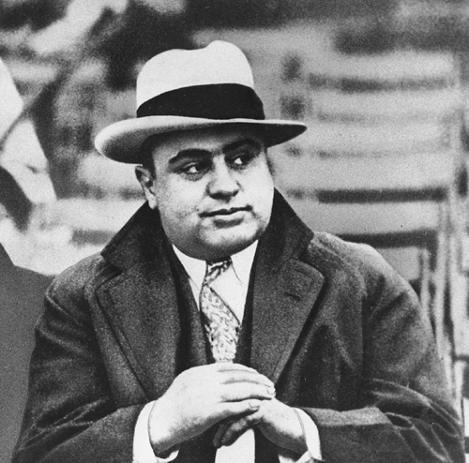

History Through Film 12 Name ___________________________

THE UNTOUCHABLES – post-film assignment

For further discussion, please write down your thoughts on the following so that you can use your notes for an enriched conversation.

In our pre-film considerations you were to come up with ways that film makers utilize different techniques to portray “good guys” vs “bad guys”. Describe 2 or 3 specific scenes in the film and how effectively one or more techniques was used.

Explain any possible symbolic meanings behind the use of the colour red throughout the film.

In what way might historians attest that the character of Eliot Ness detracts from the film’s historical authenticity?

Give your overall rating out of 10 for the film and explain.

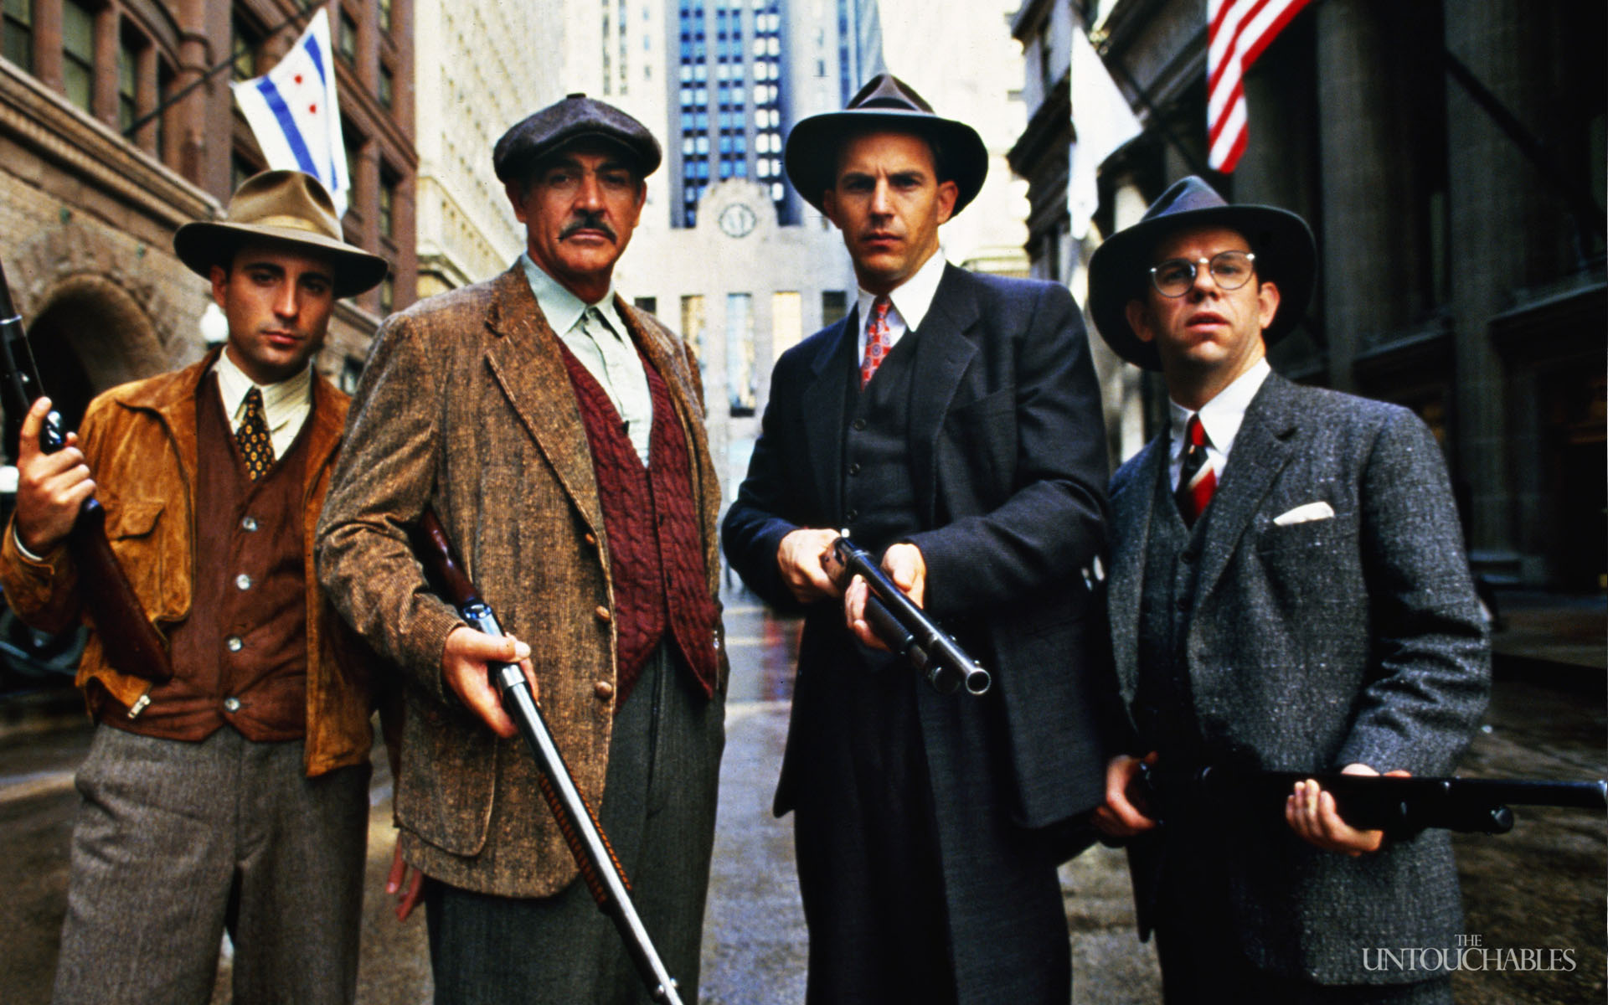

*Thanks to Ms. Lacroix and Mr. Van Camp for this Assignment.

