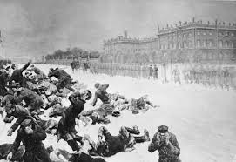

BLOODY SUNDAY

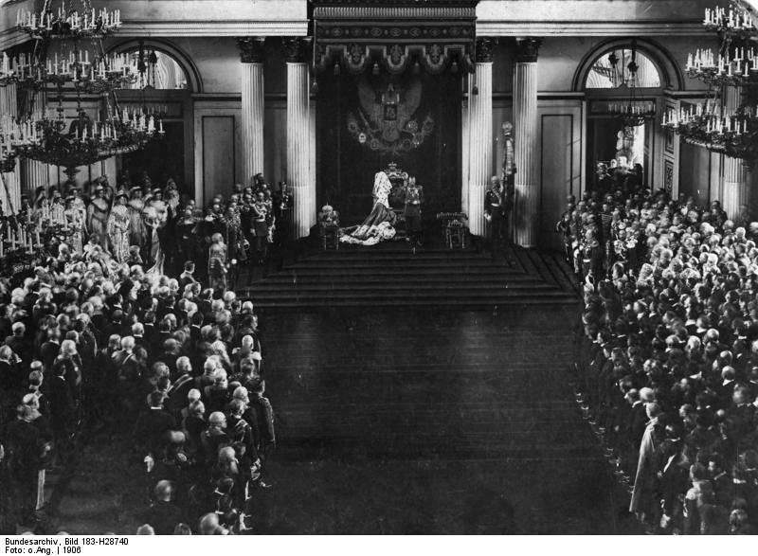

DUMA ELECTED

BUT HAS VERY LITTLE POWER

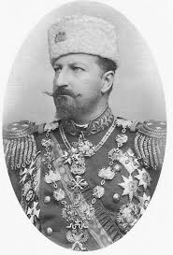

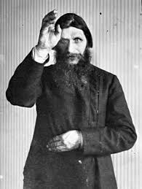

RASPUTIN ASSASSINATED

TSAR BECOMES COMMANDER OF THE ARMED FORCES