The Red Baron Film Preparation
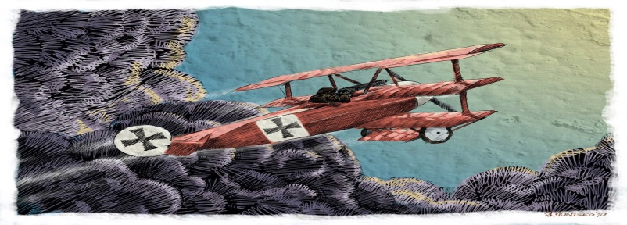
In groups of 3 quickly research the assigned topic for a brief presentation.
1. The Red Baron – back ground before the war.
2. The Red Baron – war service and accomplishments.
3. The Red Baron – death.
4. Billy Bishop.
5. Characteristics of fighter planes (tactics).
6. Zeppelins.
7. Bombers in WWI
8. Snoopy and the Red Baron.
Gather 6 -10 factoids about your topic. Present them on a whiteboard in point form along with a 2- 3 minute explanation. You may also add a short Youtube clip (2 minute maximum) after your discussion. Try not to have the clip be completely redundant – saying exactly the same things you just said.
If you are including a Youtube clip mail the link to jfitton@summer.com

Evaluation 12 marks
- Minimum 6 factoids
- Use of whiteboard to supplement discussion
- All members participate in presentation
- Enthusiasm, maturity
- Fits within time frame 2-3 minutes
- Optional Youtube clip

