English Name: ____________________
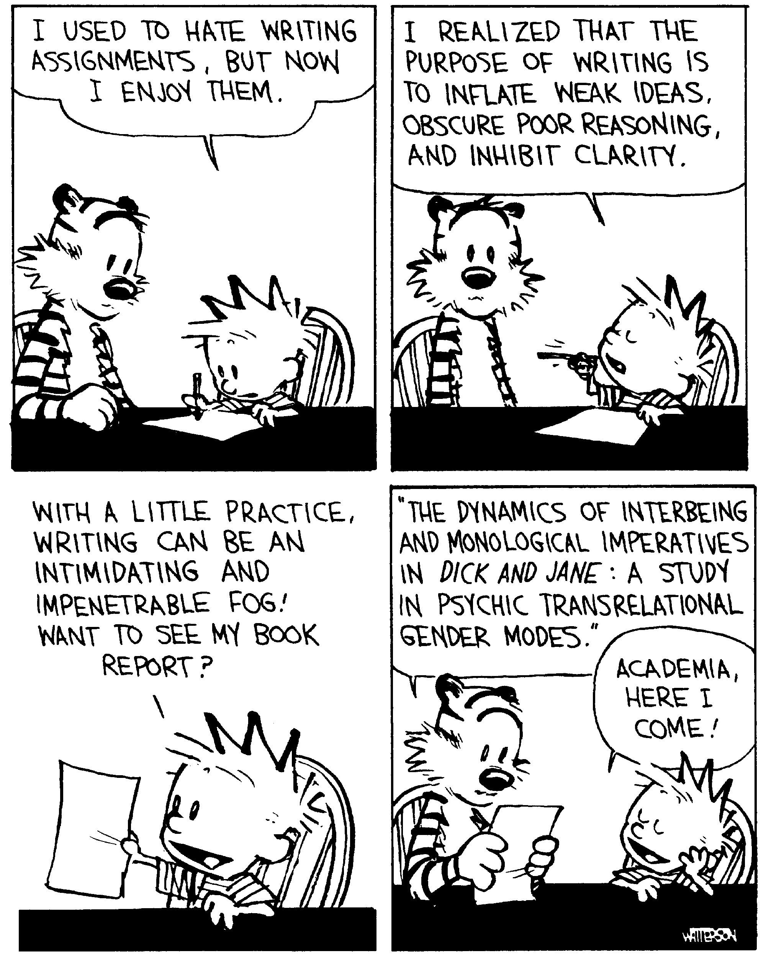The Paragraph
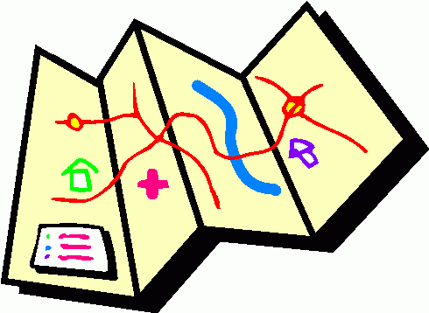
A paragraph is a series of sentences that develop a single topic. It consists of a topic sentence, at least 3 supporting ideas, transition words and a conclusion. A paragraph is kind of like a road map.

The Topic Sentence: starting point, the map of where you are going
1. Rewords the ______________________ into a statement.
2. Centres the paragraph around a single main ___________________ that will be developed in the sentences that ____________________.
3. Is specific and __________________ (outlines the argument, contains the ___________________ and the ____________________ of the story).
4. In formal writing (just be safe and assume if you are writing it for school it is formal) NEVER use____________________________________________________________________ or say “In my opinion.” Also, stay in the present _____________________________.
Weak | Better
Our Mexican vacation was planned | During winter vacation to a beach resort in Mexico, the Smiths plan to go fishing, to the market and to the beach.
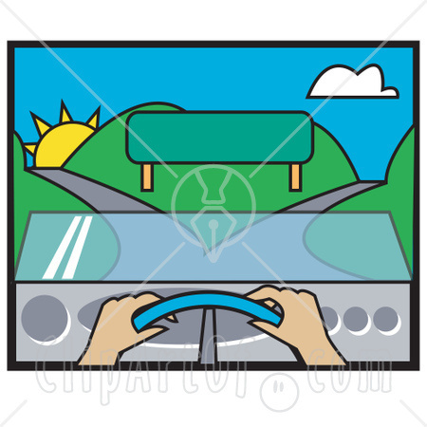
Supporting Ideas: the specific streets you have to take to get there.
-must have at least three
-paragraph should discuss how each point proves the topic sentence
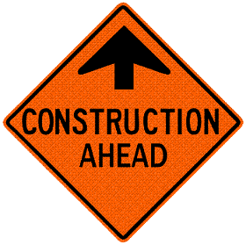
-can use quotations or paraphrased ideas from a text (story, movie, article etc) to help support your ideas.

Transition words: (words that link your ideas together) Stop ahead, slow to 50, yellow light.
Conclusions: your final destination
afterwards, also, as well as, at last, at the same time, before, first, for example, immediately,
in fact, later, meanwhile, next, not only, once, otherwise, previously, then, therefore, too, usually,
in comparison, secondly, finally, in addition, consequently, on the other hand, generally, as a result

-restates your main idea and main support in different words
-Ways to conclude in an interesting way: ask a question, state the result of a process, evoke an image, use a quotation, call the reader to action, compare to something else (make a connection).
-never introduce new information in the conclusion.

1.The Brainstorm:

2.The Outline:

3. Write a rough draft

4. Edit
Content | Format | Conventions
3 ideas ___ | Topic Sentence _____ | Grammar ______
Supported with evidence (example, quote etc.) ___ | Transition words _____ | Spelling ______
All thoroughly explained (how they support T.S) ___ | Conclusion _____ | All sentences make sense when read aloud ______

5. Write a good copy

