“The Most Dangerous Game” Name: ____________
English 11 Date: _____________

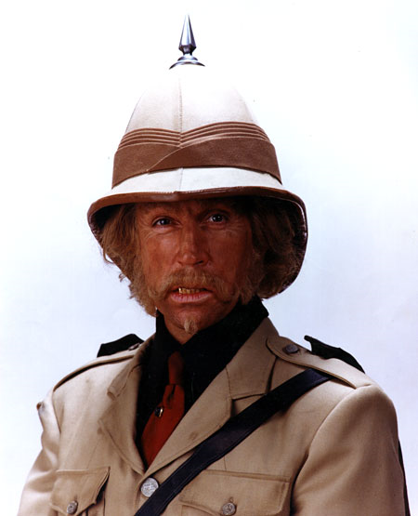
Directions: Write down your thoughts point form for each of these questions. We will be using these questions to discuss the story “The Most Dangerous Game.”

1. Zaroff says “he lives for danger.” What do you think about thrill seekers? Should thrill be sought if others are endangered in one's attempt to discover it? What is an example?

2. Zaroff says “God made him a hunter and that the weak were put here to give the strong pleasure.” Do you agree or disagree? Can you think of instances where the strong take advantage of the weak?

3. Discuss Rainsford’s state of mind before he lands on the island versus that after he meets the general. What is different? (Especially how he perceives animal’s feelings). How does this relate to the theme of the story?

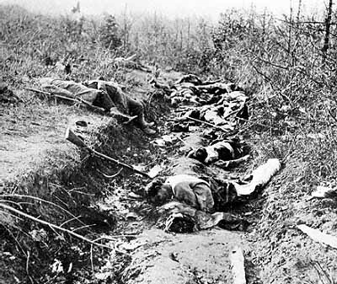
4. This story is considered to be a response to World War One. Considering what the story is about, how do you think this story is commenting on World War One?

5. This story forces us to consider the animal’s point of view in the hunt; something not often considered by the society this story was written for (The story was written in the 1920s when hunting was more popular and perhaps more socially acceptable). However, our society today loves animals (think of groups like PETA, the SPCA etc.); in your view are there any instances when we show more compassion to animals than to humans?

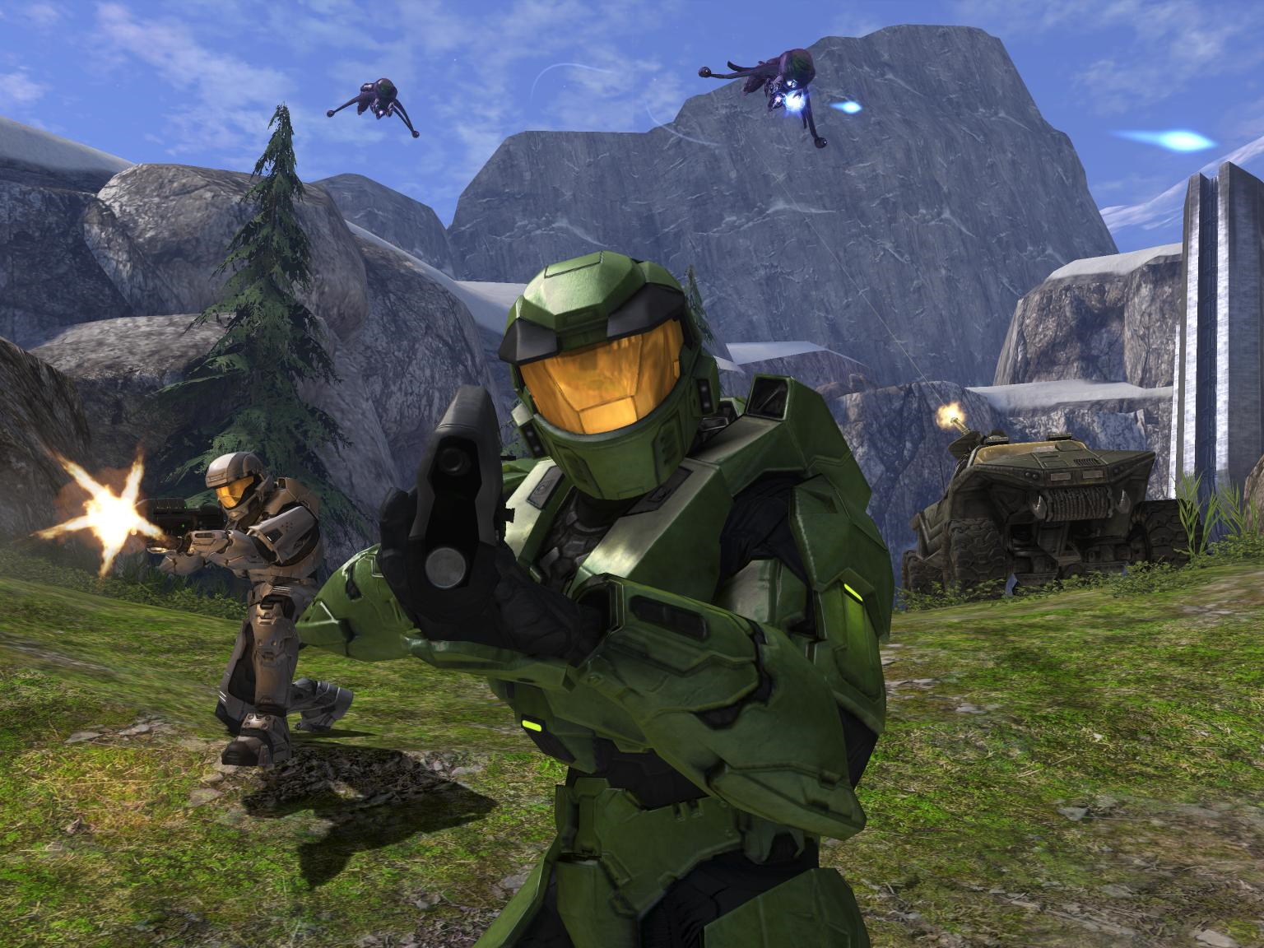
6. Many of you were likely horrified by the concept of this story (man becomes the hunted instead of the hunter) yet some of the most popular video games are first person shooter games like Doom, Grand Theft Auto, Call of Duty and Halo. Why are these games so popular? Do you think it desensitizes the people who play these games?

7. What are some themes of the story?

