The Industrial Revolution (finally a revolution where the monarch gets to keep their head)
Hi, I’m Queen Victoria and I get to keep my head!

Introduction
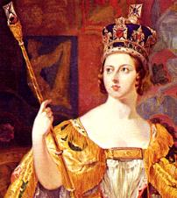
-started in approximately the 1700s
-transformed society
-continues even now
-real beginning of the modern world as we know it today

-changes for your grandparents:

*Cars and airplanes

*Television and satellites

-Changes for you: computers

Who comes to find you if you are in trouble (ie miss homework room? Go see this person’s office for information on European society before the Industrial Revolution and during/after the Revolution.
BEFORE/AFTER The Industrial Revolution

Old Society New Society

1. Farms 1. Factories/cities

2. Britain made/used what 2. Get materials from
it had in its own country colonies (like Canada!)

3. You interacted and 3. “The earth was made for
enforced technology Dombey and Son to trade in on the land by building the sun and the moon were
a house or a farm made to give them light.
Rivers and seas were made
to float their ships”
-Charles Dickens
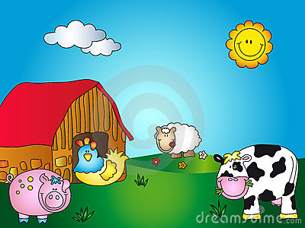
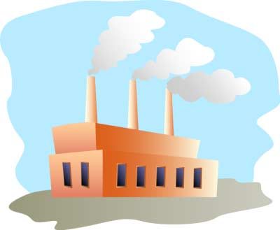
Quote show that Victorians saw the environment as something to control and manipulate, not adapt to.

Need some interesting reading? Need a quiet place to work? Where do you go? Venture inside and ask someone for information on why the Industrial Revolution happened in Britain first.
Why Britain First?

1. Labour supply (after serfs kicked off feudal lands during enclosure so unemployed, population growth)

2. Middle class had influence in government because of the Glorious Revolution, passed laws to promote business

3. Test act prohibited Catholics from the army/church and government; so have to go into business, have $ to invest.

4. Raw material at home (coal) and in colonies (wood etc)

5. Government supported technology/science, causes many new inventions

6. New developments in farming technology

7. Good Transportation (waterways, roads)

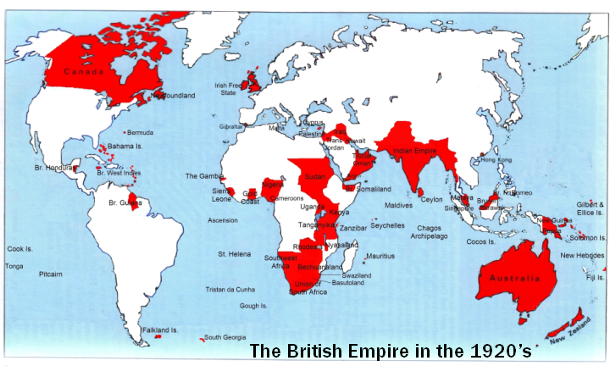
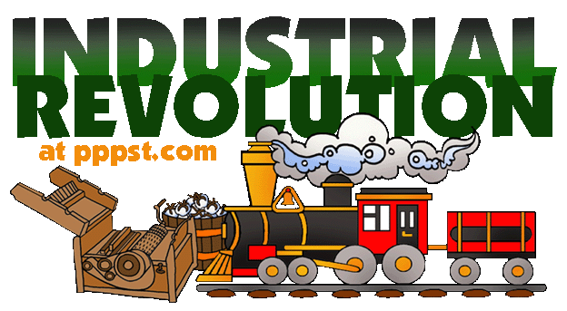
8. Could export finished products to colonies (so have a market)

Ask this person if you have a message, need a band- aid, want to page someone in the school or want information on the Agricultural Revolution
The Agricultural Revolution

Medieval Times:

Feudal system = inefficient
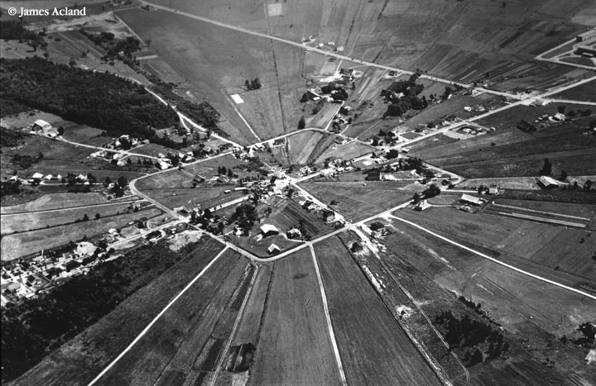

Renaissance to 1700s

-Enclosure (taking away small parcels of land from serfs and combining them in to large farms)

-starts in Renaissance and is sped up in 1700s

Want to change your timetable? Ask this person and as a bonus find information on new attitudes towards farming.

New Attitudes Towards Farming

*Farms now for money/business (not just survival)

*Farmers now want technology to advance farming techniques

*Can now grow enough food to feed a city

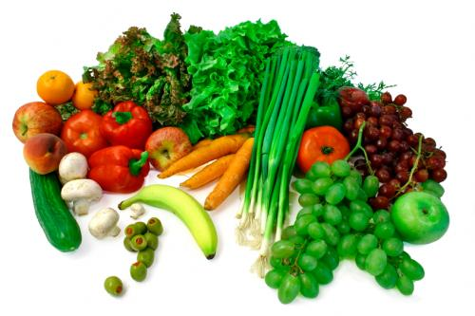

You decide you want to be a part of yearbook, make a movie or an animation. Who do you go to for help and information on New Breeds of animals.

New Breeds of animals

-Before animals kept for milk and wool

-Lacked enough fodder (animal food) to keep over winter so they killed them before winter and ate them

-Bred new sheep that had thicker wool and animals with more meat. Also heartier so that they get less diseases

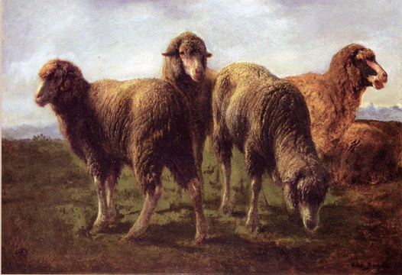

Look where all the teachers go to eat their lunch for information on new crop techniques and technology for farming!

New Crops Techniques and Farming Technologies

-Now that farms are for profit and not just survival, farmers willing to invest money in farming techniques that will make them richer

-Goal is to make an acre of land produce more crops (and therefore $), while lowering the cost of raising the crops

Two New Crops Techniques and Technologies

Technology

Jethro Tull’s Seed Drill

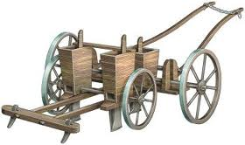
-When soil is broken up (cultivated) and enriched with manure, crops grow better.

Go to the place where most stuff prints from Mrs. Fitton’s room (but just to the place, not the actual printer) and find out why Jethro Tull’s Seed Drill was better than the old method of broadcasting.
Why this was better than the old method
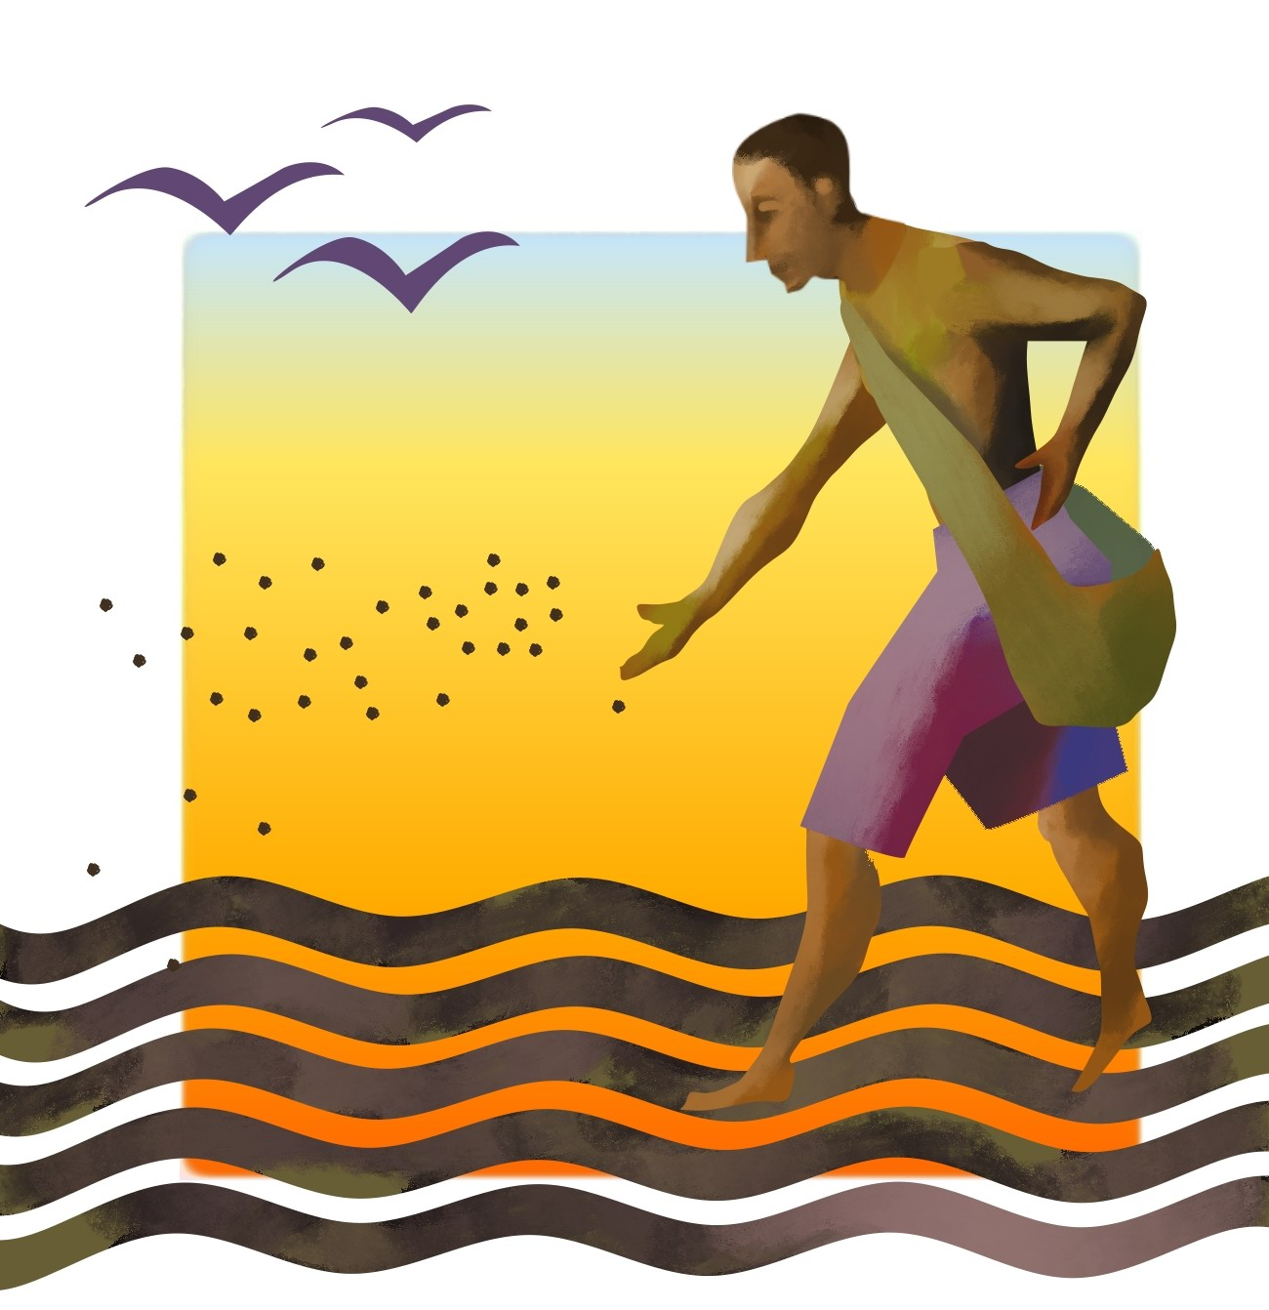

Old Method= Broadcasting

Wasteful and the birds eat the seeds

Why the New Method is Better

*Less Waste
*Rows = faster (to plant and upkeep)
*Possible to farm with fewer people
*Weeding easier
*Less eaten by animals
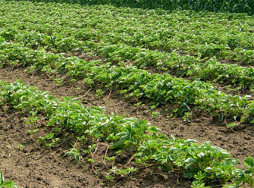

If you need help in with your classes, or need a quiet place to work you might go to this room and hang out with Mr.Van Os, Ms. Woolner or Mrs. Richert or to find information on Turnip Townsend!

Another New Farming Technology

Crop Techniques

Turnip Townsend

*No need to keep one field fallow (empty) like in Medieval times

*Turnips and Clover release nutrients into the soil and are inexpensive fodder for animals

*Easier to maintain larger crops, now cities can grow because they can feed their population without everyone growing their own food.
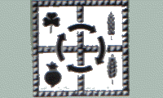

Hablas Espanol? Who would you go to ask how to say “The Industrial Revolution” in Spanish? (again, go to the class, not in it)

1. Who comes to find you if you are in trouble (ie miss homework room)? Go see this person’s office for information on European society before the Industrial Revolution and during/after the Revolution.

2. Need some interesting reading? Need a quiet place to work? Where do you go? Venture inside and ask someone for information on why the Industrial Revolution happened in Britain first.

3. Ask this person if you have a message, need a band- aid, want to page someone in the school or want information on the Agricultural Revolution

4. Want to change your timetable? Ask this person and as a bonus find information on new attitudes towards farming.

5. You decide you want to be a part of yearbook, make a movie or an animation. Who do you go to for help and information on New Breeds of animals.

6. Look where all the teachers go to eat their lunch for information on new crops and technology for farming!

7. Go to the place where most stuff prints from Mrs. Fitton’s room (but just to the place, not the actual printer) and find out why Jethro Tull’s Seed Drill was better than the old method of broadcasting.

8. If you need help in with your classes, or need a quiet place to work you might go to this room and hang out with Mr. Van Os, Ms. Woolner or Mrs. Richert or to find information on Turnip Townsend!

9. Hablas Espanol? Who would you go to ask how to say “The Industrial Revolution” in Spanish? (again, go to the class, not in it)

