Swing Kids 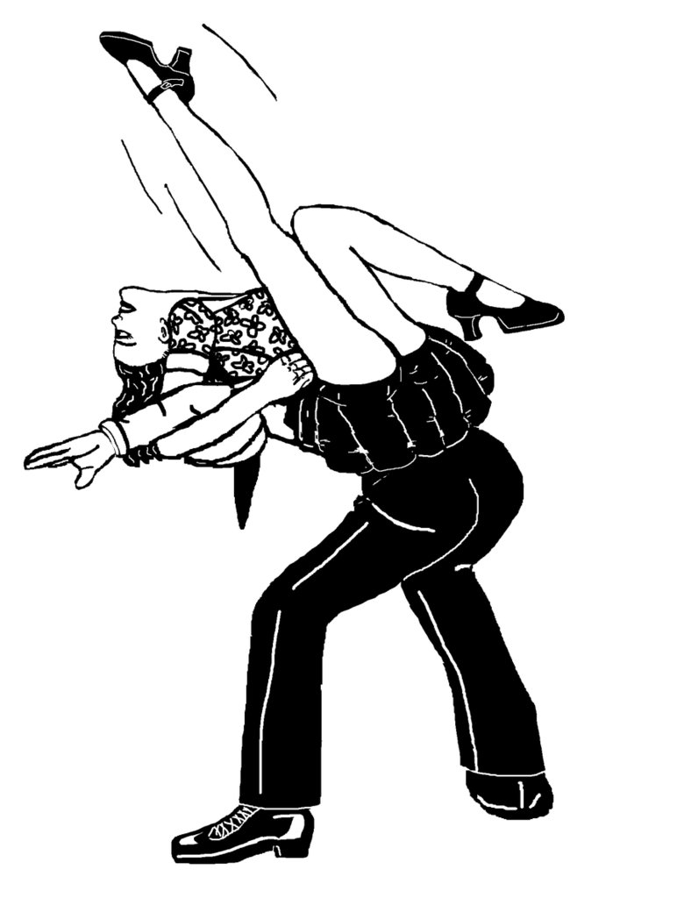
Swing Kids is set in Germany in the late 1930’s. Adolph Hitler and the Nazi party have risen to power. Not all Germans are supportive of their ideologies. The film focuses on a group of young people, your age, who are passionate about American jazz and swing music. The Nazi party has officially banned such music and dancing.
In your group you must consider what conflicts these young people face. What would their conversations be like. Consider these lines from the film. Create a scenario that includes your assigned line(s). Write a script in which each person has at least two lines. Present it to the class and after explain your reasoning. Have some fun with this but it is a serious film.
1. Peter Müller: You're turning into a Nazi!
Thomas Berger: Oh so WHAT if I AM?

2. Arvid: I would rather belong to any one... ANYONE, than belong to the Nazis like you do.
Thomas Berger: That's because you have everything backwards. Nazis go anywhere they want, do anything they want, everyone gets out of our way.

3. Arvid: You think that just because you're not doing it yourself, you're not a part of it? Well, I'm sick and tired of doing my part.

4. Emil: I am not a traitor. I just wised up. You will too.

5. Peter: I know who my friends are. I'm not alone.

6. Peter: You said they'd never split us apart.

