BCATP – Magnus and Ty
Battle of Hong Kong/Dunkirk
Battle of the Atlantic - Jared
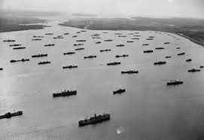
Who: The RCN (Royal Canadian Military), The Royal British navy, U.S. Transport ships, The U.S. Navy, and The Germanic Navy All took part in this long fought conflict on the Atlantic ocean.
Where: It took part in The Atlantic ocean, mostly in the northern half, as this was the quickest way between North America and Europe.
When: The Battle of the Atlantic took place during most of WWII, from September of 1939 to May of 1943.
What: This battle was over control of the Atlantic and the important trade routes between Canada and Britain.
Why: Germany wanted to control the Atlantic so they could cut off resources coming from North America, doing this would severely cripple the British war effort. Britain obviously wanted to keep the Atlantic in Allied control so as to keep the war effort from running out of resources.
RCAF – War in the Air (pg. 139, 134) – Kohl and Jacob
WHO Royal Canadian Air Force (RCAF) -more than 215 000 Canadians enlisted
-Casualty rate of the RCAF was 7/10. Nearly 10 000 Canadian bombers died during ww2
-Women’s Division (WD) created in 1941. Trained as clerks, cooks, hospital assistants, drivers, mechanics
-Licensed female pilots were not allowed to fly till later in the war

WHAT Battle of Britain
-Operation Sea Lion, German plan to invade Britain
-To be successful they would need to defeat the RAF (Royal Air Force) (British)
-1940 Luftwaffe (German Air Force) started bombing England -In retaliation the RAF bombed Berlin
-Hitler ordered attack on British cities, known as the Blitz -23 000 people killed, mostly civilians
-Germans were not able to beat the British as they had an advanced radar system
-RAF was reinforced with pilots, planes and supplies from Canada

RCAF BATTLES
-Britain’s Bomber Command (RAF directed strategic bombing of Germany)
-To diminish German Morale, and destroy industry centers
-RCAF (Canada) participated bombing Germany at night, including Dresden Cologne and Hamburg

Battle of Hamburg
-July 1943 -Created a firestorm, engulfing city in flames -Destroyed the city of Hamburg
-More than 40 000 civilians were killed

FACTS
- Some Canadians used Lancaster bombers, SuperMarine Spitfire and Curtis P-40 Warkhawk (planes)
-Some British used Spitfires and Hurricanes (planes)
-Jets did not affect the war, as they were a new, unperfected technology
Dieppe
Italian Campaign - Manreet and Harnish
Who: Britain, France, USSR, USA, Canada, New Zealand, Australia (Allies), Italy, Sicily and Germany.
Where: Sicily and Italy.
When: July 10th, 1943 – December 28th, 1943.
What: 1943 allied battles to recapture Europe from the south, through Italy and Sicily.
Battle of Sicily:
- Allies battled to recapture Europe from the south, through Italy and Sicily.
- Allies captured the land after 38 days.
- Italians surrendered but Germans continued to defend their Italian territory.
Battle of Ortona:
- Allies followed Germans to mainland Italy.
- Canadians had to capture several small villages and fight several kilometers of German occupied territory.
- Once Canadians reached Ortona, advances were slow & battles were fought in towns & rubble filled streets.
- The town was captured on December 28, 1943 but lost 1372 soldiers.
- After Ortona, Canadians advanced through Italy and were sent to join the campaign in France.
- 6000 Canadians were killed in Italy.
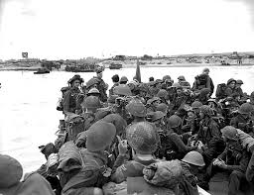
EVERYTHING YOU NEED TO KNOW ABOUT D-DAY! Teachers: Ms. Riddler Ms. Pankratz
What was D-Day event? : D-Day was the day that the allied armies invaded France.
Where did D-Day take place? : Normandy, France. The beach that the Canadian army invaded was Juno Beach.
Who was involved? : The allies- Britain, France, Russia, USA, Canada, New Zealand, Australia.
Why was D-Day Significant to Canada? :
-Canada was part of World War 2’s Biggest Allied invasion, which was very successful.
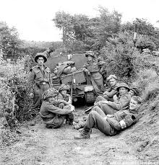
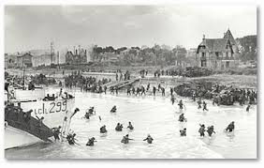
- It was hard work marching 9 miles through German defenses, but Canada and the allies pushed through.
-Canada took over Juno beach on their own.
When did D-Day happen? : June 6th 1944.
Interesting Facts :
-359 Canadian soldiers died, 715 were wounded.
-They Planned and rehearsed every detail of the attack.
- The Allies managed to keep their attack a secret from the Germans and had them at surprise.

Liberation of the Netherlands By Aidan Wallace and Dane Bateman
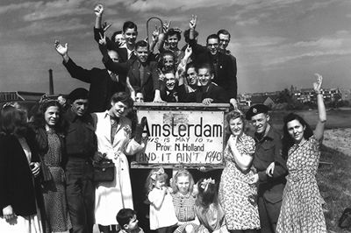
What: After allied forces reached the Rhine river Canadians were given a separate task to liberate the NetherlandsTook a month to get the Germans out of the country. Dutch were starving and had no supplies
Where: The Netherlands
Who: Canadians, Germans, Dutch
When: 1945
Significance to Canada: Canadians hailed as heroes
Canadians gained a new ally
Canadians proved their usefulness

Interesting facts: After negotiating a truce with Germany, Canadians delivered thousands of tonnes of supplies to Netherland civilians
-An earlier allied attempt to liberate the Netherlands failed
-Since 1953 the Netherlands have sent a large amount of tulips every year to Canada
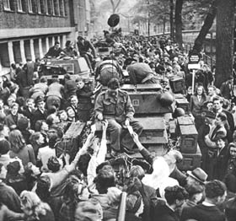

Homefront

Women

Japanese
WunderWafffen (Wonder Weapons)
Hitler’s favourite weapons created by his researchers in the Second World War were: “Wonder Weapons”. They were a plan of Hitler’s to use once he had achieved world domination to destroy the U.S.A.
Ballistic Missile Submarines. These missiles were ways to transport warheads across the Atlantic. They could fire V-2 missiles from the sea and pass through undetected. Three submarines were ordered, they arrived late after the war was over.
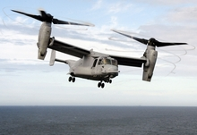
V-22 Osprey. Otherwise known as the “Hawker Harrier Jump Jet”, engineers were developing these tilt-rotor planes that can take off like helicopters. In the Nazis designs they were a one seat war plane with guns and bombing doors attached, meant to land and take off in any terrain. With top speeds of 570 km/h, we were lucky that during an Ally raid, bombing destroyed the prototype by chance.
Land Kreuzers
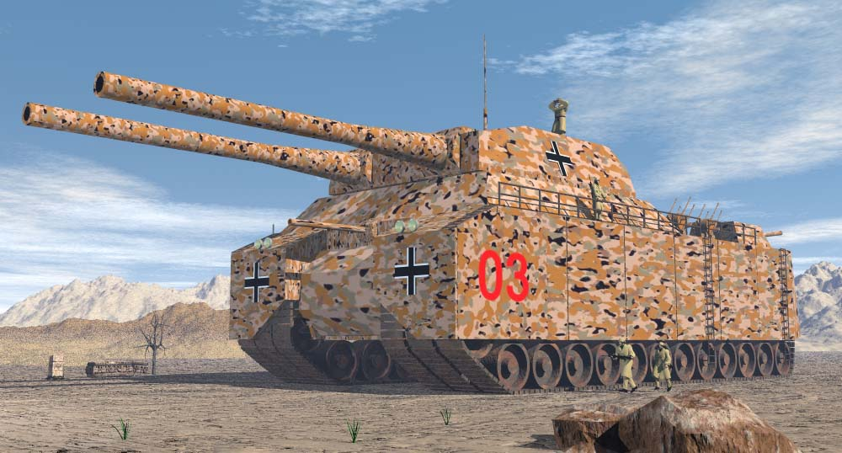
These “Super Tanks” were 4 stories tall, the L1000 was a 140 ton warship on treads. Equipped with a 280mm gun and a 128mm cannon, along with 8 anti-aircraft guns, this super tank was virtually indestructible. The Nazis seriously considered building these, but the materials needed and fuel needed was far too expensive.
Sci-Fi WunderWaffe
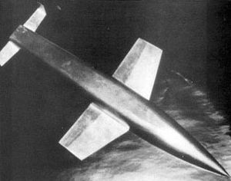
This space based rocket called the “Wunderwaffe” (Silver Bird), was meant to soar into the lower atmosphere at 5000km/h all the way to North America and drop an 8000lb free fall bomb onto the target area which was most likely New York or Washington.

