SS9 Name:_____________________________

Snowshoeing Background

Snowshoes "float" on top of deep snow by distributing the weight of the walker across the surface. Many anthropologists believe a basic snowshoe with this function allowed early humans to migrate across the top of the globe from central Asia to Canada, where Aboriginal groups eventually created and perfect hundreds of snowshoe designs.

Most of Canada's first snowshoes were carved from birch or hard ash that was soaked or steamed to become pliable and then constructed using stretched animal skin and rawhide. The shape, size and materials varied with the trees, animals, snow conditions and terrain within a particular region. All designs were based on the shape of large footed animals (Bear, Rabbits) who easily negotiated the snow.

The first Europeans in Canada – trappers, hunters, explorers and surveyors – also grew to understand the importance of the snowshoe. They were unprepared to survive in areas where snow lay deep throughout the winter and the French, in particular, were quick to intermingle with the Aboriginal groups and learn to make the best use of the snowshoe.

The snowshoe also benefitted the French during their struggle with Britain for dominion in North America. The French victory at the famous 1758 Battle on Snowshoes near Lake George led British military leaders to realize how significant snowshoes were in waging winter warfare. From that time on, the English made snowshoes part of the military's basic equipment.

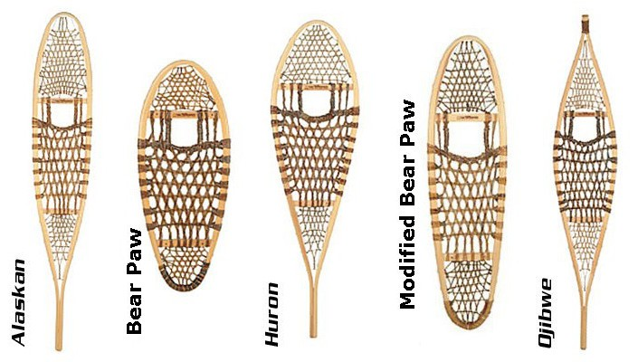

Reflection

1. From your experience, what are some of the challenges (physical, environmental etc.) that Early Canadian explorers would have faced exploring Canada?

2. Did you enjoy the experience? Why/why not? What was your favourite part?

3. How do you think this experience relates to our unit on Explorers, Early Indigenous people and Early Canada? How do you think it will help you understand or connect to the unit better?

4. List one new thing that you learned from the experience.

