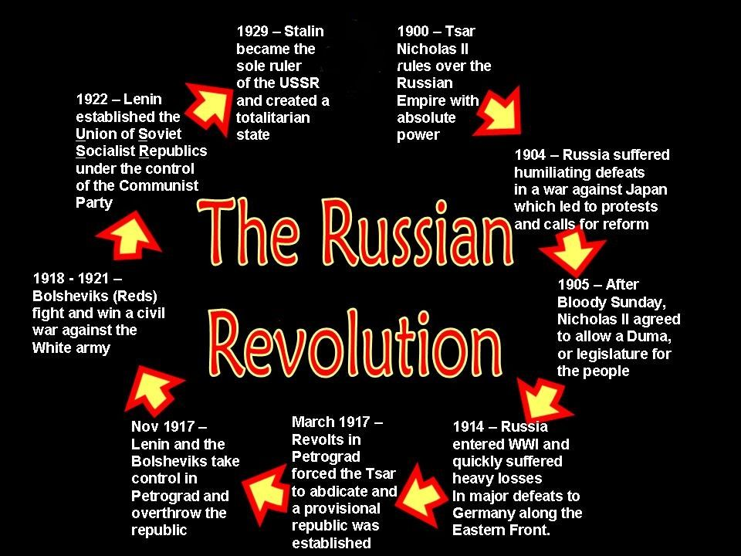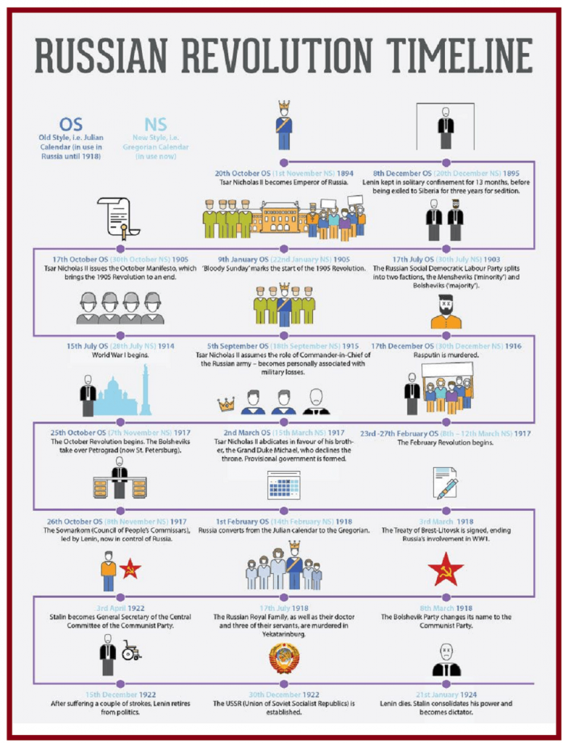

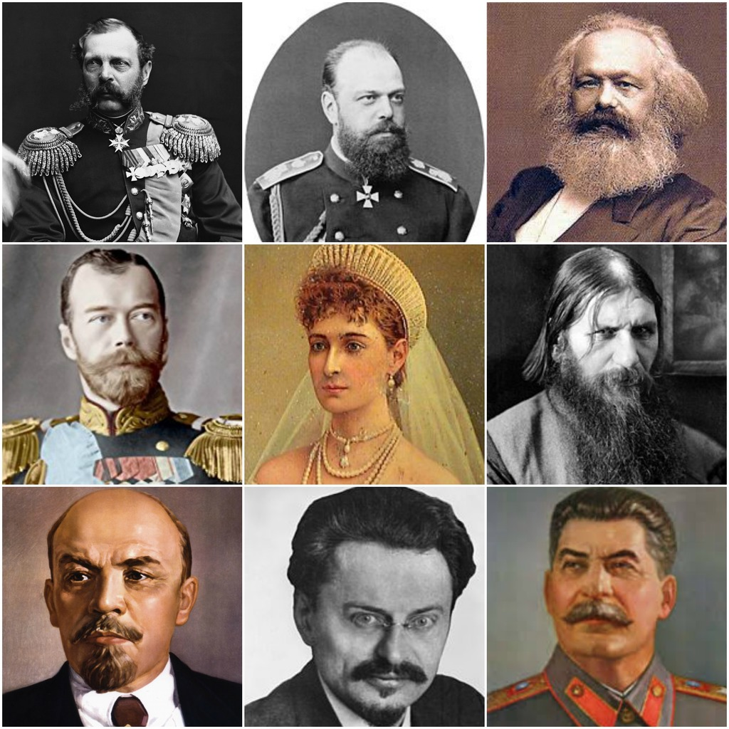

Key Players

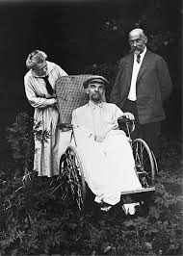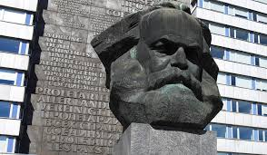

Nicholas II

Key Events Timeline

Kerensky

Rasputin

Key Takeaways

Bolsheviks

Mensheviks

Marxism

**Politics**

Lenin