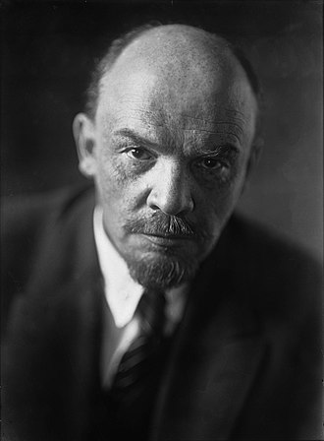 | NAME: VLADIMIR LENIN  FROM: ULYANOVSK, RUSSIA  APPEARANCE: BALD, BROWN HAIR, HAS GOATEE  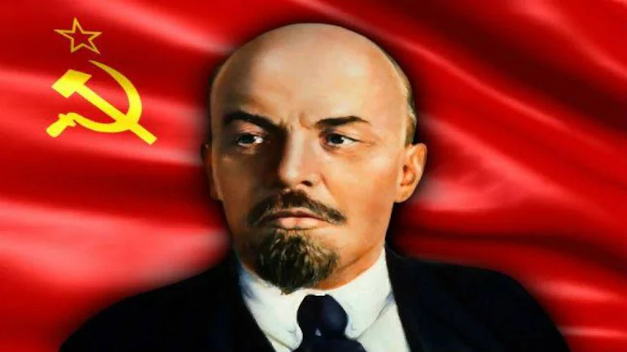

Biography:
Lenin was born in Streletskaya Ulitsa, Simbirsk on April 22, 1870. Vladimir Lenin is the founder of the Bolsheviks, he was a Russian revolutionary and is the leader of the Bolshevik Revolution. He was expelled from Kazan Imperial University for he was involved in the protests against the Tsarist government. His parents were both educated and this helped him to be the same as them too. He then finished his studies and he received his law degree in 1892. His clients were mostly Russian Peasants. Vladimir Lenin suffered a stroke in May 1922 and another one in December 1922. He suffered another stroke on March 10, 1923 which took away his ability to speak. 10 months later, he passed away in the village known as Gorki Leninskiye. His corpse was embalmed and placed in a mausoleum on Moscow’s Red Square.

Significance:
He was the first leader of the USSR and the government that took over Russia in 1917. He served as the head of government of Soviet Russia from 1917 to 1924 and of the Soviet Union from 1922 to 1924. He was a hero because once he took power, he fought with all he was for the country. Vladimir Lenin created the Soviet Union. He was the one who helped Russia to become stable after the revolution. His slogan was peace, bread and land. He would lead the Communists to victory in the Civil War and would rule until his death in 1924. The Bolsheviks helped overthrow the government of Alexander Kerensky. They ended private ownership of land, gave land to peasants to use, and gave workers control of factories and mines. They took land from the Tsar, the church, nobles and other landlords, and redistributed it among the peasants in order to reform the agricultural sector and reward the peasants for their loyalty during the Revolution. Vladimir Lenin seized power and destroyed the tradition of czarist rule. The Bolsheviks were the one who killed the Russian Imperial Romanov family. The Bolsheviks set out to cure Russia of all its injustices that arouse from social class differences.

References:
History - Historic Figures: Vladimir Lenin (1870 - 1924). (n.d.). Retrieved from http://www.bbc.co.uk/history/historic_figures/lenin_vladimir.shtml

Leadership in the Russian Revolution. (n.d.). Retrieved from https://www.britannica.com/biography/Vladimir-Lenin/Leadership-in-the-Russian-Revolution

Resis, A. (n.d.). Vladimir Lenin. Retrieved from https://www.britannica.com/biography/Vladimir-Lenin

Vladimir Lenin. (2020, December 11). Retrieved from https://en.wikipedia.org/wiki/Vladimir_Lenin

Vladimir Lenin. (2020, September 21). Retrieved from https://www.biography.com/political-figure/vladimir-lenin

