Law 12 Name:
Synthesis: In writing, it is combining multiple sources of information (use quotes). If Dr. Philip Zimbardo from the Ted Talk, “The Psychology of Evil” were to view the movie ________________________________ by ____________________________ he would comment on the following three situations:

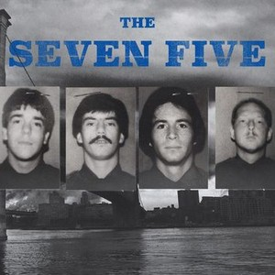
Situation to comment on and what he would say:
Situation to comment on and what he would say:

7-5 or Shawshank!

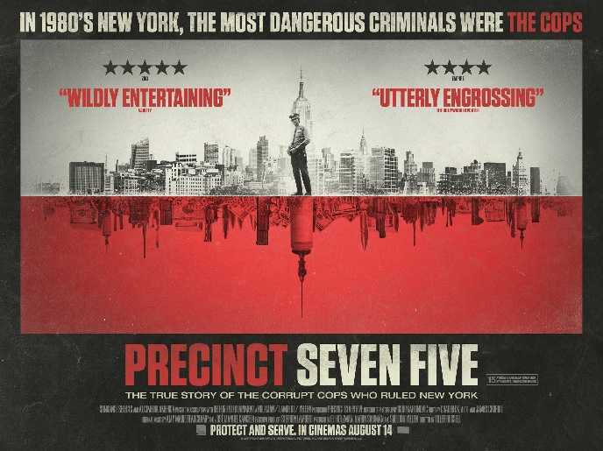
Situation to comment on and what would he say:

Examples, quotes, situations and descriptions from The 7-5 or Shawshank

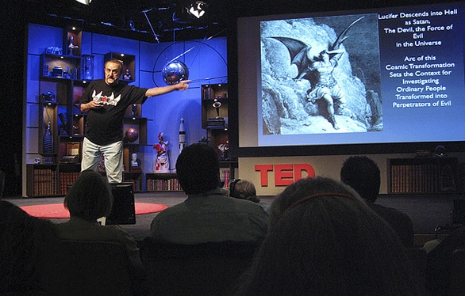

What are key ideas or points made?

What are key ideas or points made?

What are key ideas or points made?

KEY EVENTS TIMELINE
List of Photos/Reports/Newspapers/Psych Reports/Crime Scene Photos/ or other important Primary Sources
List of Cited Sources

Ted Talk Quotes/Ideas

