“Prometheus the Fire Thief” Name: _________________
pg. 152 In Context III Date: __________________

Vocabulary:
Fennel – a tall hollow plant that tastes like licorice /20
Gaff – a strong hook or barbed spear for pulling fish out of water. (7 for questions, 13 for Active reading Questions)
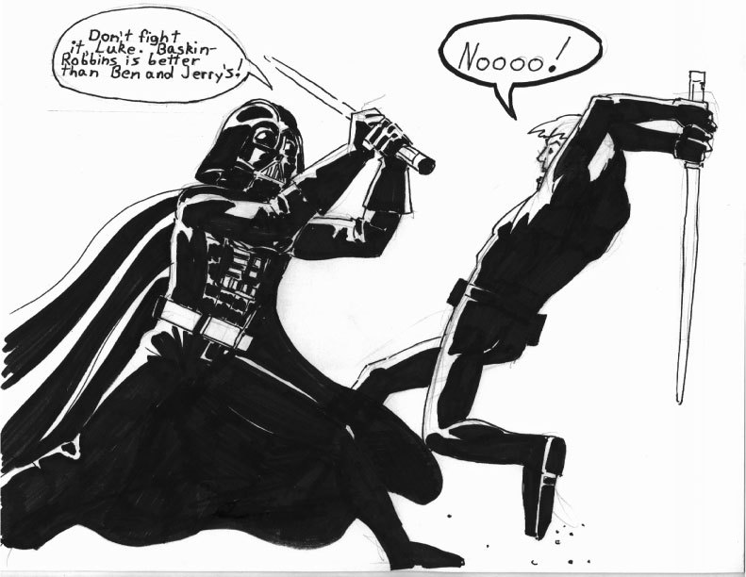
Background: In the battle against the Titans, Prometheus and Epimetheus were brothers who helped Zeus. As a reward, Zeus gave them the task of creating mankind and all the other creatures on Earth. Epimetheus, who name means “after-thought” gave all the animals the best features such as speed, fur for warmth and sharp teeth and when he went to create mankind he had only the worst features left to give them. Therefore, humankind was created with the worst possible features: no fur to keep warm, no sharp teeth to tear uncooked flesh from animals. Zeus hated these ugly creatures and was determined to kill them off, so he took away their ability to think. Promethues, whose name means “fore-thought” felt sorry for these creatures he and his brother had created and was determined to do something.

1. APK: List some movies and stories with the theme of good vs. evil (1)

2. APK: Video clip: Star Wars: Return of the Jedi

3. Background info: Where does the theme of good vs. evil come from? After creation, every culture has a myth where evil is released into the world

Example: Adam and Eve eat the apple in the Garden and are kicked out of Paradise

4. APK: Name some people who have sacrificed personally for the benefit of others. (2)

5. Prediction: Look at the title “Prometheus the Fire Thief,” the pictures in the text and think about what we talked about today. Based on that information, what do you think the story is about? (1)
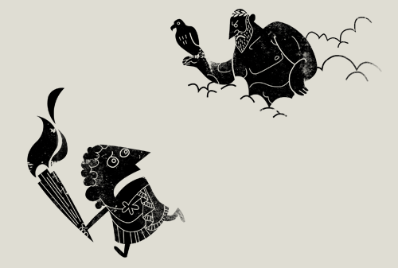

6. Read the questions for the story. (next page)
7. While stop three times and summarize what you are reading in one sentence (3)

1.

2.

3.

8. When you are finished the story, make one connection between the story (themes, plots, conflicts) and your own life. (2)

Questions:
1. Why had Zeus forbidden that humans should have fire? What does this tell you about Zeus’s nature? (2)
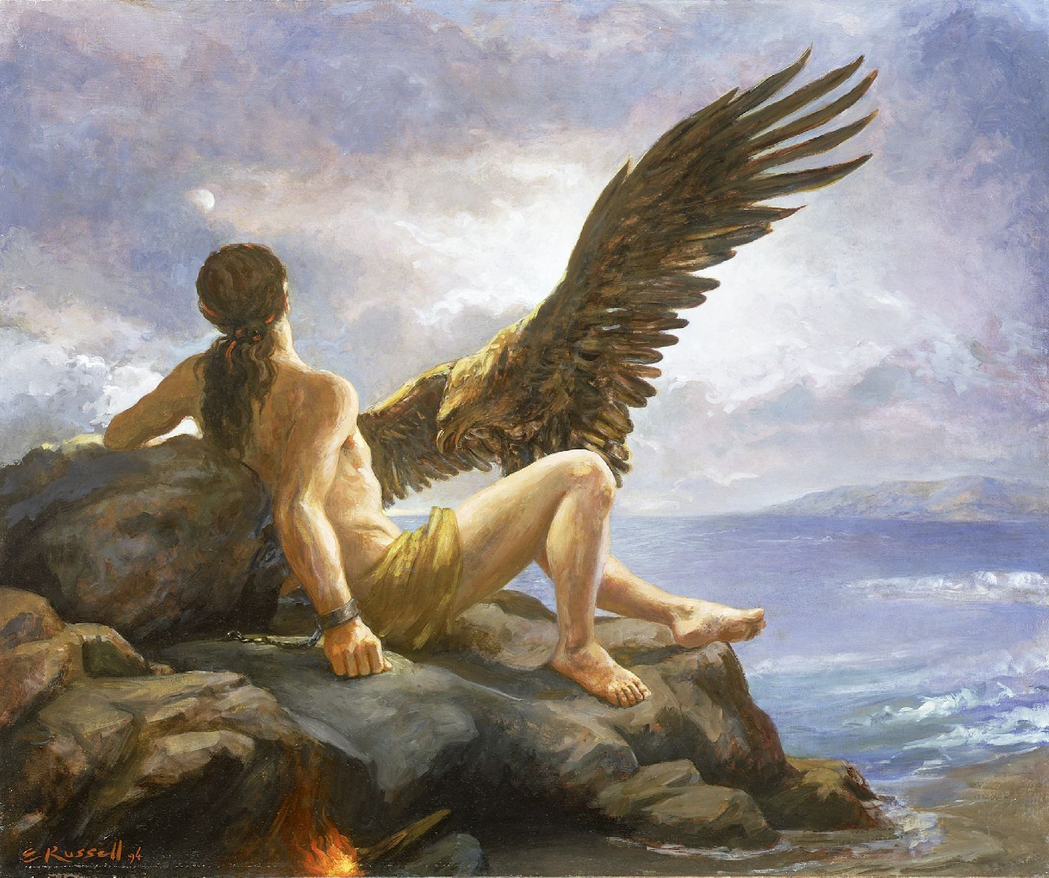

2. What is the theme of this myth? (In other words, what message does is suggest about suffering and self-sacrifice?) (2)

“Pandora” Myths pg. 17
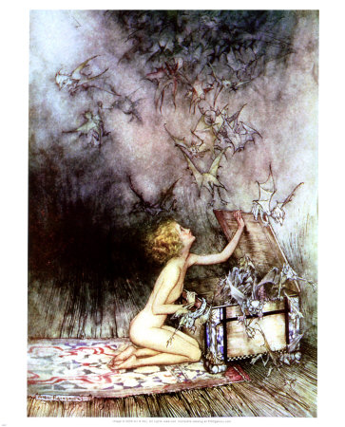
1. Background info: Zeus, angry at Prometheus for stealing fire and thus allowing humans to live, decided to get back at Prometheus through his twin brother Epimetheus by creating a beautiful women he knew Epimetheus would fall in love with and gave her a storage jar with instructions never to open it….

2. Prediction, look at the title, think about the background information and look the text. Make a prediction of what the story is about (1)

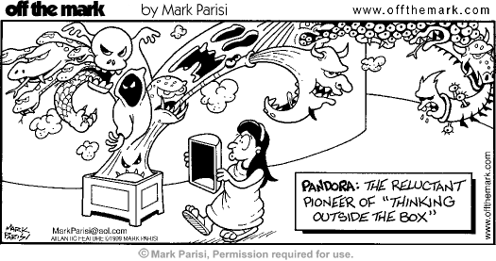
3. Read the questions (below)

4. Write down 2 questions you have while reading the story (2)

1.

2.

5. Summarize the story in one sentence: (1)
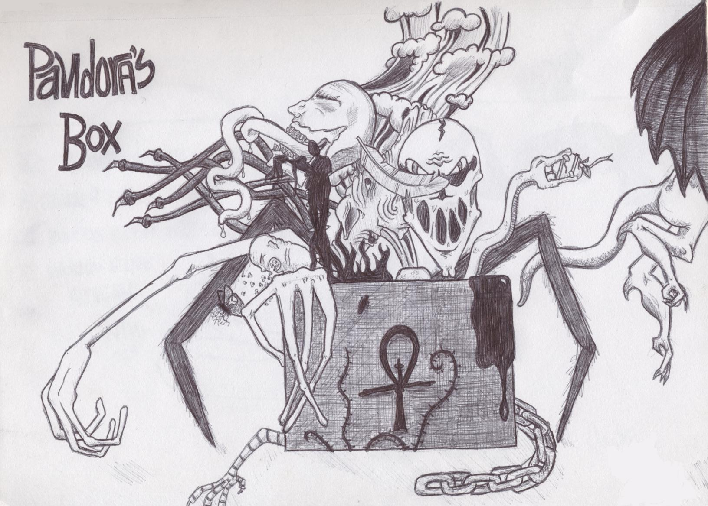

Questions

1. The last form to flutter from the jar was HOPE. How does this comfort the couple? (1)

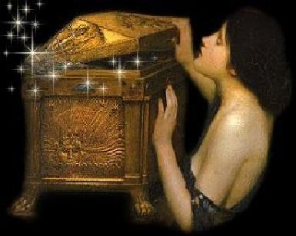

2. State the theme (message) of Pandora in a sentence. (2)

