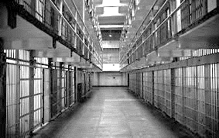
History 12 Name

Shaping Questions:
1. What is the ideal Prison?
2. Where do certain prisons sit on the political spectrum?
3. What is the goal of a Prison? Or a Gulag System?
4. Are there better alternatives than incarceration?
5. What is the impact of this system on the Soviet Union.

A. What do you think the purpose of a prison is (BEFORE UNIT)?

A. What do you think the purpose of a prison is (END OF UNIT)?

Political Spectrum (Please Label)

Libertarian
(less rules)

Economic left Economic right
More taxes, open to changes, No change, less taxes, traditional values

Authoritarian (More rules)

Justifications: Please write a justification for where you have placed each jail / prison on the political spectrum.
Use specific details/quotes/observations to justify your response.
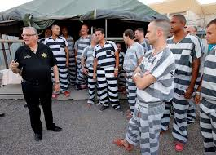
Sheriff Joe’s Maricopa County Prison:

Halden Prison (Most Humane Prison)

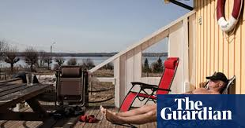
Bastoy Prison (Island)

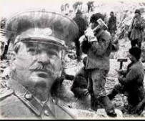
Gulags

What are the most interesting things you learned in this unit about the Gulags?

