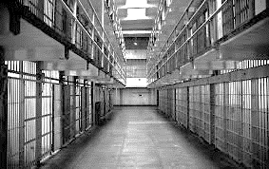
Law 12 Name

Shaping Questions:
1. What is the ideal Prison?
2. Where do certain prisons sit on the political spectrum?
3. What is the goal of a Prison?
4. Are there better alternatives than incarceration?

A. What do you think the purpose of a prison is (BEFORE UNIT)?

A. What do you think the purpose of a prison is (END OF UNIT)?

Political Spectrum (Please Label)

Libertarian
(less rules)

Economic left Economic right
More taxes, open to changes, big gov’t
No change, less taxes, traditional values, less gov’t

Authoritarian (More rules)

Justifications: Please write a justification for where you have placed each jail / prison on the political spectrum.
Use specific details/quotes/observations to justify your response.
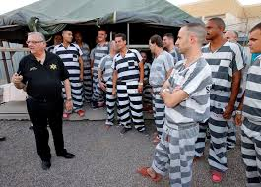
Sheriff Joe’s Maricopa County Prison:

Halden Prison (Most Humane Prison)

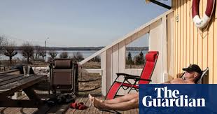
Bastoy Prison (Island)

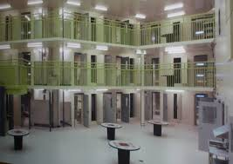
Oliver Correction Center

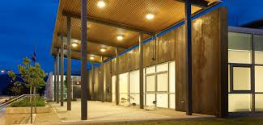
Summerland or Penticton Jail

From whichever documentary we view (World’s Most Dangerous Prisons)

