Mr. Fitton Name:
Prison Break!
/30 MARKS
Law 12 Date:

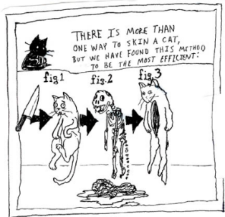
This unit on Comparative Prison Analysis has provided you with a great deal of information in a variety of forms. We have read articles, viewed documentaries, and visited prisons. This is an opportunity for you to develop an Inquiry Question on a topic of choice about Prisons. After developing a question, you will have the ability to research through online journals, documentaries, films, books and other reliable sources. Finally, you will be permitted to share your findings in any way that showcase’s your talents.
DUE DATE: The completed project is due on ___________________.

You should be half done and show Mr. Fitton on _____________

Some Suggest Project Ideas (you can present in any way you want!):
Unit Mind Map / Pictorial Matrix
-Draw a Matrix or artistic piece that shows your knowledge
-Include Key terms and points
-Pictures or Drawings
-Must demonstrate an argument/research
-Needs proper citation
-Reveals a depth of understanding enhanced by your artistic abilities.
Create A Term Paper
- Research several articles on a topic of your choice
-Create and refine a thesis
-Follow proper format of a term paper
-Use the University of Ottawa History Student handbook to guide you
-Proper use of quotes/citations
-800-1500 words maximum.

What will help you in your Career?
-In this class we have future police officers, nurses, lawyers, army personnel, secretaries, parents, construction workers, etc.
-Create your own type of demonstration of learning where you research and present in a way that will help you gain skills / present knowledge in a way you would in your future career. (Police report, Doctors notes…. Etc)

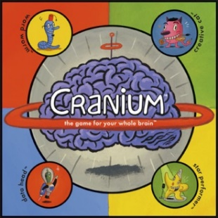
Video/Animation /Anything
- Create a video newscast, Rick Mercer Rant, Horrible Histories, Histeria, or anything using the medium of video that helps you articulate your research and viewpoints.
-Must reveal grade 12 level of research
-Must somehow include citations
-Must demonstrate a superior level of understanding.

Science Fair Poster
- Create a research project poster
- Must contain a relevant thesis
- Must display variety of arguments / viewpoints about the topic
- Must synthesize various viewpoints and eventually reveal important conclusions
-Aesthetically appealing
-Requires evidence of research/citations
Documentary
-Using film or pictures gathered from the internet, create a documentary with an overdub that explains the your argument; Draw my life
-Post to youtube for final evaluation.
-You may download and show archival footage or re-enact key scenes yourself.
-Should include citations
Design a Prison
-Use autocad, or your own artistry to design a prison
-Design menus, programs, and/or the building itself.
-Showcase what you would include in an ideal prison based on rehabilitation or if you want, a punishment model.
-Be as creative as you want
-Include research and explanations of your choices.

These are only a few suggestions.
You may show your learning in an alternate fashion (ie. police report, radio show, Rick Mercer Rant, Crash Course in History, Epic Rap Battle of History, Podcast, Musical Score or any idea you have, but consult with me first and I will be happy to discuss the viability of your idea. Some students have even researched a week in the life of a prisoner and then lived like one – their diet, exercise regime, sleep regime, locked themselves in their room for a certain time…this is called “Gonzo Journalism.”
Inquiry Assignment
Correctional Service Canada / Or Other Correctional Centers/ Prison Topic

Select Topic (what about prisons intrigues you or makes you curious)

Select one or two aspects of the prison you would like to investigate.
Examples: living conditions, food, health care, education programs, work programs, visiting rights, security, statistics, women in prison, solitary confinement, LGBT rights in Prisons, Impact of Gardens or Pets on inmates, Comparisons with USA or elsewhere… the sky is the limit!

Develop your 2 or 3 inquiry questions; You’ll end up focusing on ONE, but have extra in case one doesn’t work out!

Research (Academic Journals, Netflix Documentaries, Online, Books, etc)

Organize your findings – You may use the inquiry chart provided. Strive to document your research in a way that works for you so you are prepared for post-secondary. Organization is key.

Decide how you will share your findings and your personal thoughts on your findings. What will be the format you will share you info in – See options on assignment

Share your presentation

ASSESSMENT :
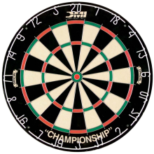
Tips to stay on target: Think of your topic Read textbook or articles on that topic Create a driving question Find academic articles / newspaper articles / documentaries to support highlight examples to support your points start the writing / creative process Done!

Assessment: Due to the extremely personalized nature of this assignment and due to the variety of choices of expression, it is incredibly difficult to assess. As a result we will be using a 6-point generalized scale.

6
A relevant thesis (argument) is evident and clearly developed throughout the project/paper
Superior use of factual content; organized in a purposeful and effective manner
Precise selection of supporting details; evaluation/analysis is exemplary; a polished and professional product
Expression is clear and fluent; errors may be present but do not interfere with meaning
Proper Bibliography in APA format; no errors

5
A relevant thesis (argument) is evident and provides direction throughout the project/paper
Proficient use of factual content; organized in a clear and thoughtful manner; a very good product
Accurate selection of supporting details; evaluation/analysis is sound
Expression is generally fluent; errors may be present but do not interfere with meaning
Proper Bibliography in APA format; minor errors

4
A relevant thesis (argument) is evident
Competent use of factual content; organized in a purposeful manner
Appropriate selection of supporting details; evaluation/analysis is satisfactory, but basic; product is rough/silly/amateurish
Expression is generally fluent; errors may impede meaning at times (some sections unclear due to writing)
Proper Bibliography in APA format; a few errors

3
A relevant thesis (argument) is attempted, but unclear
Adequate use of factual content; organization attempted or parts organized, but parts disorganized; product is draft-like
Simplistic selection of supporting details; evaluation/analysis is weak, or at times there is a lack of evaluation/analysis
Expression is simplistic; errors impede meaning
Attempts bibliography; many errors

2
A relevant thesis is absent, inaccurate or student has simply listed their topic
Limited recall of factual content; lack organization or disorganized in many places
Inappropriate selection of supporting details; Inaccurate supporting details, evaluation/analysis are absent; limited effort
Expression is flawed and errors impede meaning
Bibliography is just a list of sources in no format

1
A relevant thesis is absent
Deficient recall of factual information; lacks organization
Absence of supporting details; product is far below grade expectations
Expression is unclear and makes understanding difficult
No bibliography.

0
Writing is evident, but no attempt has been made to discuss/argue an event from the cold war era
Plagiarized; product is not meeting grade expectations in the least s
Cut and Pasted information from the internet is all that is provided

