Communications 11 / 12 Name: ____________________

1. Please watch the video for “Not Ready to Make Nice” by the Dixie Chicks. List all the images that you think are symbols and then briefly explain what you think they symbolize

“Not Ready To Make Nice” The Dixie Chicks
Forgive, sounds good
Forget, I’m not sure I could
They say time heals everything
But I’m still waiting
I’m through with doubt
There’s nothing left for me to figure out
I’ve paid a price
And I’ll keep paying
Chorus:
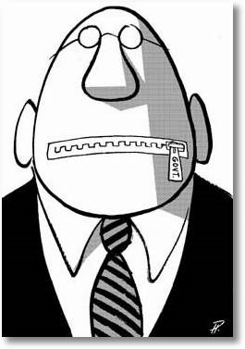
I’m not ready to make nice
I’m not ready to back down
I’m still mad as hell and
I don’t have time to go round and round and round
It’s too late to make it right
I probably wouldn’t if I could
‘Cause I’m mad as hell
Can’t bring myself to do what it is you think I should
I know you said
Can’t you just get over it
It turned my whole world around
And I kind of like it
I made my bed and I sleep like a baby
With no regrets and I don’t mind sayin’
It’s a sad sad story when a mother will teach her
Daughter that she ought to hate a perfect stranger
And how in the world can the words that I said
Send somebody so over the edge
That they’d write me a letter
Sayin’ that I better shut up and sing
Or my life will be over
Chorus (x2)
Forgive, sounds good
Forget, I’m not sure I could
They say time heals everything
But I’m still waiting

2. “Mad as hell” is an example of a
a. hyperbole b. alliteration c. symbol d. free verse

3. “I made my bed” is an example of
a. alliteration b. rhyme c. cliché d. simile

4. “Not ready to make nice” is a metaphor for:
a. being friendly b. apologizing c. giving up d. hesitating

5. Sleep like baby is an example of
a. personification b. metaphor c. simile d. allusion

6. “paid a price” is an example of
a. personification b. alliteration c. simile d. metaphor

While listening to the poem below, identify as many poetic devices as you can by circling and writing in margins

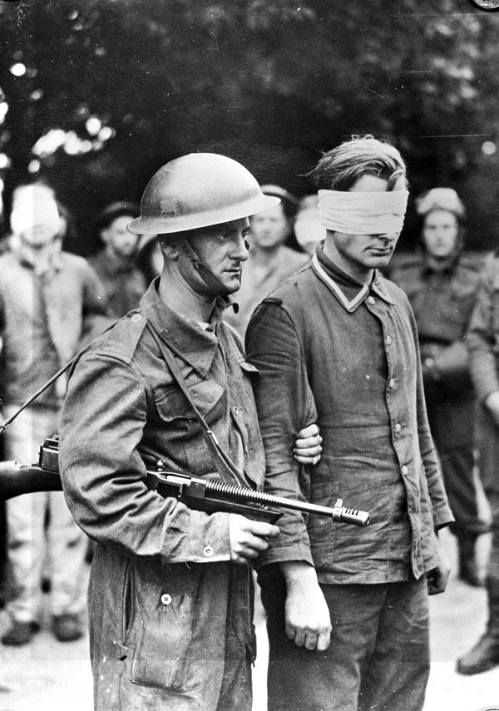
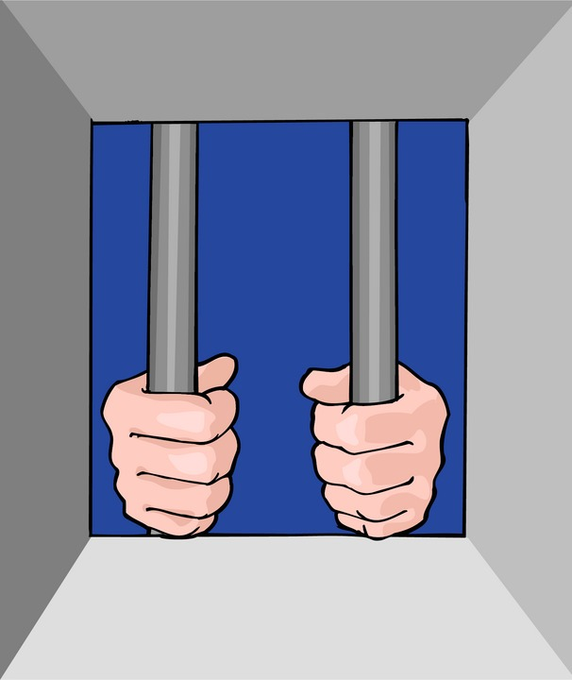
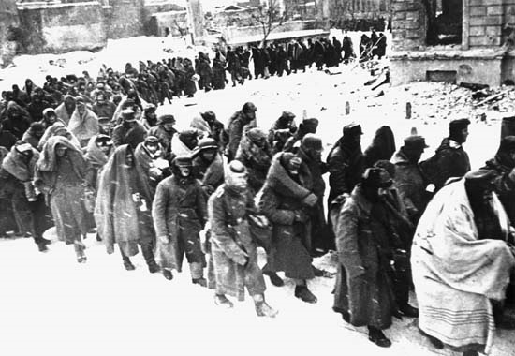
“P.O.W” By Alicia Keys
I'm a prisoner
Of words unsaid
Just lonely feelings
Locked away in my head
I trap myself further
Every time I stay quiet
I should start to speak
But I stop and stay silent
And now I've made
My own hard bed
Inside a prison of words unsaid
I am a P.O.W.
Not a prisoner of war
A prisoner of words
Like a soldier
I'm a fighter
Yet only a puppet
Mostly I only say
What you wanna hear
Could you take it if I came clear?
Or would you rather see me
Stoned on a drug of complacency and compromise
M.I.A.
I guess that's what I am
Scraping this cold earth
For a piece of myself
For peace in myself
It'd be easier if you put me in jail
If you locked me away
I'd have someone to blame
But these bars of steel are of my making
They surround my mind
And have me shaking
My hands are cuffed behind my back
I'm a prisoner of the worst kind, in fact
A prisoner of compromise
A prisoner of compassion
A prisoner of kindness
A prisoner of expectation
A prisoner of my youth
Run too fast to be old
I've forgotten what I was told
Ain't I a sight to behold?
A prisoner of age dying to be young
To my head is my hand with a gun
And it's cold and it's hard
Cause there's nowhere to run
When you've caged yourself
By holding your tongue
I'm a prisoner
Of words unsaid
Just lonely feelings
Locked away in my head
It's like solitary confinement
Every time I stay quiet
I should start to speak
But I stop and stay silent
And now I've made
My own hard bed
Inside a prison of words unsaid
2. Identify the theme of either Not Ready to Make Nice or POW.
-Remember to write a full theme statement.
-List 2 quotes that support the theme and explain how they back it up.

Theme statement:

Quote 1 to support:

Quote 2 to support:

