Fitton Name ___________________________
Socials 11
Population and Demography Notes
Demography – the study and analysis of ________________________________________________

Census – ________________________________________________________. Used by a demographer to answer where and why questions. (Canada conducts a detailed one every 10 years and a less detailed one every 5 years). Rarely completely accurate (people without permanent addresses / people avoid to avoid tax inquiries / some countries have many unrecorded births and deaths / illiteracy.

According to our census… ________________ is Canada’s largest and most populated city (more than 6 million). The Windsor to Quebec City corridor contains our largest cities (_____________________________________________________________), therefore the majority of our population and industry

Population Density – the concentration of people living in a geographic area. To calculate:

Factoids!
*Singapore, an almost entirely urban nation, has over 6000 ppl/km² *Bangladesh has more than 1000 people/km²
*Canada has approximately 3 people/km² *BC has approximately 4.2 people/km²
*The city of New York has more than 10 000 people/km² *Downtown Vancouver has over 20,000 ppl/km²

Vital Statistics – _______________________________________________________________________

By recording these, communities can plan and allocate resources.

Fertility Rate:

Birth Rate:

Mortality – death rate

i.e. In 2004 there were 233, 087 deaths in Canada, while the nation’s population recorded at 31 946 316. Through mathematics we figure the death rate at approximately 7%.

The birthrate combined with the death rate affects the _________________________________
____________________. This helps us understand population structure.

Population structure – ______________________________________________________________

Cohort group - _____________________________________________________________________

Population change – ________________________________________________________________

__________________ –Process of people moving to another country/region from their country of origin

__________________– Process of people moving away from their country/region of origin.

Factoids!
→In 2003, BC experienced a net increase of 1,037 inter-provincial migrants
→In 2004, BC experienced a net increase of 7,333 inter-provincial migrants.
→In 2003, AB experienced a net increase of 11,903 inter-provincial migrants.
→In 2004, AB experienced a net increase of 10,902 inter-provincial migrants.
→In 2003, ONT experienced a net increase of 637 inter-provincial migrants
→In 2004 ONT experienced a net decrease of 8,793 inter-provincial migrants to other provinces
→In 2003 NFLD experienced a net decrease of 1,683 inter-provincial migrants to other provinces
→In 2004, NFLD experienced a net decrease of 1,980 inter-provincial migrants

Population Growth Rate – First, determine the net migration rate -

Then, add the migration rate to the rate of natural increase.

Doubling Time: The time it takes for a population to double. To calculate:

This means that with a current growth rate of 0.9%, Canada’s population will double in about 78 years. This is assuming that no changes occur in immigration rate or fertility rates.

Demographic Transition Model
Pre Transition (Stage 1)

Early Transition (Stage 2)

Middle Transition (Stage 3)
-low death rates / rapidly declining birth rates
-social programs, industrialization and urbanization eliminate need for large families

Late Transition (Stage 4)
--rates of natural increase have stabilized
-low birth and death rates = low growth
-changing role of women + family planning

Future Transition (Stage 5)

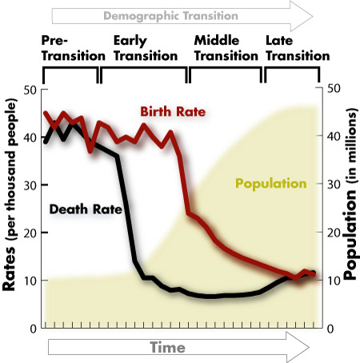

Population Pyramids – 4 categories!

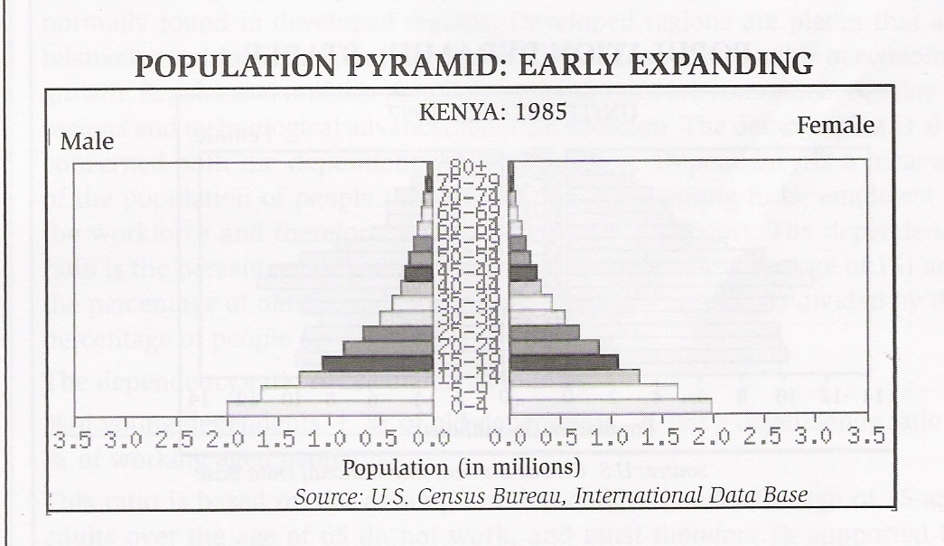
Early Expanding

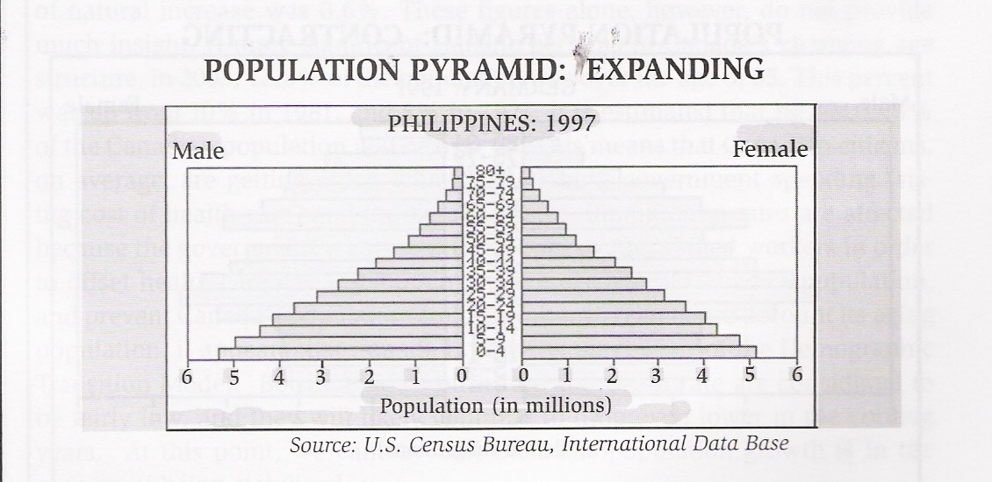

Expanding
-very wide base (high birth rate)
-the cohort groups begin to enlarge or increase towards the middle of pyramid
-this widening comes from: improved medical care, modern hygiene and improved diets.
-results in a decreased death rate

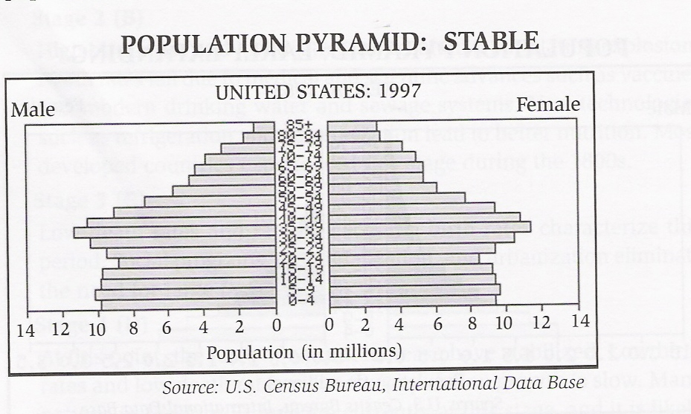

Stable

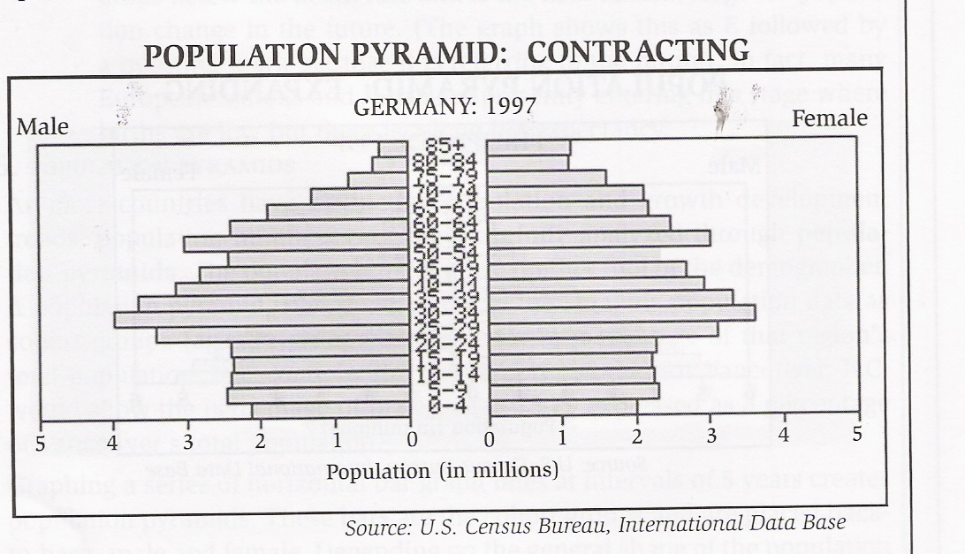

Contracting
-birth rate reaches very low levels (women employed in workforce, child-rearing is expensive, contraceptive programs are successful, small families are encouraged by the state)
-death rate continues to decrease
-life expectancy rises.

The demographer is also concerned with the dependency ratio. This shows the percent of the population that is too young or old to be employed, and therefore require governmental support. (Young dependents are below age of 15, old dependents are above the age of 64).
Dependency Ratio is calculated as follows:

Mr. Fitton TEACHER KEY TO STUDENT SHEET Name ___________________________
Socials 11
Population and Demography Notes
Demography – the study and analysis of Population and Numbers.

Census – the formal counting of people in a particular region or space. Used by a demographer to answer where and why questions. (Canada conducts a detailed one every 10 years and a less detailed one every 5 years). Rarely completely accurate (people without permanent addresses / people avoid to avoid tax inquiries / some countries have many unrecorded births and deaths / illiteracy.

According to our census… TORONTO is Canada’s largest and most populated city (more than 6 million). The Windsor to Quebec City corridor contains our largest cities (Windsor, London, Hamilton, Toronto, Ottawa, Montreal and Quebec), therefore the majority of pop & industry
Population Density – the concentration of people living in a geographic area. To calculate:
Total # of people living in an area
Actual area the people occupy = density

i.e. 10 000 inhabitants
100 square km = 100 people per square kilometer

Factoids!
*Singapore, an almost entirely urban nation, has over 6000 ppl/km² *Bangladesh has more than 1000 people/km²
*Canada has approximately 3 people/km² *BC has approximately 4.2 people/km²
*The city of New York has more than 10 000 people/km² *Downtown Vancouver has over 20,000 ppl/km²

Vital Statistics – population #s that record births, deaths & other significant population related #s.
By recording these, communities can plan and allocate resources.
Fertility Rate: to calculate: total live births x 1000 (avg # of kids per woman in their
Total population lifetime. Ie: Canada: 1.52)
Birth Rate: # of births per 1,000 people.

Mortality – death rate to calculate: total deaths x 1000
Total population

i.e. In 2004 there were 233, 087 deaths in Canada, while the nation’s population recorded at 31 946 316. Using math, we figure the death rate at approximately 7%.

The birthrate combined with the death rate affects the rate of natural increase.
This helps us understand population structure.

Population structure – refers to general make-up of a pop as well as different age groups.
Cohort group - age–sex group in a country/area (males aged 5-9 in Vancouver, B.C.)

Population change – changing or altering make-up of a population over a period of time.

Immigration –Process of people moving to another country/region from their country of origin

Emigration – Process of people moving away from their country/region of origin.

Factoids! →In 2003, BC experienced a net increase of 1,037 inter-provincial migrants
→In 2004, BC experienced a net increase of 7,333 inter-provincial migrants.
→In 2003, AB experienced a net increase of 11,903 inter-provincial migrants.
→In 2004, AB experienced a net increase of 10,902 inter-provincial migrants.
→In 2003, ONT experienced a net increase of 637 inter-provincial migrants
→In 2004 ONT experienced a net decrease of 8,793 inter-provincial migrants to other provinces
→In 2003 NFLD experienced a net decrease of 1,683 inter-provincial migrants to other provinces
→In 2004, NFLD experienced a net decrease of 1,980 inter-provincial migrants

Population Growth Rate – First, determine the net migration rate -
***(Immigration rate) subtract (emigration rate) = net migration rate

Then, add the migration rate to the rate of natural increase.
***(Birth rate) minus (death rate) plus (net migration rate) = population growth rate

Doubling Time: The time it takes for a population to double. To calculate:
70 = # of years for population to double
% rate of population growth

This means that with a current growth rate of 0.9%, Canada’s population will double in about 78 years. This is assuming that no changes occur in immigration rate or fertility rates.
Demographic Transition Model
Pre Transition (Stage 1)
-high birth and death rates
-small population growth
-disease/malnutrition = high infant mortality rates
-low life expectancy
-common in some developing nations

Early Transition (Stage 2)
-high birth rates / low death rates
-population EXPLOSION!
-death rates fall due to medical advance (vaccine/sewage/drinking water systems)
-most developed countries reached this stage during the 1800’s

Middle Transition (Stage 3)
-low death rates / rapidly declining birth rates
-social programs, industrialization and urbanization eliminate need for large families

Late Transition (Stage 4)
-rates of natural increase have stabilized
-low birth and death rates = low growth
-changing role of women + family planning

Future Transition (Stage 5)
-birth rate drops below death rate
-long life expectancy

Population Pyramids – 4 categories!

Early Expanding
-wide base (high birth rate)
-decrease towards the top (very short life expectancy)
-few, if any countries are currently classified in the early expanding stage
-note the date is 1985!

Expanding
-very wide base (high birth rate)
-the cohort groups begin to enlarge or increase towards the middle of pyramid
-this widening comes from: improved medical care, modern hygiene and improved diets.
-results in a decreased death rate

Stable
birth rate falls because of changing attitudes towards family and family sizes
-education, changing societal attitudes and economic factors can cause this decline
-medical care continues to improve so the death rate continues to fall

Contracting
-birth rate reaches very low levels (women employed in workforce, child-rearing is expensive, contraceptive programs are successful, small families are encouraged by the state)
-death rate continues to decrease
-life expectancy rises.

The demographer is also concerned with the dependency ratio. This shows the percent of the population that is too young or old to be employed, and therefore require governmental support. (Young dependents are below age of 15, old dependents are above the age of 64).
Dependency Ratio is calculated as follows:
% of young dependents + % of old dependents X 100 = dependency ratio
% of working aged people

