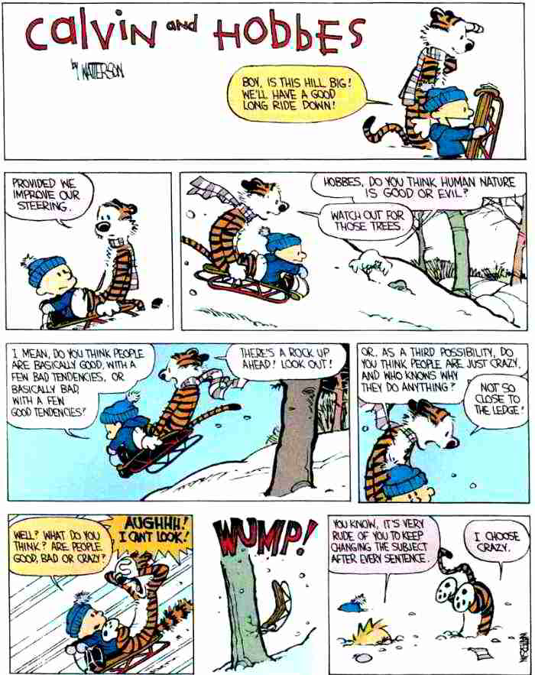

All are lunatics, but he who can analyze his delusion is called a philosopher.
-Ambroise Briose

The point of philosophy is to start with something so simple as not to seem worth stating, and to end with something so paradoxical that no one will believe it.
-Betrand Russell

Philosophy: unintelligible answers to insoluble problems.
-Henry Adams

