The Boston Tea Party

Following the Seven Years War England went through a serious financial crisis

Taxes were imposed on many products to raise money

The colonists organized a boycott campaign.

Many newspapers published a declaration renouncing tea.

The colonists replaced tea with contraband tea imported mostly by Dutch merchants.

The East India Company decided to export cargoes of tea to America, intended for sale directly to the colonists, without going through the merchants.

In December, three of the company's ships, the Dartmouth, Eleonor, and the Beaver reached port in Boston.

During the night of December 16, a group of 150 patriots led by the merchant John Brown, took the boats by force and threw their cargo into the sea.

In return, London forbade all commerce with Boston.

The other American cities joined in a united front, burning or throwing into the sea other English cargoes of tea.

Tea became a symbol of the intolerable relationship between colonies and mother country.

After independence, many Americans remained faithful to coffee, and the consumption of tea would never be popular again.

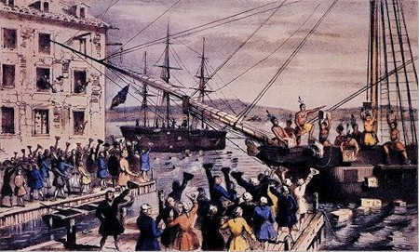

Socials 9 Name ___________________________

DISCONTENT IN AMERICA
Fill in the following boxes by reading P. 300-306
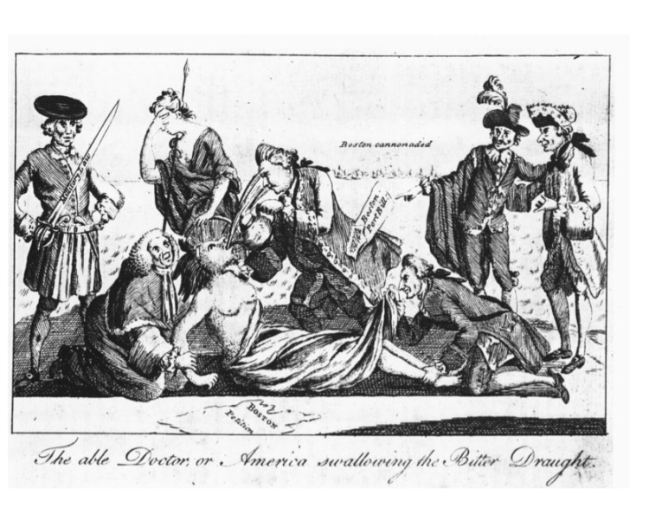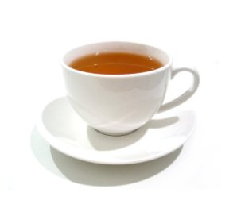
Intolerable Acts
Quebec Act:

Stamp Act:
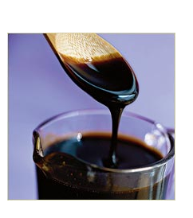

Sons of Liberty
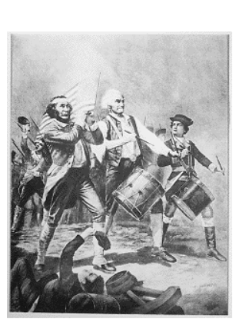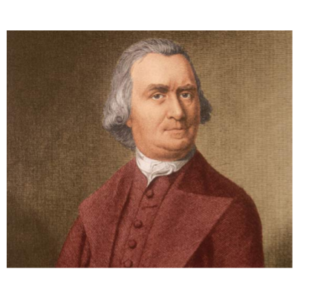

Boston Massacre & Boston Tea Party
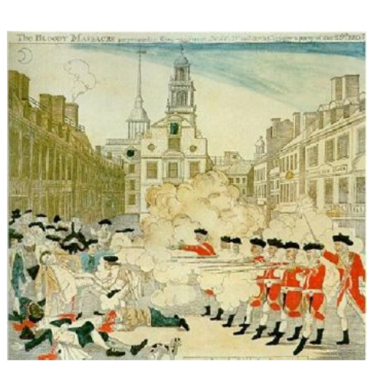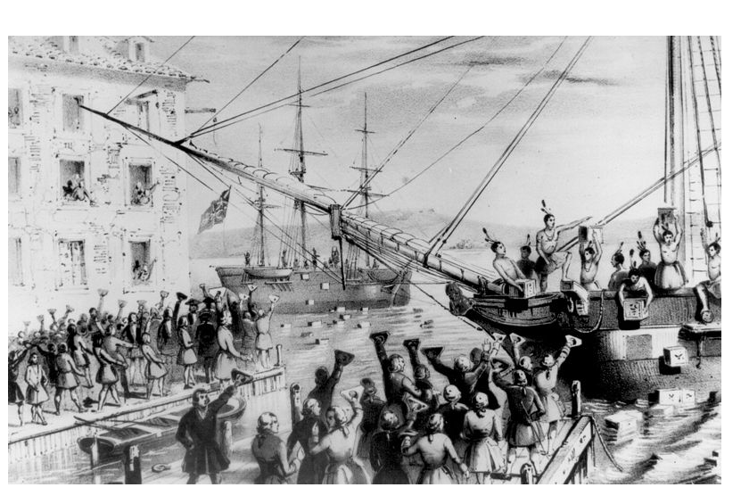

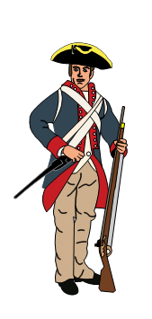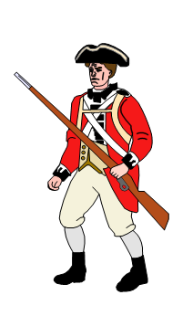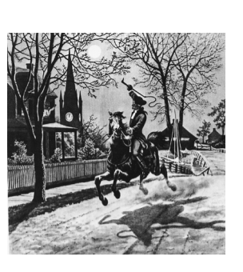
Beginnings of a Revolution

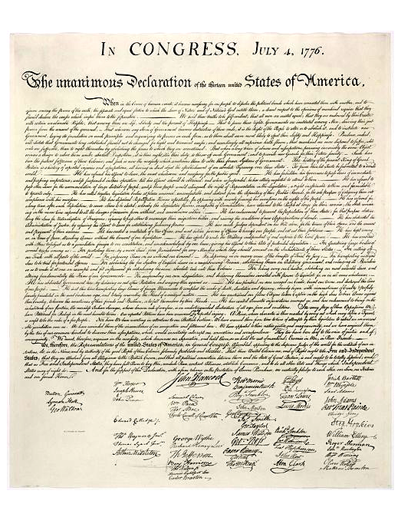

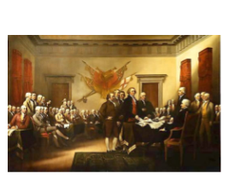
Declaration of Independence

Socials 9 Name ___________________________

ANALYZING DOCUMENTS FROM THE AMERICAN REVOLUTION

Use the following art sources to answer the questions.
This British cartoon, depicting the Intolerable Acts as an assault upon a Native American woman (a symbol of the American colonies), was copied and distributed by Paul Revere

1. Is this a primary or secondary source? Justify your answer.

2. Identify any bias in this political cartoon.

This engraving, depicting British soldiers firing upon a rioting Patriot crowd in Boston, was created by Paul Revere.

1. Is this a primary or secondary source? Justify your answer.

2. Identify any bias in this source.

