Socials 9 Name ___________________________

Mr. Fitton

**THE ENGLISH CIVIL WAR – UNIT OUTLINE**

**Terms that will become more familiar:**

**People Groups Events/laws Ideas Governments**

Charles I Whigs Magna Carta Treason Constitutional Monarchy Archbishop Laud Tories Blue Laws Abdication Absolute Monarchy

Colonel Pride New Model Army Court of Star Chambers Colonization Republic

Oliver Cromwell Roundheads Civil War Militia Tyrant

Matthew Hopkins Catholic Seditious Libel Entrepreneur Democracy

Walter Prynne Puritan Restoration Civil Rights Parliament

James I Papists Ship Money Pillory

Charles II Royalists Tonnage and poundage Broadsides

Lord Stratford Cavaliers Bloody Assizes Revolution

Protestants Colonization

Presbyterian Drawn & quartered Regicides

**Intended Learning Outcomes**

1. You will be able to describe the main events of the English Civil War, Commonwealth and Glorious Revolution

2. You will be able to describe life in 17th Century England

3. You will be able to see that democracy has not always existed but has come about as a result of struggle and bloodshed.

4. You will be see how our laws/customs came from England

5. You will understand how different religions caused tension in 17th century England

**Textbook Readings:**

1. “Crossroads: A Meeting of Nations” chapter 2 (pages 13 – 49)

**Tasks to be completed:**

1. Chapter questions 5. Civil War quizzes

2. Mapping Great Britain 6. Civil War Trial

3. Civil War Podcast/Song 7. Civil War Active Study Review

4. Civil War Unit Test 8. Analyzing Propaganda

**CHAPTER 2 QUESTIONS – “CROSSROADS”**

1. Describe how the **Magna Carta** was important in contributing to democracy. (19)

2. Describe the extent to which England established colonies and how they helped England gain wealth. (20)

3. Describe the 3 classes that existed in English society. (21)

4. Describe the differences that existed in the diets of the rich and poor in England (23)

5. What were some of the different beliefs held by Catholics compared to Protestants? (26)

6. What sort of women came under suspicion as being witches? (27)

7. Who made up the **House of Commons**? The **House of Lords**? (29)

1. What was the **Divine Right of Kings?** (29)
2. Characterize James I. (page 30)
3. List the ways that Charles I attempted to raise money for himself (page 32)
4. What was the punishment for **seditious libel?** (32)
5. Why were both Strafford and Laud unpopular with the people? (33)
6. Why did Charles I shut down his **“Short Parliament”**? (34)
7. What was the **Grand Remonstrance** that the Long Parliament wanted to pass? (34)
8. How was Queen Henrietta Maria involving herself in the King’s plans to wage war? (35)
9. Define the term **Civil War.** (35)
10. Describe Oliver Cromwell’s **New Model Army**. (36)
11. What is a **republic**? (42)
12. How did Cromwell treat the Presbyterians and Catholics that he had conquered? (42)
13. What did the Calvinist **Blue Laws** outlaw? (44)
14. Who were the **Tories**? (45)
15. Define the term **regicide.** What happened to them? (45-46)
16. Which group did the **Test Act** restrict? (46)
17. What actions by James II caused rebellions to break out in England? (47)
18. What did Mary and William have to agree to upon receiving the crown of England? (47)

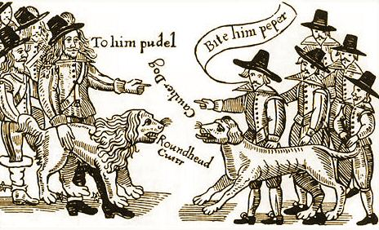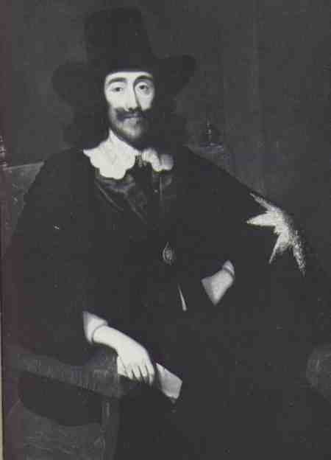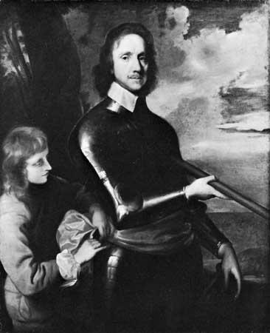

Charles 1

Oliver Cromwell