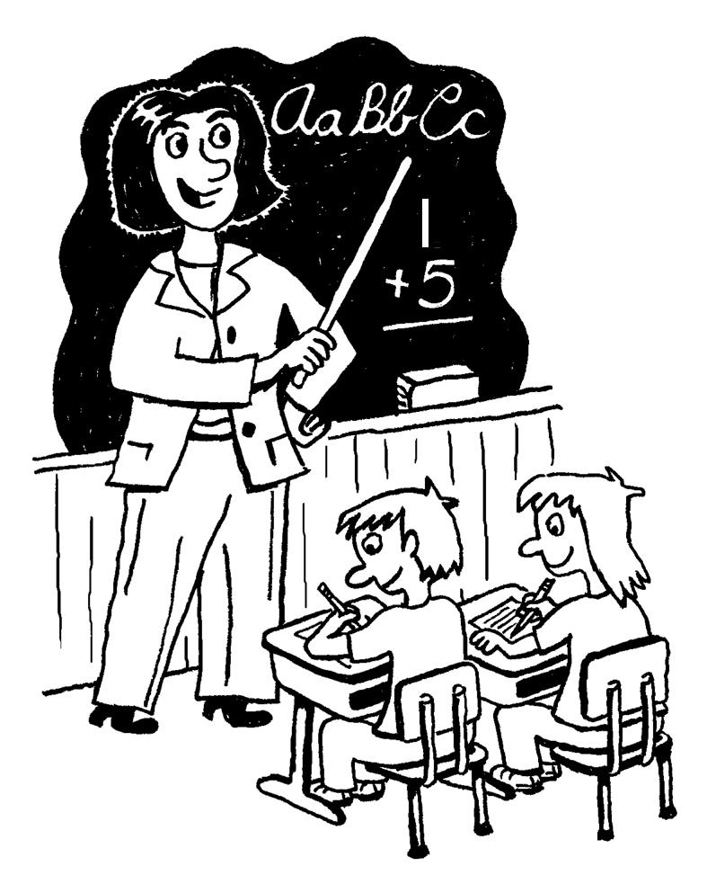
Five in One

Name:

Date:

Assignment
A Five in One requires you to combine several skills on one page. Students must demonstrate ability to: recall facts, think critically and display creatively. After reading a work of literature or viewing a film, think of the main idea or moral of the story. This is the theme. To begin, write down the theme on a piece of blank white paper. You may write it anywhere you choose. Second, write out a quotation from the story that relates to the theme you’ve selected. Third, draw an image that relates to the main idea. Fourth, think of an original title. Fifth, write a concise 150-word Justification detailing how your Five in One connects (how does the quote connect with theme? How does the title connect with theme? How does your image connect with theme?). Et Voila

Step-by-Step Instructions (check off as you complete the assignment)

1. Chose a theme and write it somewhere on a piece of blank paper. Make sure it is a proper theme statement (The theme of __________________________by ______________________________ is that):

Theme: The theme of “The Monkey’s Paw by W.W. Jacobs is people should be content with what they already have.

2. Choose a quote that backs up that theme __________ and write it somewhere on the piece of paper, remember to cite it properly:

Quote: “"I wish for two hundred pounds," said the old man distinctly. A fine crash from the piano greeted the words, interrupted by a shuddering cry from the old man. His wife and son ran toward him. "It moved, he cried, with a glance of disgust at the object as it lay on the floor. "As I wished it twisted in my hands like a snake"” (Jacobs 3).

3. Chose an image to draw that you think represents the theme and quote. Draw it somewhere on the page. ____________
Image: You could draw Mr. White holding onto the paw wishing, or you could draw when Hubert the zombie is knocking at the door while the wife is frantically trying to answer and Mr. White is looking for the paw it or you could draw thread, a Greek symbol for fate.

4. Create a title for your five-in-one. ___________ Instead of it being the title of the story, choose something that you think represents your theme, image and quote.

Title: Be Careful What You Wish For

5. Justify your choices in a 150-200 word paragraph.
First explain how you know that your theme is a theme in the story, then, explain how your quote, image and title represent that theme. Use specific examples from the story to back up your justification
Justification:
The theme of “The Monkey’s Paw” by W.W. Jacobs is that people should be content with what they have. In the story, the White’s are a well off family that are given a mysterious monkey’s paw. They are informed that it will grant wishes. Even though they have “got everything [they] want” they “wish for two hundred pounds” (Jacobs 3) and are horrified when the wish is granted in the form of their son being killed at work and the company compensating them with money. The Whites did not realize that their greedy wish might come to them in a way that they did not expect. This is why the title “Be Careful What You Wish For” is perfect, because Mr. and Mrs. White did not think about the consequences of their wish before they asked for it. Finally, the image relates to the theme because it shows that Mrs. White has not learned to be happy with what she has and is trying to wish her son back, no matter what condition he may return in.

6. Colour/shade your five and one and make sure your white space is used effectively.

Criterion A: Analysing
Level | Level Descriptor | Task-Specific Clarification
0 | The student does not reach a standard described by any of the descriptors below. | Theme statement is missing  Justification is missing
1-2 | The student:  - provides limited analysis of the content, context, language, structure, technique and style of text(s) and the relationship among texts,  - rarely justifies opinions and ideas with examples or explanations; uses little or no terminology, | Theme statement is stated as a topic or the plot  Missing the quote or it does not relate to the theme  Justification paragraph is too short to effectively explain choices
3-4 | The student:  - provides adequate analysis of the content, context, language, structure, technique and style of text(s) and the relationship among texts,  - justifies opinions and ideas with some examples and explanations, though this may not be consistent; uses some terminology, | Theme statement is correct but basic  Quote is present but doesn’t really back up the theme. May not be accurately cited  Justification paragraph may miss parts of the explanation
5-6 | The student:  - competently analyses the content, context, language, structure, technique, style of text(s) and the relationship among texts,  - sufficiently justifies opinions and ideas with examples and explanations; uses accurate terminology, | Theme statement is correct and competent  Quotes competently supports the theme and is accurately cited  Justification paragraph explains all components
7-8 | The student:  - provides perceptive analysis of the content, context, language, structure, technique, style of text(s) and the relationship among texts,  - gives detailed justification of opinions and ideas with a range of examples, and thorough explanations; uses accurate terminology, | Theme statement is complete, correct and sophisticated  Quote completely supports the theme and is cited correctly  Justification analyzes all components in a sophisticated way
Criterion C: Producing Text
Level | Level Descriptor | Task-Specific Clarification
0 | The student does not reach a standard described by any of the descriptors below.
1-2 | The student produces texts that:  - demonstrate limited personal engagement with the creative process; demonstrates a limited degree of insight, imagination or sensitivity and minimal exploration of and critical reflection on new perspectives and ideas,  - makes minimal stylistic choices in terms of linguistic, literary and visual devices, demonstrating limited awareness of impact on an audience, | May miss one of either the title or theme  Title or theme are very literal and unimaginative  5 in 1 is messy and unreadable  Everything is visually unbalanced  Many mistakes in spelling or grammar
3-4 | The student produces texts that:  - demonstrate adequate personal engagement with the creative process; demonstrates some insight, imagination or sensitivity and some exploration of and critical reflection on new perspectives and ideas,  - makes some stylistic choices in terms of linguistic, literary and visual devices, demonstrating adequate awareness of impact on an audience, | Title and image are there are there but are quite literal  5 in 1 has all components, but less care has been given to organization of each part and may not be visually balanced  Some mistakes in spelling or grammar
5-6 | The student produces texts that:  - demonstrate considerable personal engagement with the creative process; demonstrates considerable insight, imagination or sensitivity and substantial exploration of and critical reflection on new perspectives and ideas,  - makes thoughtful stylistic choices in terms of linguistic, literary and visual devices, demonstrating good awareness of impact on an audience, | Title and image go beyond a literal interpretation of the theme  5 in 1 is organized in mostly a visually appealing way  It is visually balanced  Few mistakes in spelling or grammar
7-8 | The student produces texts that:  - demonstrate a high degree of personal engagement with the creative process; demonstrates a high degree of insight, imagination or sensitivity and perceptive exploration of and critical reflection on new perspectives and ideas,  - makes perceptive stylistic choices in terms of linguistic, literary and visual devices, demonstrating good awareness of impact on an audience, | Title and image are creative and relate to the theme in a sophisticated way  5 in 1 is organized in a visually balanced and appealing way  No obvious mistakes in spelling or grammar

Step by Step instructions (check off as you complete the assignment)

1. Chose a theme _______ (refer to your notes, or choose your own theme) and write it somewhere on a piece of blank paper, write it as a proper theme statement (The theme of__________________ by __________________ is that: ):

Theme: The theme of “Lambs to the Slaughter” by Roald Dahl is that often society can make decisions based on uninformed biases encouraged by stereotypes

2. Choose a quote that backs up that theme _______ (refer to your chart, your notes, or the story) and write it somewhere on the piece of paper, remember to cite it properly:

Quote: “Probably right underneath our very noses. What do you think Jack” (Dahl 8)?

3. Chose an image to draw that you think represents the theme and quote. Draw it somewhere on the page. _______

Image: You could draw two policemen eating a leg of lamb while Mary looks on with a grin on her face, or you could just draw a leg of lamb

4. Create a title for your five-in-one. _____ Instead of it being the title of the story, choose something that you think represents your theme, image and quote.

Title: “The Perfect Murder: Eating Away the Clues”

5. Justify your choices in a 75 word paragraph. ____First explain how you know that your theme is a theme in the story, then, explain how your quote, image and title represent that theme. Use specific examples from the story to back up your justification

Justification: In “Lambs to the Slaughter” by Roald Dahl, an important theme shown by this 5- in -1 is that society makes decisions based on uninformed biases encouraged by stereotypes. This theme is evident when the policemen accept a lamb dinner from Mary Malone while they are investigating her house after the murder of her husband Patrick. The policemen are unaware that they are eating away the murder evidence after declaring that if they “get the weapon, […they will get] the man” (Dahl 6). They accept the dinner because Mary seems to be the perfect 50s wife, therefore they do not suspect that she murdered Patrick. The quote “probably right underneath our very noses” (Dahl 8) shows that they are completely unaware of what actually took place in that house that night and are trusting of Mary. The image of Mary looking on and giggling while they eat the lamb shows that she knows she is using her appearance to fool the policemen. Finally, the title of the 5-in-1 declares that she has created the perfect murder by appearing to be sweet while actually using the policemen to hide the murder weapon. All aspects of this 5-in-1 represent the theme of biases encouraging rash decisions.

6. Colour/Shade; make sure white space is used effectively. _____

7. Hand in this sheet with your 5 in 1, be sure to write your name on it. _____

