Wellness 11/12 Name:
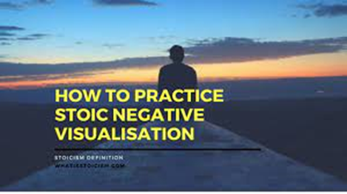
Assignment: Practicing Negative Visualization
Negative visualization, also known as premeditatio malorum, is a powerful technique borrowed from ancient Stoic philosophy. It involves contemplating potential negative events to gain a deeper appreciation for the positive aspects of your life. It is a prime way to thwart hedonic adaptation. In this assignment, you will get the opportunity to practice negative visualization by spending 15 minutes writing in your journal. Follow the steps below to complete the assignment.
Process Instructions:
- Reflection: Take a few moments to reflect on the things you value most in your life. Consider your possessions, loved ones, work, entertainment, hobbies, and any other aspects that are important to you.
- Journaling: Spend 15 minutes writing in your journal. During this time, choose one category from your reflection (possessions, loved ones, work, etc.) and imagine the scenario of losing something significant within that category. Write about how you would feel and how you could cope with the loss.
- Contemplation: Consider the impact of the loss and think about ways to minimize its effect. Reflect on how this exercise makes you feel (what emotions did you experience) and what are your insights (what did you learn/take away).
- Repeat: Repeat this exercise for different categories in subsequent journaling sessions. Aim to explore various aspects of your life to gain a holistic perspective.
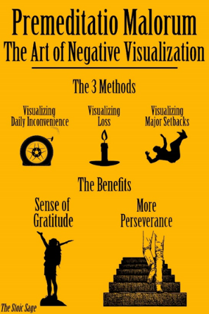
Tips if you want to Embrace this Philosophy:
- Consistency is Key: Schedule regular sessions for negative visualization. Start once or twice a week and gradually increase the frequency if you find it beneficial.
- Embrace Discomfort: While it might be uncomfortable to think about negative scenarios, remember that the purpose is to appreciate the positives in your life more deeply.
- Reflection Questions: Consider these questions to guide your writing:
  - What specific item, person, or aspect of your life did you visualize losing?
  - How did this exercise make you feel? Did it change your perspective on the things you value?
  - What strategies did you come up with to cope with the imagined loss?
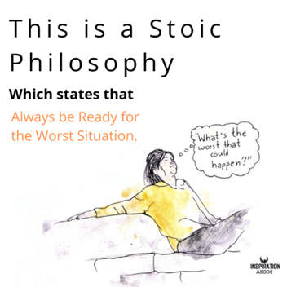
Alternative Responses:
If you prefer a different approach to journaling, here are some alternative ways to engage with the concept of negative visualization:
- Creative Expression: Create a piece of art, a poem, or a short story that captures the emotions and thoughts associated with the imagined loss. Write a reflection below.
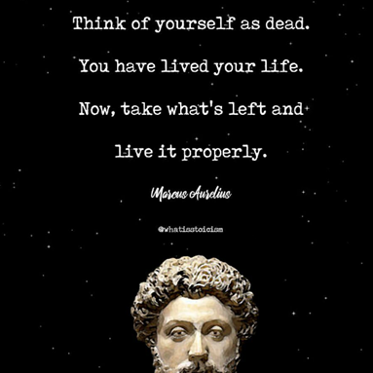
- Mind Map: Use a mind map to visually represent the things you value and explore the potential challenges associated with losing each item.
- Discussion: Engage in a group discussion with your classmates. Share your reflections and listen to others' perspectives on the practice of negative visualization. Write a reflection afterwards.
- Letter Writing: Write a letter to your future self, reflecting on the importance of appreciating the present and being prepared for challenges in the future.
Remember, the goal of this assignment is to enhance your appreciation for the positives in your life and prepare you mentally for potential adversities. Embrace the process, and feel free to explore different ways to engage with the concept of negative visualization.
Grading Rubric and Proficiency Scale Name:
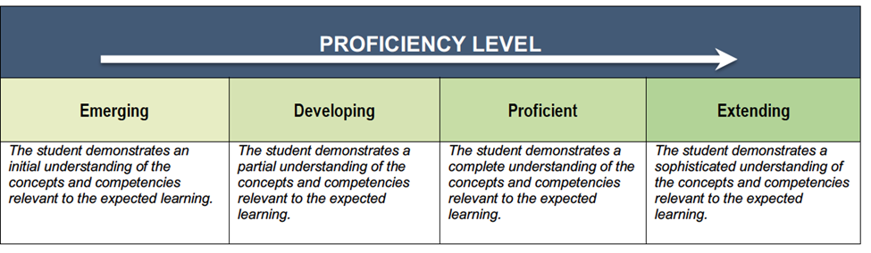
Please be aware that this is being graded as a first draft, journal and on the first attempt, we are simply trying out the concept of negative visualization. Try your hardest, because, after all – this is for YOU.

Criteria | Emerging | Developing | Proficient | Extending
Understanding of Concept | Limited understanding of negative visualization. Fails to grasp the concept's significance and purpose. | Demonstrates a basic understanding of negative visualization but lacks depth and insight. | Shows a good understanding of negative visualization, explaining the concept with clarity. | Demonstrates a profound understanding of negative visualization, showcasing deep insights into the practice
Reflection and Depth | Provides shallow reflections on the imagined scenarios, lacking depth and emotional engagement. | Offers some depth in reflections but lacks significant introspection and emotional expression. | Reflects adequately on the imagined scenarios, demonstrating a decent level of introspection. | Provides insightful and emotionally rich reflections, showcasing deep introspection and self-awareness.
Clarity and Organization | Writing lacks clarity and coherence. Ideas are disorganized and difficult to follow. | Presents ideas with some clarity but lacks smooth transitions and overall organization. | Communicates ideas clearly with mostly smooth transitions between thoughts. | Demonstrates exceptional clarity and organization. Ideas flow logically and coherently.

Teacher Comments:

/20

Negative visualisation is a technique that encourages us to regularly spend a short amount of time imagining the negative events that could befall us. For example:
- Giving thought to what things you value most in your life and then imagining losing those things.
- Contemplating the unexpected death of a loved one.
- Envisaging what would happen if you lost your job.
It may seem somewhat pessimistic but the result of the exercise is powerful. You can slowly develop a greater appreciation for the things in your life, make the most of the time you have with loved ones and even get good plans in place for when things go wrong.
1. Start by taking stock of things that are valuable to you and note them down. Here are some ideas:
- Possessions – home, vehicles, gadgets, things with sentimental value
- Loved ones – family members, friends, pets
- Work – job, colleagues, boss
- Entertainment – access to the internet, favourite foods, TV shows
- Hobbies – sports, activities, volunteer work
2. If you can think of your own, add it to the categories above.
3. Set a reminder on your phone to schedule Negative Visualisation sessions – don’t overwhelm yourself to begin with, once or twice a week should be enough to get you into the habit.
4. In each session, spend 5-10 minutes working through one of the categories you previously noted and do the following:
- Think of all the things in that category that are important to you, that you have an attachment to.
- Contemplate how you’d feel if that thing was taken away from you or no longer possible.
- Consider how you could minimise the impact of losing that thing. Just having thought about it, you’re now more prepared than you were!
The benefit of these sessions is that you’re likely to feel a greater appreciation for the things you already have in your life as well as preparing yourself mentally should you ever lose them.
The Romans called it premeditatio malorum, the premeditation of evils/troubles. Seneca summarised the exercise beautifully in his Consolation to Marcia:
“Error decipit hic, effeminat, dum patimur quae numquam pati nos posse prouidimus. Aufert uim praesentibus malis qui futura prospexit.”
“He robs present ills of their power who has perceived their coming beforehand.”

Psych pro tip number three is that we can also thwart hedonic adaptation through a process of what's called negative visualization. This is something that the ancient stoics back in the day came up with. You can visualize the bad thing to get some happiness boost. How are we going to define negative visualization, we're going to call it this act of thinking about a bad counterfactual of a good thing.

one of the most famous cases of negative visualization
was this famous holiday movie, It's a Wonderful Life.
Have you any of you seen It's a Wonderful Life
to use another premise, show of hands.
Some of you. For those that haven't seen it.
Basically the Jimmy Stewart character,
he's sad about his life,
and I think this angel or somebody comes and basically it
shows him what his life would be
like if he was never existed.
He's like oh my gosh,
this counterfactual of me never
existing would be really bad.
I'm so happy with my life. I love it.
That's negative visualization and it sounds strange,
but it can powerfully make you
appreciate things that you don't often appreciate.

That's negative visualization and it sounds strange,
but it can powerfully make you
appreciate things that you don't often appreciate.
To see the power of this, let's try it.
I'm guessing that most of you have a phone right now,
some sort of cell phone with you.
I want you to think about what would happen if when
you reach for your phone the next time it was dead,
you get the brick of death.
It's just gone, and you have this moment of realizing,
like oh my gosh, I had all my contacts on there.
I didn't really back them up.
My photos are gone.
How am I going to call somebody later?
I don't even know what I'm going to do this summer
and my programs, I need my phone.
But, you don't, that didn't happen
probably when you take your phone.
It's going to be okay.
That was just a silly little toy example,
but my guess is the next time you pick your phone up,
having done that, you'll have a little
bit more savoring for it.
You won't have hedonically adapted to it as much.
That's negative visualization.

Rubric: Negative Visualization Journaling Assignment

Note: This rubric assesses the students' understanding, reflection, creativity, clarity, engagement, and writing skills on a four-point scale, using the terms "Emerging," "Developing," "Proficient," and "Extending" to indicate varying levels of achievement.

