Law 12 “Making a Murderer” (KEY)
Mr. Fitton

First.
Question: Have you ever heard of someone being wrongfully convicted of a crime?
What happened? _________________________________________________________________________________________________________________________________________________________________________________________________________________________________________________________________

Second.
Watch the following episode of Netflix’s critically acclaimed “Making a Murderer” and answer the questions. Be sure to take the time during commercials to catch up and fill in as many questions as you can.

Hook: What happens on September 11, 2003?
-Steven Avery freed after 18 years in prison for rape

Prediction:
-What do you think this episode is about?

Break:--------------------------------------------------------------------------------------------------------------

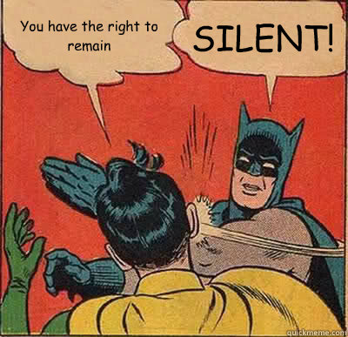
Opening Credits

Who is Steven Avery taking to court? Why?
Vogel, Kourcek,
Reckless behaviour towards the defendents
Obstruction of justice

What was the initial incident that may have caused for his imprisonment?
Ran Sandy Morris off the road, pulled out a gun

How did locals view the Avery family?
Different, didn’t fit into the community, different clothes, had a huge salvage yard
Strong sense of family, support each other

What was Steven Avery’s criminal past?

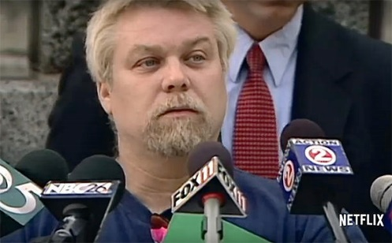
Why did Sandra Morris start rumours about Steven Avery?
Sheriff’s department wanted to take down the Avery family

I don’t want to be a criminal, I want to be normal

Commercial Break____________________
(time to answer a couple of questions!)

What happened in 1985?
Penny Beersten was sexually assaulted by a man while jogging. Beaten and left her for dead

How did Judy Dvorak and Sandra Morris know each other?

How was Steven Avery picked out by Penny Beerntsen?
Gene Kusche made a picture of Steven Avery, Dvorak showed it to Beerntsen
The physical description of the perpetrator did not fit with the description of Steven Avery. What was it?
Sheriff’s deputy says, I think its this guy
They made the case against Steven Avery, that night, themselves
“I got you now!”
Sherriff involved in case from Day 1

What rights were denied to Steven Avery?
Have a phone call
Have a lawyer
Treated like everyone else

Who was Gregory Allen in this case?
Man who the police were following
Violent past

Where was Steven Avery at 3:50pm on the day Penny Beernsten was attacked?
Pouring concrete at auto slavage, went to a gravel pit, went to Green Bay, shopped

At the age of 23, Steven is found guilty of Sexual Assault, Attempted Murder and False Imprisonment. He is sentenced to 32 years in prison.

New evidence was found for the case to be re-examined in 1996 after 12 years in prison, and then in 2001. What was “new”?
DNA evidence for fingernail scrapings – 3 alleles present – this helped to free him
Eye colour, white underwear
1 pubic hair that conclusively excluded Steven Avery. Hair matched to Gregory Allen.

Return to September 11, 2003
What was the bomb?
Repercussions in the law office. Law enforcement officers are writing memos to events that had occurred 10 years earlier. Vogel asked if whether Gregory Allen was in Vogel’s file for a crime that was similar to where Avery was convicted in Beernsten case. Vogel knew the connection but continued on with the prosecution.

Developing issues – innocent guy being locked up; dangerous rapist out on the street

Internal investigation did not see any criminal or ethical wrongdoings.

Law 12 “Making a Murderer”
Mr. Fitton

.
1. Question: Have you ever heard of someone being wrongfully convicted of a crime? What happened?

2
. Watch the following episode of Netflix’s critically acclaimed “Making a Murderer” and answer the questions. Be sure to take the time during breaks to catch up and fill in as many questions as you can.

Hook: What happens on September 11, 2003?

Prediction:
-What do you think this episode is about?

Break:--------------------------------------------------------------------------------------------------------------

Opening Credits

Who is Steven Avery taking to court? Why?

What was the initial incident that may have caused for his imprisonment?

How did locals view the Avery family?

What was Steven Avery’s criminal past?

Why did Sandra Morris start rumours about Steven Avery?
I don’t want to be a criminal, I want to be normal

Commercial Break____________________
(time to answer a couple of questions!)

What happened in 1985?

How did Judy Dvorak and Sandra Morris know each other?

How was Steven Avery picked out by Penny Beerntsen?

The physical description of the perpetrator did not fit with the description of Steven Avery. What was it?

What rights were denied to Steven Avery?

Who was Gregory Allen in this case?

Where was Steven Avery at 3:50pm on the day Penny Beernsten was attacked?

At the age of 23, Steven is found guilty of Sexual Assault, Attempted Murder and False Imprisonment. He is sentenced to 32 years in prison.

New evidence was found for the case to be re-examined in 1996 after 12 years in prison, and then in 2001. What was “new”?

Return to September 11, 2003

What was the bomb?

Developing issues – innocent guy being locked up; dangerous rapist out on the street

Internal investigation did not see any criminal or ethical wrongdoings.

Next episode!

