Law is everywhere – Quizzie /19
Habeas Corpus Rule of Law Substantive Law Procedural Law Tort Law
Criminal Law Constitutional Law Code of Hammurabi Mosaic Law Family Law
Administrative Law Common Law Precedent Civil Rights International Law
Bill Negotiation Mediation Arbitration Employment Law
Human Rights Retribution Restitution Public Law Property Law
Private Law Morals / Rules Justice (Any other terms we covered) Contract Law
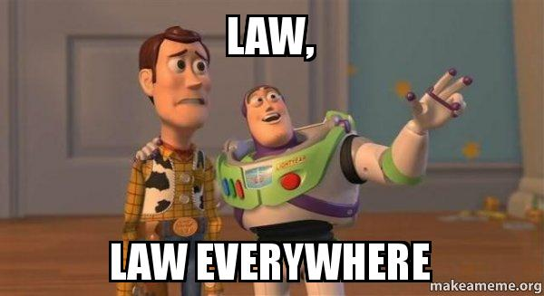
Instructions: The word bank above consists of all of the terms we have learned in this particular unit. The quiz below consists of two parts.
Part 1: Define key Terms.
Part 2: Read a scenario and identify the types of Law therein.

Define the Key Terms Below and provide an example. 1 Mark for proper definition; 1 Mark for Example. /10

- Rule of Law:

- Morals, Rules or Justice:

- Arbitration:

- Restitution:

- Private Law:

Part 2 – read the Scenario below and identify the Terms contained within. There are usually 2 or more /9
(0.5 per correct term, X2 = 1 point – maximum of one point per section)

Isabella and Abigail had just ordered double-doubles. As they sat, they both accidentally stumbled, and their hot coffee splashed like acid on their arms. Both received burns as employee Cohen. came out with a mop and surveyed the mess. He was surprised to note that none of the cups had “caution hot” warnings on them. Angry – the two wanted revenge.
1. _________________________________________________________________________________________ (1)

Meanwhile, across town Mark, Joey and Ekjot were just getting off the city bus to get to school. The bus driver, Logyn was distracted by an Instagram post that he was reading and began to drive away. The bus lurched forward, and the three kids all got caught in the doorway and were dragged about a meter before the driver noticed them and stopped. Fortunately they were not seriously hurt. After gesturing their disapproval with a carefully selected finger to the driver, they marched indignantly toward the school. Logyn offered to buy them each a new backpack. Mark silently thought, ``I forgive him.`` Joey and Ekjot secretly plotted to run him over to get some street justice.

2. _________________________________________________________________________________________ (1)

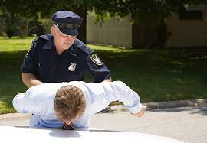
The school erupted with rumours as the Principal and Vice-Principals were at the door checking everyone’s backpacks. Dallen, Kayla and Ceanna demanded to know why they were being searched. The admin team produced a copy of The School Act and informed the two to read section 2, subsection 7, paragraph (a) – the section which permits school employees to search student belongings to ensure the safety of those in the building. As Denzer entered the front doors, he appeared very nervous as the Principal produced two kilos of an object from his bag. The RCMP were quickly called. 1.
3. _________________________________________________________________________________________ (1)

After her toe was ran over in the parking lot, Sylvia was screaming something about “Eye for an Eye and Tooth for a Tooth” and that she would see the driver in Court – and see what sentence the Judge would impose based on past cases.

4. _________________________________________________________________________________________ (1)

After waiting outside of an exclusive local restaurant, two students from PMSS got to the front of the line. The bouncer, Deepika looked the two over and saw that Erik was wearing a religious symbol around his neck. Deepika took one look at the artifact and refused him entry. Kayla tried to explain the significance of the necklace and explained its deep and important significance. But the brute wouldn’t budge. The aggrieved kids planned to go to the Human Rights Tribunal to launch a complaint ASAP.

5. _________________________________________________________________________________________ (1)
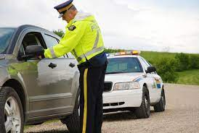
Emma was stopped by the police for speeding. Cst. Fitton, decided to stop the car because of the “N” on the back, the speed and the number of passengers. Because of the raucous discussions in the over crowded car, Emma had failed to notice the change in the speed limit when she left the highway. The fine would be $167.

6. _________________________________________________________________________________________ (1)

Meanwhile, Raquel was having a bad day. She had just bought a new house, but when she arrived, the previous owner, Marlo, had taken her money, but decided not to sell to her. Marlo noticed that Raquel was a young female and did not want to sell to a woman.

7. _________________________________________________________________________________________ (1)

In a foul mood, walking home, Rediet noticed a police car had pulled over her friends. In a momentary lapse of judgment, Rediet made reference to the police officer smelling like a delicious, cured breakfast meat. Cst. Minardi did not take this as a compliment and placed Rediet in handcuffs without reading her rights.

8. _________________________________________________________________________________________ (1)
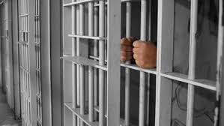
Why am I being arrested” she shouted. “I’ll think of something,” retorted the officer. That night, Rediet spent 30 hours in jail with a cellblock filled with nefarious criminals like, Emerson, Justin, Jaxen, David and Neil without speaking to a lawyer or going before a judge. Rediet pondered how she would react to this egregious lack of justice? Should she forgive the police officer or should she file a complaint and hope the constable got fired? Or she she talk it out with him?

9. _________________________________________________________________________________________ (1)

