Mr. Fitton’s Weekly LAW Learning Bulletin

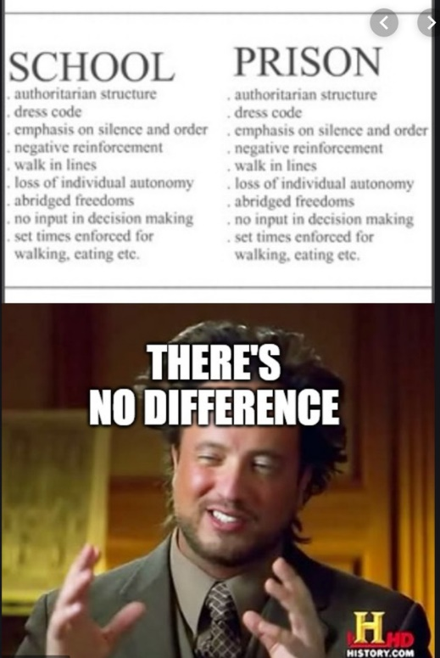

Week 8 - May 25th – June 1st

1. HOW TO START.
-Go to my website at: https://mrfitton.weebly.com/corruption---online-unit.html
2. This is a Unit on Corruption and Evil.

Checkmark  When Done | Task – Assignments, Learning Activities
 | 1. Go to: https://mrfitton.weebly.com/corruption---online-unit.html A New Unit on Corruption
 | 2. Watch the Ted Talk “The Psychology of Evil.” https://youtu.be/OsFEV35tWsg
 | 3. Write down 5 quotes/facts from the Ted Talk about Evil. (We will apply these to another video later).
 | 4. Watch the Trailer for “The Seven-Five” a film about police corruption: https://youtu.be/vM0IOHiZSl4
5. Watch the Documentary “The Seven-Five” https://youtu.be/adZaHShRa3A
-Please make sure you have parent permission to watch the documentary, because it has violence/coarse language in it.
6. No assignment this week. There will be an assignment next week where you write about what
Dr. Zimabardo would say if he was watching the Seven-Five with you. Assignment coming soon!
*Please note, I am available on TEAMS /Remind / Email Every day to help students with homework/assignments or anything they need! I will be working through my list and trying to
Contact every student this week

